Effectiveness and Capability Review of the Australian Securities and Investments Commission

Financial Regulator Assessment Authority

July 2022

© Commonwealth of Australia 2022

ISBN: 978‑1‑925832‑52‑5

This publication is available for your use under a [Creative Commons Attribution 3.0 Australia](http://creativecommons.org/licenses/by/3.0/au/deed.en) licence, with the exception of the Commonwealth Coat of Arms, the Treasury logo, photographs, images, signatures and where otherwise stated. The full licence terms are available from <http://creativecommons.org/licenses/by/3.0/au/legalcode>.

Creative Commons attribution licence 3.0 icon. 

Use of Treasury material under a [Creative Commons Attribution 3.0 Australia](http://creativecommons.org/licenses/by/3.0/au/deed.en) licence requires you to attribute the work (but not in any way that suggests that the Treasury endorses you or your use of the work).

**Financial Regulator Assessment Authority material used ‘as supplied’.**

Provided you have not modified or transformed Treasury material in any way including, for example, by changing the Treasury text; calculating percentage changes; graphing or charting data; or deriving new statistics from published Treasury statistics – then Treasury prefers the following attribution:

*Source: The Financial Regulator Assessment Authority*

**Derivative** **material**

If you have modified or transformed Treasury material, or derived new material from those of the Treasury in any way, then Treasury prefers the following attribution:

*Based on the Financial Regulatory Assessment Authority data*

**Use of the Coat of Arms**

The terms under which the Coat of Arms can be used are set out on the Department of the Prime Minister and Cabinet website (see [www.pmc.gov.au/government/commonwealth‑coat‑arm](http://www.pmc.gov.au/government/commonwealth-coat-arm)s).

**Other uses**

Enquiries regarding this licence and any other use of this document are welcome at:

Manager  
Media Unit  
The Treasury  
Langton Crescent   
Parkes ACT 2600  
Email: [media@treasury.gov.au](mailto:media@treasury.gov.au)



29 July 2022

The Hon. Stephen Jones, MP

Assistant Treasurer and

Minister for Financial Services

Parliament House

Canberra ACT 2600

Dear Assistant Treasurer and Minister for Financial Services

**Financial Regulator Assessment Authority** **Effectiveness and Capability Review of the Australian Securities and Investments Commission**

In accordance with the *Financial Regulator Assessment Authority Act 2021*, we are pleased to present to you the Financial Regulator Assessment Authority (FRAA) report – *Effectiveness and Capability Review of the Australian Securities and Investments Commission* (ASIC).

Our first review is an assessment of ASIC’s activities in the following areas:

strategic prioritisation, planning and decision‑making

surveillance

licensing.

Our views and recommendations are based on evidence gathered from a range of sources including public consultation, surveys of ASIC staff and stakeholders, meetings with ASIC senior leaders and consultation with peer regulators, industry and consumer advocacy bodies and academics.

In our view ASIC is generally effective and capable in the areas reviewed, although there are important opportunities to enhance its performance. In this report we make recommendations which if implemented we believe should improve the effectiveness and capability of ASIC. During this review, ASIC initiated several projects in the areas we identified.

Notwithstanding areas of improvement, it is well recognised that Australia has a world leading financial system to which ASIC’s contribution is crucial.

We wish to acknowledge the work of Ms Gina Cass‑Gottlieb as an inaugural member of the FRAA.

We commend the report to you.

Yours sincerely

|  |  |  |
| --- | --- | --- |
| Nicholas Moore  Chair | Fiona Crosbie  Member | Craig Drummond  Member |

# Contents

Acknowledgments 1

Executive summary 3

Recommendations 3

Inaugural review of ASIC 4

Themes 4

Future actions 6

Outline of this report 6

Chapter 1: FRAA objectives and methodology 7

Overview of the FRAA 7

The FRAA’s approach 7

Measuring the effectiveness and capability of financial regulators 10

Scope and methodology of this review 14

Chapter 2: ASIC’s role in the Australian financial system 17

Introduction 17

Financial system regulators 17

Statutory mandate 17

Funding and resourcing 21

Chapter 3: Strategic prioritisation, planning and decision‑making 23

Introduction 23

Governance and accountability at ASIC 23

Assessment 30

Strategic prioritisation, planning and decision‑making 31

Effectiveness and capability of ASIC’s strategic prioritisation, planning and decision‑making 33

Planned initiatives 42

Assessment 43

Chapter 4: Surveillance 45

Introduction 45

Surveillance at ASIC 45

Effectiveness and capability of ASIC’s surveillance function 46

Planned initiatives 59

Assessment 59

Chapter 5: Licensing 61

Introduction 61

Licensing at ASIC 61

Effectiveness and capability of ASIC’s licensing function 64

Planned initiatives 78

Assessment 79

Chapter 6: Outcomes of this review 81

Introduction 81

Data and technology 81

Quality of engagement with stakeholders 82

Measuring, assessing and reporting on outcomes 85

Mix of skill sets 86

Abbreviations and acronyms 89

Appendix A: Methodology of this review 91

Appendix B: Examples of international frameworks for measuring performance 97

# Acknowledgments

The FRAA would like to thank the ASIC Chair, deputy chairs, commissioners, senior executive leaders and staff for their assistance and engagement in this review.

The FRAA would also like to thank everyone who generously gave their thoughts, insights and time throughout the consultation process, particularly through participation in meetings, focus groups and surveys, and preparation of submissions.

The FRAA wishes to acknowledge the assistance of Boston Consulting Group for identifying, collating and preparing evidentiary material for this review.

The FRAA acknowledges the significant contribution of Ms Gina Cass‑Gottlieb to this review of ASIC during her time as an inaugural member of the FRAA.

Finally, the FRAA wishes to acknowledge the support provided by members of the Treasury Secretariat.

# Executive summary

ASIC plays a key role in the Australian financial system. It is Australia’s integrated corporate, markets, financial services and consumer credit conduct regulator and its remit, having grown over time, is now one of the broadest of comparable regulators globally.[1]

ASIC has undergone recent organisational changes, in part driven by several external reviews.[2] These changes to its governance arrangements include the clearer delineation of executive and non‑executive responsibilities between the Commission and senior leaders. In 2021, a new Chair, Mr Joseph Longo, and Deputy Chair, Ms Sarah Court, were appointed to ASIC. Chair Longo has publicly stated he wishes ASIC to become an ambitious, confident and digitally enabled regulator.[3]

It is well recognised that Australia has a world‑leading financial system to which ASIC’s contribution is crucial. As the financial landscape transforms, ASIC must increasingly be alert to emerging trends and issues, keep pace with new technologies and products, and continue to enhance its effectiveness and capability.

## Recommendations

The FRAA considers that ASIC is generally effective and capable in the areas reviewed, although there are important opportunities to enhance its performance. The FRAA makes the following recommendations which if implemented should enhance the culture of ASIC and improve its effectiveness and capability.

|  |
| --- |
| Recommendations   * ASIC requires a substantial uplift in its data and technology capability, which will involve cultural change. * ASIC should have a stronger focus across the organisation on enhancing the quality of its engagement with stakeholders. * ASIC should enhance its ability to measure its own effectiveness and capability and communicate the outcomes of such assessment transparently, both internally and externally. * ASIC should continue to broaden its mix of skill sets to ensure it can meet the current and future needs of the organisation. |

The FRAA expects that the implementation of these recommendations will require a cultural shift in the way that ASIC approaches its work and engages with its regulated population and broader stakeholders. If achieved, ASIC at all levels should have the confidence to:

engage openly with its stakeholders

communicate with clarity and certainty

assess itself continually and identify opportunities for improvement, without compromising its role to apply and enforce the law.

Such a cultural shift should increase the confidence of government, and indeed all stakeholders, in ASIC’s effectiveness and capability.

## Inaugural review of ASIC

The FRAA has assessed ASIC’s effectiveness and capability in 3 areas: strategic prioritisation, planning and decision‑making, surveillance and licensing. The FRAA has used a qualitative framework to conduct its assessment and has gathered evidence from a range of sources. These included:

public consultation

meetings with industry and consumer advocacy bodies, academics, peer regulators and ASIC senior leaders

surveys of ASIC staff and stakeholders.

As set out below, the FRAA considers that ASIC is generally effective and capable in the areas of this review, with several opportunities to improve its performance. During this review ASIC initiated several projects in areas identified by the FRAA.

ASIC’s strategic prioritisation, planning and decision‑making processes are generally effective in supporting ASIC’s operations. ASIC’s current publications are generally well regarded and serve to communicate ASIC’s strategic priorities. ASIC is working on initiatives to improve its strategic planning process which will enhance its long‑term capability and resourcing needs. However, ASIC needs to identify and clearly communicate its critical priorities as well as target, measure and report outcomes to stakeholders. The FRAA understands that ASIC is taking steps towards this in its   
2022–26 planning cycle.

ASIC’s risk‑based approach to surveillances, as well as the types of surveillances used, generally enable it to appropriately target and design its activities. However, there remain opportunities for ASIC to increase the effectiveness of its surveillance function, including through the improved use of data analytics and better engagement with its regulated population. A broader uplift in surveillance systems and analytical capabilities will help drive such an improvement. ASIC is undertaking work to improve the measurement of the impact of its surveillance activities, and these outcomes should be clearly communicated to stakeholders.

ASIC’s licensing function is broadly effective, although somewhat constrained by limited resourcing and technology. ASIC undertakes robust licensing assessments but could improve the timeliness of licensing decisions with more resourcing and better data and systems. ASIC should place greater emphasis on the experience of licence applicants and consider the benefits of its licensing staff members engaging in more direct communications with applicants. There is opportunity for ASIC to measure the quality of its licensing decisions.

## Themes

In conducting this review, common themes emerged that came to form the basis of the FRAA’s recommendations. These themes relate to ASIC’s data and technology capability, the nature of its relationships particularly with external stakeholders, the need for it to assess the outcomes of its activities and the skill sets of its people to support these areas.

### Data and technology capability

Improved data, analytics and technology capabilities would support ASIC to better identify and act on emerging harms, set strategic priorities, create efficiencies, lower the regulatory burden, and deliver a digital stakeholder experience. There are a range of opportunities for ASIC to enhance its effectiveness through improved technology capability and the better use of data, particularly in its Financial Services and Wealth Group. ASIC recognises this and has developed a digital strategy (due to launch in August 2022) to:

expand its use of technology to support more efficient regulatory processes

improve its use of data analytics tools to better identify harms and regulatory priorities

improve the way it interacts with its regulated population.

It is the FRAA’s view that ASIC requires a substantial uplift in its data and technology capability and will need to undergo material cultural change to embed the benefit from the required investment. The Commission and ASIC’s senior leaders will need to lead this cultural shift to realise the benefits of its planned digital uplift.

### Quality of engagement with stakeholders

ASIC must maintain clear independence from the community it regulates and resist regulatory capture. Improving stakeholder engagement in a thoughtful and considered way need not compromise this imperative. To deliver its objectives ASIC should have a strong, trusted and, where appropriate, open and collaborative relationship with its stakeholders. This is necessary to support ASIC’s effectiveness and provide it with intelligence that would enable it to act earlier to minimise harm.

ASIC has identified the need to improve its stakeholder engagement. It has started to communicate its priorities more clearly, and use innovative channels to communicate emerging harms. It has also indicated it will review its approach to external engagement.

The FRAA considers that ASIC will need to complement these initiatives with a mindset that sees it become more transparent, open and responsive to feedback from stakeholders. This will require ASIC to engage proactively with its stakeholders and consider their ongoing experience in interacting with ASIC.

### Measuring, assessing and reporting on outcomes

To determine whether ASIC is achieving its statutory objectives it is necessary that ASIC establish and embed measures to assess the outcomes of its regulatory activities. ASIC should publish the results of these measures to increase transparency and accountability.

The FRAA notes that ASIC plans to improve the manner in which it evaluates its performance. The FRAA considers this will complement the FRAA’s joint work with ASIC to develop a transparent and consistent framework to measure the regulators’ effectiveness and capability.

The FRAA considers it important that alongside the development of measures, ASIC leadership drive a cultural shift to be open to and look for opportunities for continual improvement.

### Mix of skill sets

ASIC has identified the need to support and equip its staff with the right mindset and the necessary tools and capabilities, including to become more digitally enabled. ASIC has developed a new People Strategy and has identified initiatives to support this goal. The FRAA considers it important that ASIC has an ongoing focus on broadening its mix of skill sets.

To implement the recommendations in this report ASIC will need the right cultural settings, organisational capability and people skills to:

uplift its data and technology capability

improve its engagement with stakeholders

self‑assess its regulatory outcomes.

The FRAA expects that this would support ASIC to deliver its vision to create an environment for its staff to make confident decisions and achieve ambitious regulatory outcomes.

## Future actions

As outlined in Chapter 1: FRAA objectives and methodology, the FRAA intends to work with ASIC and Australian Prudential Regulation Authority (APRA) over the coming year to develop metrics to measure their effectiveness and capability.

The FRAA’s next review of ASIC in 2023–24 will assess different areas of its functions. The FRAA will consider how the changes in ASIC’s governance and accountability framework are operating in practice (refer Chapter 3: Strategic prioritisation, planning and decision‑making). The FRAA also intends to review ASIC’s progress on the recommendations outlined in this report including the projects that ASIC has underway or commenced during this review. These projects are set out in Box 3.3, Box 4.2 and Box 5.2.

## Outline of this report

This report begins with an overview of the FRAA and the methodology for its reviews (refer   
Chapter 1: FRAA objectives and methodology) and then outlines ASIC’s role in the Australian financial system (refer Chapter 2: ASIC’s role in the Australian financial system). Chapters 3 to 5 outline the evidence gathered and the overall assessment for each of the 3 review areas. The outcomes of this review and recommendations are discussed in Chapter 6: Outcomes of this review.

# Chapter 1: FRAA objectives and methodology

## Overview of the FRAA

* 1. The FRAA was established in response to the Royal Commission into Misconduct in the Banking, Superannuation and Financial Services Industry (Royal Commission).[4] The Royal Commission recommended the creation of an independent oversight authority to assess the effectiveness and capability of ASIC and APRA (together, the regulators). The FRAA is a permanent body, composed of 3 part‑time members appointed by the minister for 5‑year terms. The FRAA is supported by a secretariat of Treasury staff.
  2. The FRAA’s statutory mandate requires it to assess and report on the effectiveness and capability of the regulators on a biennial basis, with reports to be delivered to the minister and tabled in Parliament.[5] The relevant minister can also direct the FRAA to prepare a report on any matter related to the regulators’ effectiveness and capability.[6] The FRAA’s legislative authority precludes it from assessing or reporting on only a single case.[7]

## The FRAA’s approach

* 1. ASIC is subject to a range of external accountability and oversight mechanisms and in recent years, has been the subject of a number of performance reviews.
  2. Figure 1.1 sets out ASIC’s accountability mechanisms, including the various sources of its responsibilities, its reporting requirements, the means by which its performance is currently assessed, and the external review mechanisms available to hold it to account.
  3. The FRAA intends to complement and not duplicate the existing external accountability mechanisms that apply to ASIC. Over time, it is hoped that the FRAA’s activities will enhance the operation of these other mechanisms through creating a base of evidence and transparent benchmarks that can be drawn upon.

Figure 1.1: ASIC’s accountability mechanisms[8]

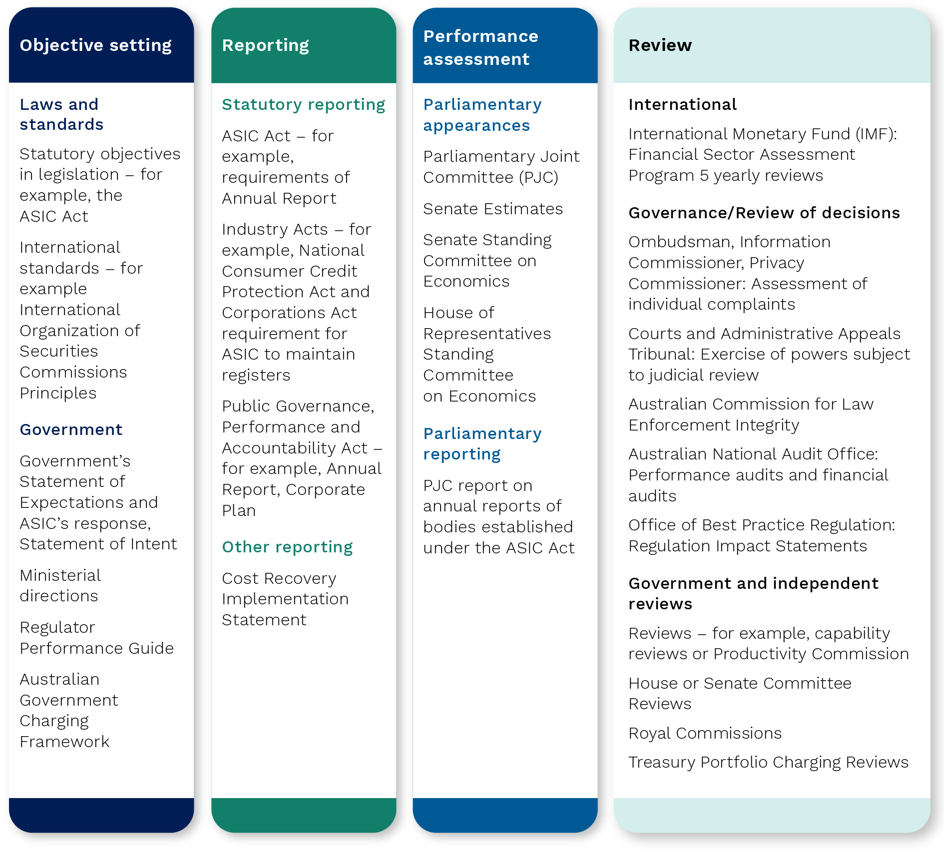

Source: Treasury, 2022.

* 1. In this initial FRAA review of ASIC (this review), the FRAA has laid the foundations of an approach which the FRAA expects to enhance over time. It is the FRAA’s expectation that ASIC, with the benefit of these reviews, can work to strengthen its own processes for assessing its effectiveness and capability.
  2. The FRAA’s assessment has been guided by ASIC’s statutory objectives and responsibilities, the Government’s Statement of Expectations and ASIC’s Statement of Intent and Corporate Plan. The FRAA’s approach has been informed by the following considerations:
* the importance of engagement with ASIC
* the need to consult broadly with a range of stakeholders to arrive at an evidence‑based assessment
* the desirability of creating an approach that is replicable across subsequent reviews to arrive over time at transparent measures.
  1. Each review of ASIC conducted by the FRAA will assess a set of regulatory functions and operations so that over consecutive reviews the breadth of ASIC’s activities will be assessed. This approach will enable the FRAA to undertake meaningful assessments of each function and provide sufficient opportunities for ASIC to act in response. The FRAA has divided ASIC’s regulatory and operational activities into a number of modules, recognising that the activities of ASIC are not readily divisible into discrete functions. For example, ASIC’s licensing, surveillance and enforcement activities are interrelated.
  2. Figure 1.2 depicts the budget and staff allocated to each of ASIC’s key regulatory and operational teams’ activities as a percentage of ASIC’s overall funding. ASIC allocates 22% of its budget to its licensing and surveillance teams, a portion of which is spent on licensing and surveillance activities.[9] These licensing and surveillance activities are the subject of this review.

Figure 1.2: Budget and staff allocation of ASIC regulatory and operational teams[10]

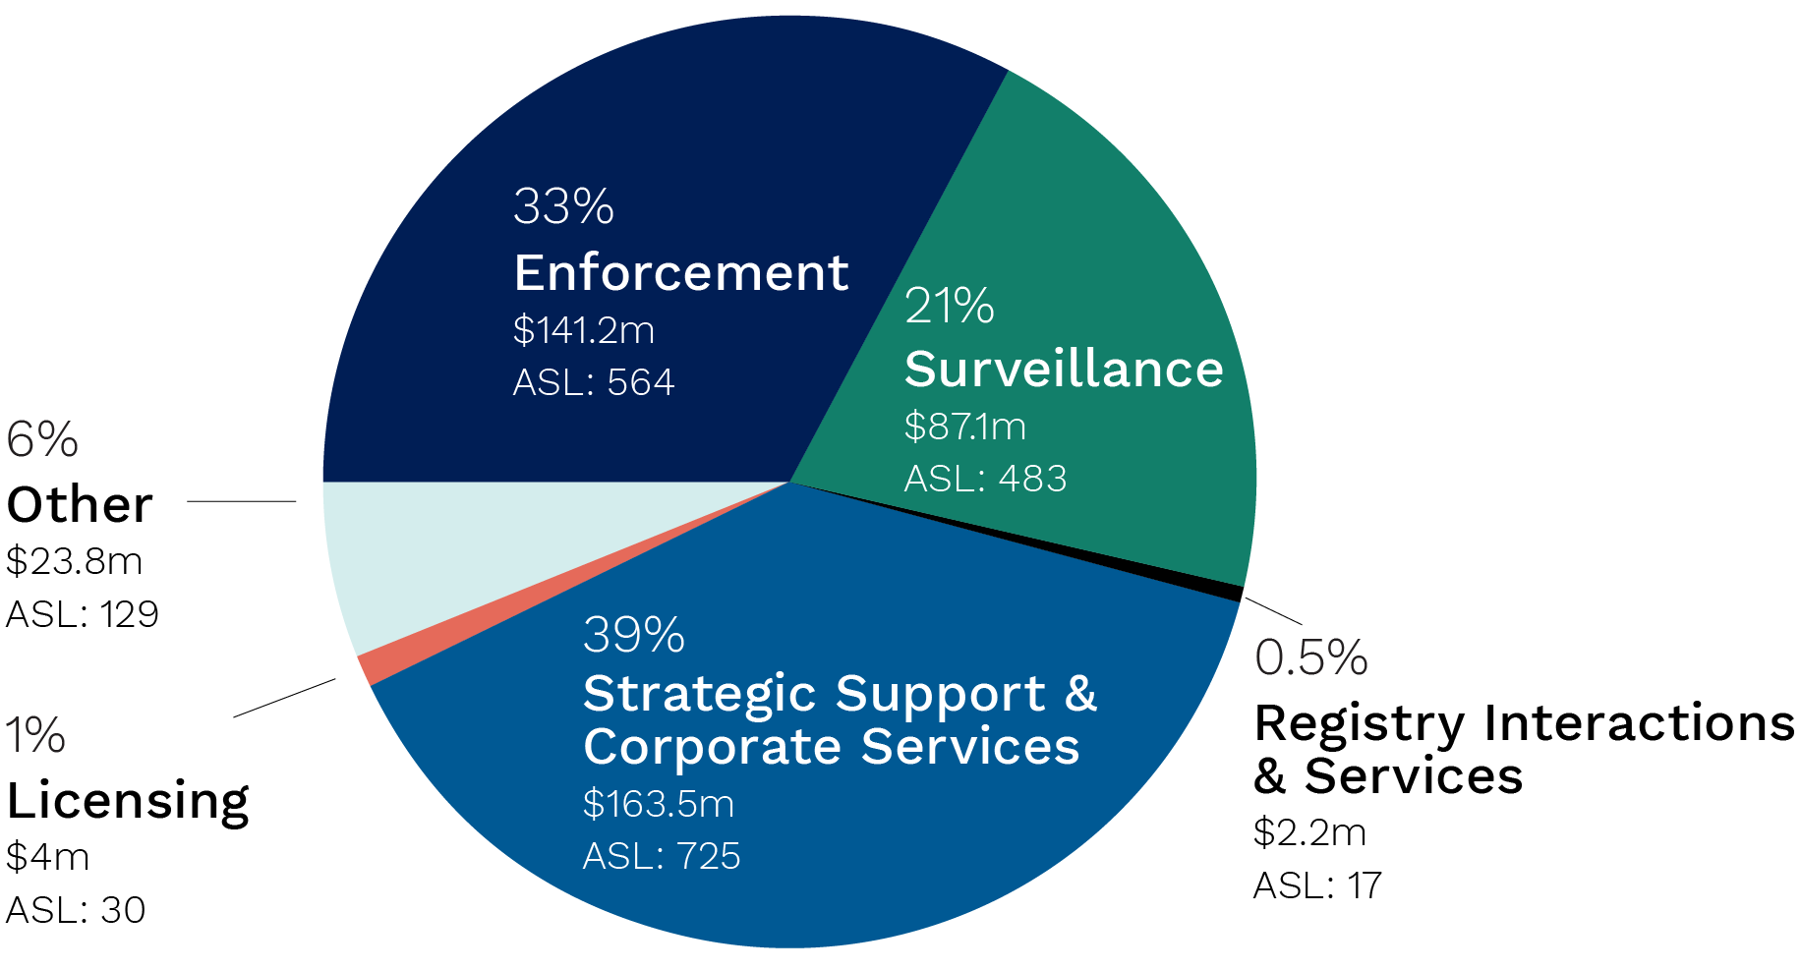

Source: ASIC, Material supplied to this review, 2022.

## Measuring the effectiveness and capability of financial regulators

* 1. Globally, the FRAA is unique in its mandate and the permanent nature of the FRAA provides an opportunity to take a medium‑term approach to developing a transparent and consistent framework to measure the effectiveness and capability of the regulators.
  2. There are no settled metrics to assess regulatory effectiveness and capability and there are substantial complexities in comparing regulators. The lack of globally accepted metrics reflects the difficulty of the task. That said, individual metrics can assist in the ongoing management of a regulator and help senior management with the difficult trade‑offs that are a central part of their role.
  3. The FRAA considers it important that alongside more qualitative forms of assessment through stakeholder submissions, interviews, case studies and surveys, assessments by the FRAA can come to rely on more enduring metrics to measure effectiveness and capability over time.

### Developing a framework of indicators and metrics to measure effectiveness and capability

* 1. There are several frameworks for the measurement of regulatory and financial system performance from international bodies such as the Organisation for Economic Co‑operation and Development (OECD), the International Monetary Fund (IMF) and the Basel Committee on Banking Supervision. However, these frameworks do not provide a clear basis for assessing the effectiveness or capability of regulators. See Appendix B: Examples of international frameworks for measuring performance for examples of international frameworks.
  2. The FRAA intends to work with the regulators and broader stakeholders, including academics, international regulators and international bodies such as the IMF, OECD and International Organization of Securities Commissions (IOSCO) to develop metrics for measuring the effectiveness and capability of the regulators.[11]

|  |
| --- |
| Box 1.1: Mandate for ASIC  ASIC’s mandate, as the conduct regulator, is broad. It is responsible for the regulation of Australian companies, financial markets, financial services organisations, professionals who deal and advise in investments, superannuation, insurance, deposit taking and credit. ASIC’s objectives are to maintain, facilitate and improve the performance of the financial system and entities in it; promote confident and informed participation by investors and consumers in the financial system; administer the law effectively and with minimal procedural requirements; receive, process and store, efficiently and quickly, information it receives; make information about companies and other bodies available to the public as soon as practicable; and take the action necessary to enforce and give effect to the law. See Chapter 2: ASIC’s role in the Australian financial system for more information on ASIC’s mandate. |

* 1. ASIC currently reports on its performance through a range of publications such as its Annual Report and Corporate Plan.
  2. Most reported metrics focus on the regulatory activities undertaken and the resources available to undertake these activities – that is, measurements of regulatory outputs. For example, ASIC currently reports on its regulatory activities by reference to a suite of metrics. This is illustrated in Box 1.2.

|  |
| --- |
| Box 1.2: Output metrics for ASIC   * Number of licences granted or varied * Time taken to grant licences * Number of policy/guidance documents issued * Number of regulatory relief decisions * Surveillances completed * Number of thematic reviews * Number of programmatic reviews * Number of surveillances of entities or individuals * Investigations completed * Number of enforcement actions * Quantum of enforcement penalties   Note that ASIC currently reports a wide suite of outputs.[12] |

* 1. While measurements of ASIC’s activities or outputs are useful to provide transparency and accountability, they offer limited insight into the effectiveness and capability of ASIC. For example, the time taken to grant a licence and the number of licences granted do not provide an assessment of whether the licensing process is appropriately rigorous or efficient. Similarly, the number of enforcement actions and the quantum of pecuniary penalties imposed do not measure whether the regulator’s enforcement strategy is appropriately targeted and deters misconduct.
  2. To assess effectiveness and capability, metrics are required that look at the quality of the regulatory activities and outcomes delivered. In the case of ASIC, some examples of outcomes that could be measured include:
* consumer confidence in the fairness of the financial system
* enforcement actions that deter future misconduct
* licensing decisions that ensure only those who are proper, competent and have adequate resources and systems are able to enter the financial system
* surveillance, education and engagement activities that enhance compliance, reduce misconduct and promote positive outcomes for consumers and investors.
  1. However, none of the above outcomes is readily measurable through individual metrics. The FRAA expects that a manageable number of indicators and metrics will need to be developed that allow for assessment of ASIC’s effectiveness and capability in delivering against each such outcome.
  2. There are some limited examples of regulators developing effectiveness and capability metrics.
  3. The United Kingdom’s Financial Conduct Authority (FCA) recently commenced a 3‑year project to develop and embed a set of metrics that link outcomes for consumers and market participants to the tools and interventions the FCA deploys. The FCA has proposed a number of metrics and is developing its methodology. [13] The FRAA will engage with the FCA to learn from its experience.
  4. ASIC has committed to refining its performance assessment framework so it can use data and other tools to measure the outcomes of activities.[14]
  5. For example, ASIC has formulated a framework to assess the impact of its regulatory interventions, including surveillance projects. This framework is being applied in the 2022–23 business plans to strategic projects where ASIC is seeking to intervene to address broad or systematic harms. The framework requires that success criteria are identified at the outset, to support ex‑post analysis of the outcomes, and whether ASIC has been effective in reducing the identified harm.
  6. ASIC’s statutory mandate requires it to maintain, facilitate and improve the performance of the financial system and the entities within that system.[15] There is therefore, value in considering at a high level the outcomes being delivered by the overall financial system.
  7. A well‑functioning financial system is efficient, resilient and treats participants fairly.[16] Australia has a generally well‑functioning financial system, demonstrated by its resilience and efficiency through economic cycles and particularly evident during the Global Financial Crisis (GFC) and COVID‑19 pandemic. [17] However, as identified by the Royal Commission, the fairness of the financial system and the conduct of financial firms have seen failures requiring considerable reform over the previous decade.
  8. Essential to a fair financial system is adequate compensation arrangements for harm suffered by investors and consumers. In 2020–21 the Australian Financial Complaints Authority awarded $241 million in compensation for financial misconduct causing harm to investors and consumers, in addition to remediation overseen by ASIC.[18]
  9. A well‑functioning financial system has a number of attributes that can be measured. Box 1.3 provides some examples of indicators and metrics for measuring the performance of the financial system.

|  |  |  |  |  |  |  |  |  |  |  |  |  |  |  |  |
| --- | --- | --- | --- | --- | --- | --- | --- | --- | --- | --- | --- | --- | --- | --- | --- |
| Box 1.3: Example indicators and metrics of a well‑functioning financial system   |  |  |  | | --- | --- | --- | | Characteristics | Indicators | Metrics | | Efficiency | Financial products and services delivered in cost efficient way | Cost of capital raisings (equity) | | Cost of doing business (brokerage commission fees and initial public offering costs) | | Markets are competitive | Size/volatility of bid/ask spreads | | Resilience | Ability to adjust to business cycles and economic shocks | Levels of capital, capital ratios, liquidity | | Fair treatment | Prompt identification of misconduct and action by regulators, and appropriate mechanisms for redress | Internal and external dispute resolution data (volume of complaints and compensation awarded) | |

* 1. It is difficult to assess the overall performance of Australia’s financial system and further challenges arise when seeking to draw from such an assessment, reliable inferences as to the effectiveness and capability of ASIC. To illustrate:
* There is no consensus as to the relative importance of the attributes of a functioning financial system and the trade‑offs required. For example, the pursuit of efficiency may operate to the detriment of fairness to participants.
* There are temporal issues; a well‑performing financial system may reflect the past rather than the current effectiveness and capability of ASIC.
* The types of metrics outlined in Box 1.3 reflect factors beyond ASIC’s control such as tax policy settings, global markets and economic conditions and the behaviour and conduct of participants (demand and supply).

### Consultation on measuring regulator effectiveness and capability

* 1. To develop measures to assess the effectiveness and capability of a regulator is a novel endeavour.
  2. Over the next year the FRAA, through consultation with the regulators and others, will seek to develop indicators and metrics. This is likely to be an iterative process that will continue to evolve. Also, the FRAA will look to determine benchmarks that will facilitate comparisons over time.
  3. Consideration will be given to measures of the performance of the financial system including promoting confident and informed investors and consumers and the value such measures provide in assessing regulator effectiveness and capability.[19]
  4. The FRAA will use the consultation to inform the development of a framework and expects the regulators will do likewise to assess their own effectiveness and capability.

### Approach to measuring effectiveness and capability in the first review of ASIC

* 1. Without pre‑empting its outcome, the FRAA expects the above consultation will examine many of the following attributes of effectiveness and capability, in addition to other indicators of performance against the regulators’ mandates and objectives:
* Efficiency in the allocation of resources within ASIC, including the use of technology and data, to manage risk proportionately, to ensure timely decision‑making and to minimise the regulatory burden experienced by those regulated.
* Fairness of ASIC’s operations which requires that people engaging with ASIC have the right to be heard and are treated impartially.
* Transparency of ASIC’s activities which is achieved when objectives, procedures, approaches and decisions are widely known and understood internally and externally.
* Accountability where ASIC owns its decisions, assesses and reports on its outcomes and actively seeks ways to achieve continual improvements in its performance.
* Organisational capability through strong systems, processes, resources (including people) and culture.[20]
  1. In this review, the FRAA has had regard to these attributes, among others, in its assessment of ASIC’s strategic prioritisation, planning and decision‑making, and its surveillance and licensing functions.

## Scope and methodology of this review

### Scope

* 1. This review assesses ASIC’s effectiveness and capability in strategic prioritisation, planning and decision‑making and its surveillance and licensing functions. In examining these scope areas, this review also considers ASIC’s data and technology capabilities.

### Strategic prioritisation, planning and decision‑making

* 1. ASIC’s effectiveness in setting and executing its strategic priorities and making regulatory decisions is central to its overall effectiveness and the starting point to assess ASIC’s other activities.
  2. The assessment of strategic prioritisation, planning and decision‑making examines the decision‑making within ASIC, its alignment with articulated priorities and whether the prioritisation process is sufficiently responsive to risks. This includes regulatory decisions, strategic decisions and decisions relating to ASIC’s organisational management process.

### Surveillance

* 1. Surveillance at ASIC refers to the review of entities, individuals, products, practices, transactions or industry sectors, to identify misconduct or harm, understand or influence behaviours, drive compliance or promote good consumer or investor outcomes. This review has examined the processes involved in the different types of surveillance, including how ASIC makes decisions about the prioritisation and resourcing of surveillance activities. It considers to what extent ASIC’s surveillances are targeted, efficient and proportionate, and whether they are effective. This review does not examine the process for submitting or triaging reports of misconduct and breach reports, single cases or instances of surveillances, or subsequent enforcement action.

### Licensing

* 1. ASIC’s licensing function governs entry into the financial system. It is an important element of ASIC’s regulatory toolkit to ensure financial service providers comply with legislative obligations and that competition and innovation are supported in accordance with ASIC’s statutory mandate.
  2. The FRAA has assessed ASIC’s receipt, processing, and granting of licences and registrations for regulated entities and individuals.
  3. In a future review of ASIC’s enforcement function, the FRAA will assess decisions relating to licence and registration variations, cancellations and conditions imposed.

### Methodology

* 1. During the course of this review, the FRAA has used information, feedback and data gathered from:
* a public consultation process
* targeted consultation with a broad range of stakeholders
* a self‑assessment undertaken by ASIC and data provided as part of subsequent requests
* a survey of ASIC staff
* interviews of ASIC commissioners and executives and senior staff focus groups
* a survey of stakeholders including consumer advocacy bodies and regulated entities
* consultation with consumer advocacy bodies
* consultation with domestic and international peer regulators
* a roundtable meeting of academics.
  1. See Appendix A: Methodology of this review for further information on the methodology of this review.

# Chapter 2: ASIC’s role in the Australian financial system

## Introduction

* 1. This chapter provides an overview of the regulatory architecture of the Australian financial system and the role ASIC plays. This chapter also traces the growth in ASIC’s legislative mandate and regulated population, references its funding and resourcing profile and makes international comparisons where possible.

## Financial system regulators

* 1. The regulatory architecture of the Australian financial system follows the ‘twin peaks’ model, which was introduced following recommendations from the 1996 Financial System Inquiry.[21] Under the ‘twin peaks’ model, financial regulation is separated between 2 authorities, with one that is responsible for market conduct regulation (ASIC); and a second that is responsible for prudential regulation and promoting financial system stability (APRA). The smooth operation of the ‘twin peaks’ model requires proactive cooperation, coordination and engagement between ASIC and APRA to strengthen their effectiveness and contribute to efficient regulatory outcomes across the financial system.
  2. In addition to these 2 regulators, the Reserve Bank of Australia (RBA) is responsible for monetary policy, financial system stability and payments systems and the Australian Competition and Consumer Commission (ACCC) is responsible for the proper function of markets, fair trading, and promoting competition to improve consumer welfare. While both ASIC and the ACCC share jurisdiction for consumer protection laws, ASIC is responsible for consumer protection laws applying to financial products, services and credit. The ACCC is responsible for those laws as they apply to all other products and services.

## Statutory mandate

* 1. The *Australian Securities and Investments Commission Act 2001* (ASIC Act) establishes ASIC as an independent Commonwealth statutory body to administer and enforce the ASIC Act, *Corporations Act 2001* (Corporations Act) and other legislation.[22] ASIC’s statutory functions are:
* monitoring and promoting market integrity and consumer protection in relation to the Australian financial system
* monitoring and promoting market integrity and consumer protection in relation to the payments system by:
  + promoting the adoption of approved industry standards and codes of practice
  + promoting the protection of consumer interests
  + promoting community awareness of payment system issues
  + promoting sound customer‑banker relationships, including through monitoring the operation of industry standards and codes of practice
  + monitoring compliance with such standards and codes.[23]
  1. The ASIC Act requires that, in performing its functions and exercising its powers, ASIC must strive to:
* maintain, facilitate and improve the performance of the financial system and the entities within that system in the interests of commercial certainty, reducing business costs, and the efficiency and development of the economy
* promote the confident and informed participation of investors and consumers in the financial system
* administer the laws that confer functions and powers on it effectively and with a minimum of procedural requirements
* receive, process and store, efficiently and quickly, the information given to ASIC under the laws that confer functions and powers on it
* ensure that information is available as soon as practicable for access by the public
* take whatever action it can take, and is necessary, in order to enforce and give effect to the laws of the Commonwealth that confer functions and powers on it.[24]
  1. ASIC’s statutory mandate has grown considerably since its establishment in 1991, known then as the Australian Securities Commission. This expansion reflects the growing complex and dynamic global environment in which ASIC operates. Figure 2.1 illustrates a timeline of key legislative reforms made from 1991 to 2021.

Figure 2.1: Changes to ASIC’s mandate from 1991 to 2021

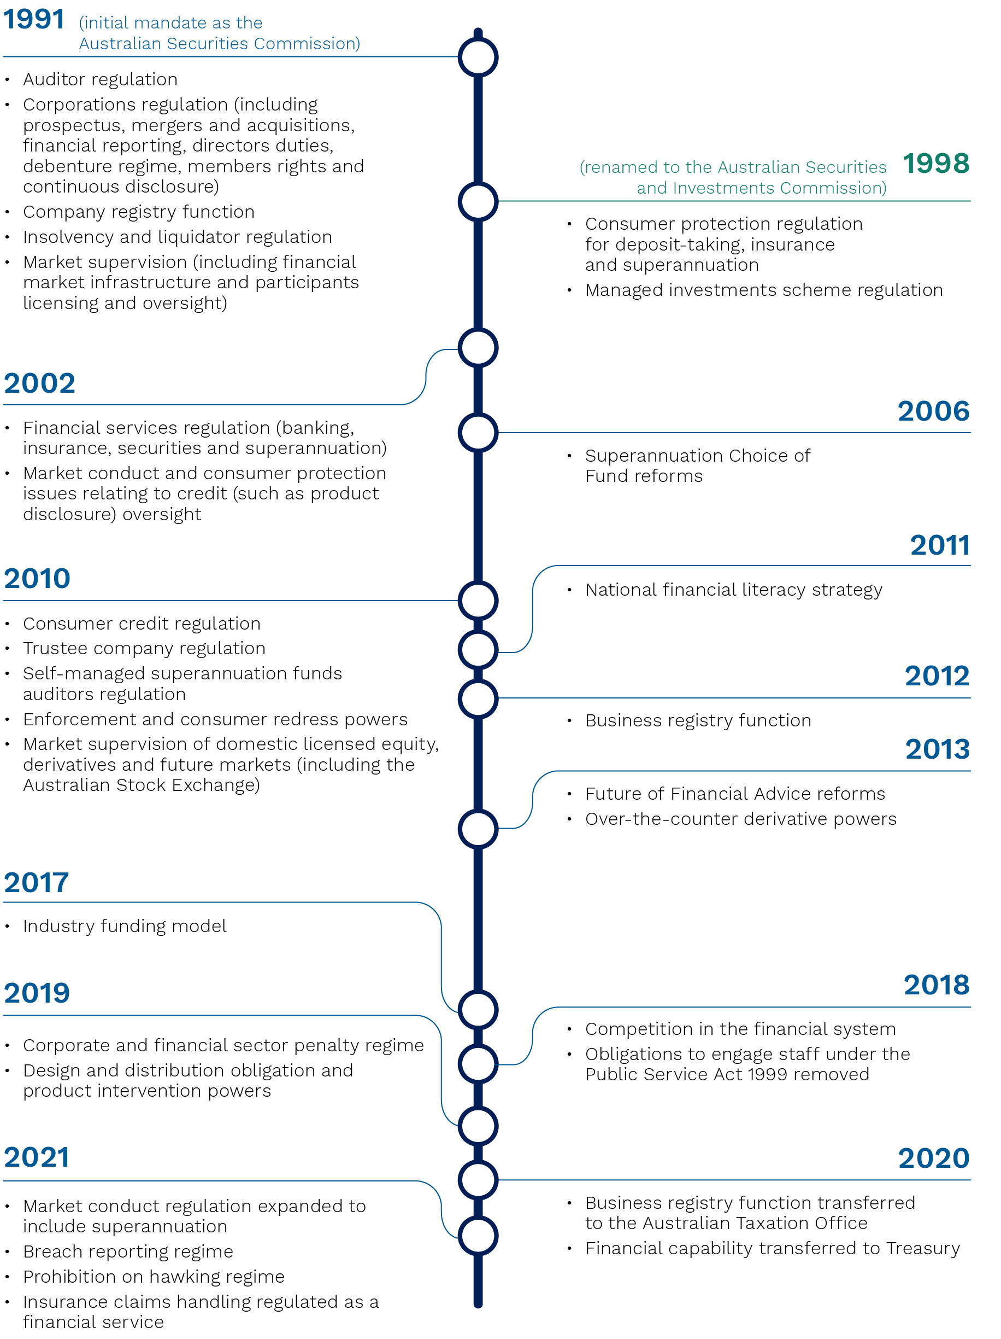

Source: Treasury, 2022.

* 1. Internationally, ASIC’s statutory mandate is one of the broadest. Figure 2.2 illustrates that ASIC has a wider regulatory remit than comparable market conduct regulators in overseas jurisdictions, including the United States, United Kingdom, Germany, Netherlands, Hong Kong and New Zealand. Singapore is the only comparable jurisdiction with a wider remit.

Figure 2.2: Comparison of ASIC’s mandate to international peers[25]

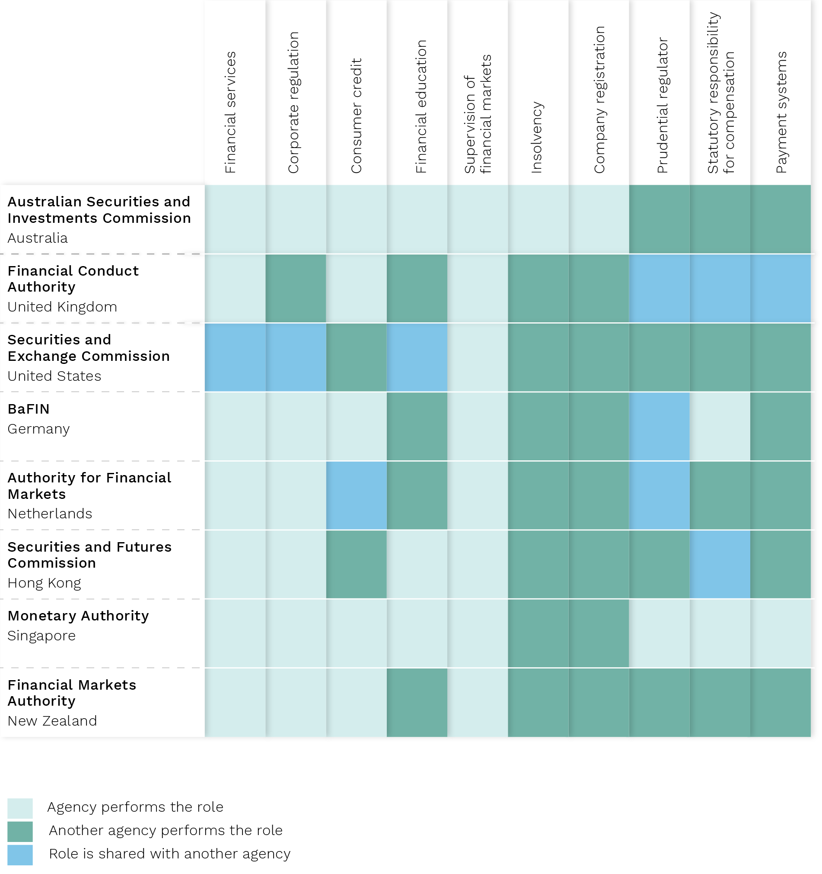

Source: Treasury, 2022.

* 1. ASIC’s expansive remit is also reflected in the wide range of entities it regulates. In 2020–21, this included: 6,179 Australian financial service licensees (AFSL), 4,777 Australian credit licensees (ACL), 67 authorised market infrastructure providers, 5,540 registered self‑managed super funds (SMSF) auditors, 3,553 registered company auditors, 649 registered liquidators and 2,612 registered managed investment schemes.[26]

## Funding and resourcing

* 1. The Government provides funding to ASIC through the annual budget process as appropriation revenue. In 2021–22, ASIC received $422 million in departmental appropriation revenue for its operating expenditure and corresponding to an estimated average staffing level (ASL)[27] of 1,972.[28] ASIC also receives a capital expenditure budget from government and has limited flexibility to reallocate its operational expenditure budget to capital expenditure. ASIC’s average budget estimates over the 5‑year period spanning 2017–18 to 2021–22 for operating and capital expenditure were $456 million and $48 million respectively.[29] ASIC ultimately determines the internal allocation of funding and resources across functional areas.[30]
  2. In 2017, an industry funding model (IFM) was introduced for ASIC to recover the cost of regulatory activities directly from industry participants through levies and fees to reflect the cost of regulating the different industry sectors. The legislative framework for industry funding levies was established by a number of Acts, regulations and legislative instruments, including the *ASIC Supervisory Cost Recovery (Collection) Act 2017*, Cost Recovery Levy Regulations and *Corporations (Review Fees) Regulations 2003*. Regulatory activities that are recovered through the IFM include: supervision and surveillance; enforcement; and industry engagement, education, guidance and policy advice. ASIC also recovers indirect costs which support regulatory activities, such as: governance, central strategy and legal; information technology (IT) support; operations support; and property and corporate services.
  3. In 2021–22, ASIC expects to recover $266 million through cost recovery levies, $66 million through statutory levies and $17 million through fees‑for‑service.[31] This accounts for approximately 83% of its total departmental appropriation of $422 million recovered through the IFM. The amount ASIC recovers through the IFM is less than the total departmental appropriation, as ASIC engages in some non‑regulatory activities such as, registry activities where the Government has decided the costs associated with those activities will not be recovered from the regulated population through the IFM.[32]
  4. Figure 2.3 demonstrates ASIC’s funding amount recovered through the IFM and ASL over the last decade. In 2019–20, ASIC received additional funding of approximately $405 million over 4 years to implement the recommendations of the Royal Commission. This funding supported an accelerated enforcement strategy, expanded regulation of financial services, enhanced on‑site supervision of larger institutions, an expanded role as the conduct regulator for superannuation and administering a conduct‑focused accountability regime.

Figure 2.3: ASIC’s funding, amounts recovered through the IFM and ASL from 2012–13 to   
2020–21[33]

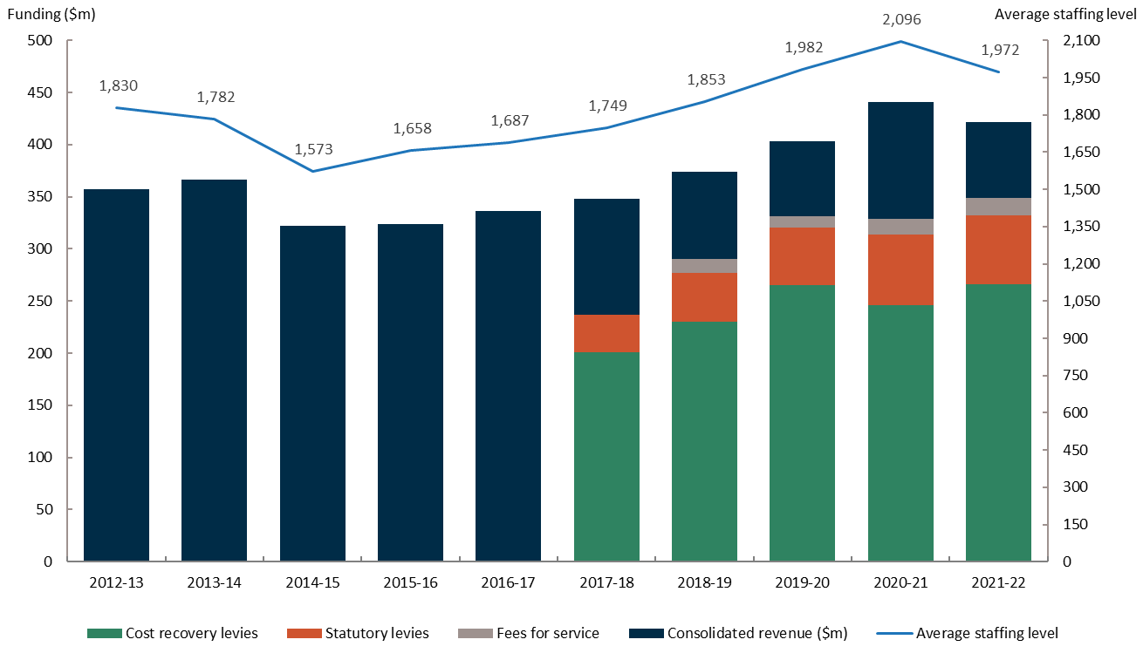

Source: Australian Government, *Portfolio Budget Statements Treasury Portfolio*, 2012–13 to 2022–23; ASIC, *Cost Implementation Recovery Statement: ASIC industry funding model*, 2017–18 to 2021–22.

# Chapter 3: Strategic prioritisation, planning and decision‑making

## Introduction

1. A well‑functioning governance structure is fundamental to ASIC’s overall effectiveness and capability.
2. This chapter begins with an overview of ASIC’s governance and accountability framework, previous reviews of ASIC’s governance structure and a description of recent changes to ASIC’s governance.
3. This chapter then provides an overview of ASIC’s strategic prioritisation, planning and decision‑making processes, considers feedback from stakeholders and ASIC staff, and describes the actions ASIC currently has underway to improve these processes. This chapter concludes with an overall assessment of ASIC’s effectiveness and capability in this area.
4. ASIC’s strategic prioritisation, planning and decision‑making processes support ASIC’s ability to make deliberate choices about the activity it undertakes with the finite resources at its disposal. ASIC is not expected to prevent all harm or misconduct and must make risk‑based decisions about its areas of focus.

## Governance and accountability at ASIC

1. ASIC is an independent statutory authority, established by the ASIC Act to administer, among other things, the Corporations Act. ASIC is subject to the *Public Governance, Performance and Accountability Act 2013* (PGPA Act) and is a non‑corporate Commonwealth entity.
2. The ASIC Act does not stipulate the requirements of ASIC’s governance structure. ASIC is governed by commissioners, collectively referred to as the Commission, who are appointed by the Governor‑General on nomination by the responsible minister. In accordance with s 9A(b) of the ASIC Act and PGPA Act, the Chair is the Accountable Authority for ASIC.
3. ASIC’s Governance and Accountability Framework outlines the role of the Commission, Chair and executive directors, identifies decision makers at each committee and summarises the purpose of each committee supporting ASIC’s leadership. This framework is depicted in   
   Figure 3.1.

Figure 3.1: ASIC governance framework and key roles as at July 2021

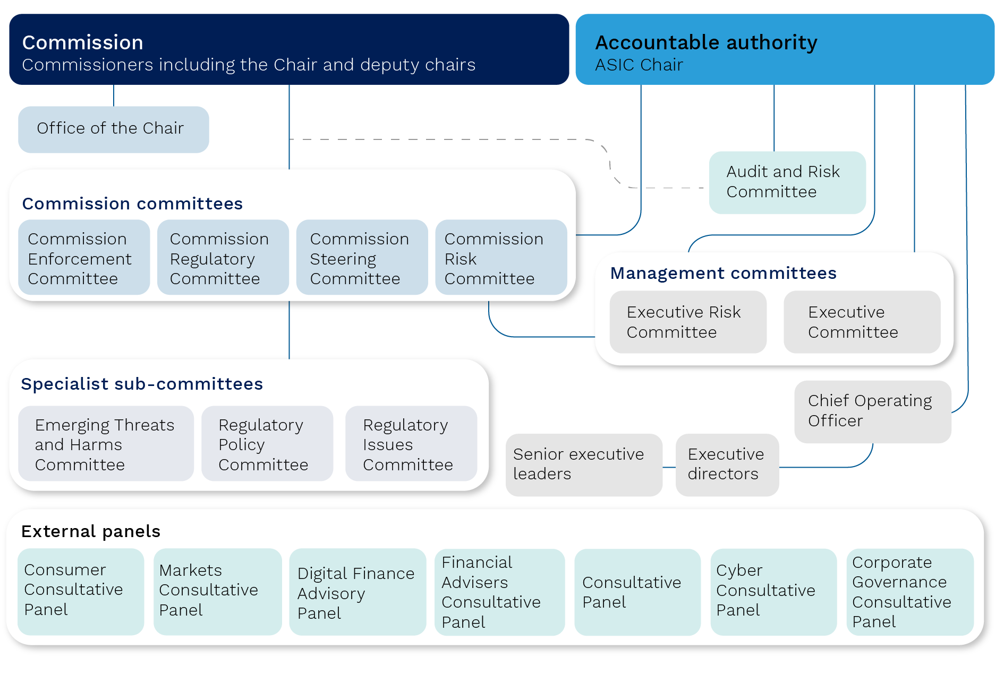

Source: ASIC, Materials supplied to this review, 2022.

1. The Commission is composed of 5 full‑time members consisting of the Chair, 2 deputy chairs and 2 commissioners.[34]
2. The Commission acts as a non‑executive body under the leadership of the Chair.[35] The Commission focuses on high level regulatory and statutory decision‑making and stakeholder management.
3. As Accountable Authority, the Chair is responsible for, and has control over, ASIC’s operations. While the Commission provides support to the Chair on the oversight of ASIC, the Chair relies on ASIC’s senior executives to carry out day‑to‑day management.
4. The Chief Operating Officer, a new role established in 2021, is responsible for long‑term organisational planning and the implementation of organisational strategy. The Chief Operating Officer is the delegated chair of the Executive Committee, ASIC’s peak management committee consisting of ASIC’s executive directors.
5. The Executive Committee makes day‑to‑day decisions about ASIC’s operations or elevates matters to the Commission for decision. As a result, the Executive Committee and Chief Operating Officer enable the Commission to focus on strategic matters, external engagement and communication.
6. Executive directors are responsible for the development and delivery of group business plans and for day‑to‑day regulatory and enforcement decisions.[36] There are 7 executive directors responsible for Strategy, Financial Services and Wealth, Financial Services Enforcement, Markets, Markets Enforcement, the Chief Legal Office and Operations. The executive directors report to the Chief Operating Officer. In addition to the executive directors, the chief of staff advises the Chair and, among other roles, operates as a link between the Commission, senior leaders and key external stakeholders.
7. ASIC’s internal committees assist the performance of ASIC’s regulatory and governance functions. These include Commission committees which all commissioners attend, specialist sub‑committees comprised of commissioners and/or senior executives, and management committees.
8. Although not formally part of ASIC’s governance structure, 7 external panels support ASIC to understand developments and systemic risks within the regulated and unregulated industries operating within the financial system. These are:

* **ASIC Consumer Consultative Panel**: raises current and emerging consumer issues in regulated sectors; provides feedback on proposed regulatory changes; and informs the development and delivery of ASIC’s priorities.
* **ASIC Consultative Panel:** enables ASIC to consult on proposed regulatory changes; provides intelligence on the external environment, including market conditions; and identifies threats and harms in regulated markets. Panel members are senior representatives from the academic, consumer, industry, legal and regulatory sectors.
* **Markets Consultative Panel**: advises ASIC on the approach to its responsibilities for day‑to‑day supervision of the Australian market and on broader market developments.
* **Digital Finance Advisory Panel**: helps inform ASIC’s efforts in the areas of financial technology (fintech) and regulatory technology (regtech).
* **Financial Advisers Consultative Panel**: provides ASIC with views on a broad range of issues relating to the financial advice industry.
* **Cyber Consultative Panel**: advises ASIC on its supervisory approach for the cyber resilience of financial services and markets.
* **Corporate Governance Consultative Panel**: helps ASIC gain a deeper understanding of developments and emerging issues in corporate governance practices.

### Previous reviews of ASIC’s governance and ASIC action

Figure 3.2: Timeline of previous reviews that commented on ASIC’s governance

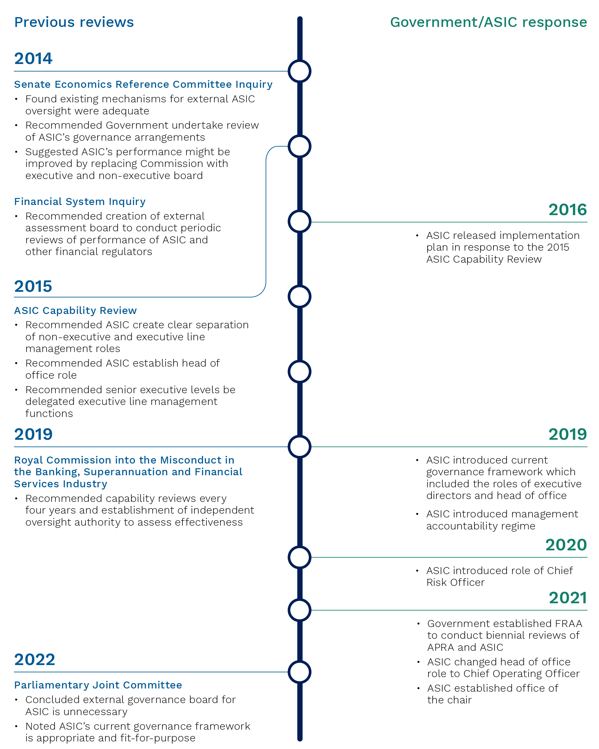

Source: Treasury, 2022.

1. In 2014, the Senate Economics References Committee sought to assess ASIC’s performance with reference to ASIC’s enabling legislation, accountability framework, collaboration with other regulators and enforcement bodies, complaint management and whistleblower protection.
2. The Senate Economics References Committee expressed concern about commissioners holding both executive and non‑executive roles, which had resulted in ASIC operating in silos as individual commissioners performed executive functions. This review also noted that in this structure commissioners were responsible for assessing their own decisions.
3. The Senate Economics References Committee made recommendations to improve the overall regulatory environment and encourage ASIC to become more self‑evaluating. The Senate Economics References Committee further recommended the Government undertake a review of ASIC’s governance arrangements within 2 years and revisit the matter of an executive and non‑executive member board.
4. The Senate Economics References Committee’s report on ASIC’s performance was released shortly before publication of the 2014 Financial System Inquiry’s Interim Report. The Financial System Inquiry considered the Senate Economics References Committee’s recommendations in its final deliberations.
5. The Financial Systems Inquiry considered the effectiveness of and need for financial regulation in Australia including the performance of financial regulators. The Financial System Inquiry rejected the proposal that financial regulators, including ASIC, should be placed under the control of a non‑executive board, referencing blurred accountability in APRA’s governance structure in the lead up to the collapse of HIH Insurance Limited.[37] Instead, the Financial Systems Inquiry recommended creating an external assessment board to conduct periodic reviews of the performance of ASIC, APRA, and the payment systems regulation function of the RBA. The inquiry also recommended that financial regulators undertake periodic capability reviews.[38]
6. The 2015 ASIC Capability Review was established in response to the Financial System Inquiry recommendation and considered ASIC’s governance and leadership, strategy management and delivery.[39] The Capability Review considered that ASIC’s governance structure left insufficient bandwidth for the commissioners to focus on strategic matters, external engagement, internal oversight and accountability. This view was based on:

* panel discussions with ASIC commissioners and staff members, a review of meeting minutes, and attendance at committee and Commission meetings
* a comparison of internal governance models applied by regulators in Australia and overseas
* evidence that commissioners spent insufficient time engaging with the market, estimating that on average 26% of their time was spent on meetings and engagement activities with external stakeholders (materially less than that of other domestic regulators)
* evidence collected by consultancy PwC indicating that 58‑77% of commissioner time was spent on operational and administrative matters (executive role), leaving only 23‑42% for strategic initiatives and external engagement (non‑executive role).[40]

1. The 2015 ASIC Capability Review recommended:

* ASIC realign governance arrangements by elevating the Commission role to that of a full‑time non‑executive function (not an external board), with a commensurate strategic focus and external accountability free from executive line management responsibilities.
* ASIC establish a new role of head of office, with delegated responsibility and accountability for executive line management functions. ASIC established the Head of Office role in 2019, which subsequently became the Chief Operating Officer role in 2021.
* Senior executive leaders be delegated executive line management responsibilities, reporting to the head of office. ASIC introduced the executive director layer in 2019, which now reports to the Chief Operating Officer.

1. Part of the Royal Commission’s terms of reference included the requirement to report on the effectiveness and ability of financial regulators to identify and address misconduct. The Royal Commission further considered the matter of an independent non‑executive director board structure for ASIC, concluding that ASIC and APRA should instead be subject to additional external review and accountability. The Royal Commission recommended quadrennial capability reviews and a new, independent oversight authority for ASIC and APRA. The FRAA was established in 2021 in response to these recommendations.
2. In response to a Royal Commission recommendation, ASIC introduced a management accountability regime to support accountability in its executive layers. This regime applies to ASIC’s senior executives who are responsible for the management of ASIC or a significant part of the operations of ASIC. The accountability statements outline role accountability for particular aspects of ASIC’s operations, who each accountable person is accountable to, and how an individual meets their obligations.
3. The 2022 Parliamentary Joint Committee considered ASIC’s governance structure following the findings of the Australian National Audit Office relating to payments made on behalf of ASIC commissioners and recent changes ASIC had made to its governance arrangements. The Parliamentary Joint Committee considered previous reviews of corporate governance for public sector statutory authorities, reviews of ASIC’s performance and governance, views of independent experts, and ASIC’s governance arrangements at the time.
4. The Parliamentary Joint Committee concluded that despite there being no perfect governance model for a statutory authority, ASIC’s governance framework appeared appropriate and fit‑for‑purpose. Further, the Parliamentary Joint Committee rejected the suggestion that ASIC install an independent non‑executive board and noted that the issue should not be revisited in the future.

### Feedback on ASIC’s governance

1. ASIC’s governance framework was not an area of focus. However, ASIC staff provided feedback on the effect of governance changes on decision‑making. This is contained in the ‘Effectiveness and capability of ASIC’s strategic prioritisation, planning and decision‑making’ section of this chapter.
2. ASIC’s staff and stakeholders have observed the commissioners are moving away from holding both executive and non‑executive roles, as ASIC transitions to the new governance structure. One commissioner noted that ASIC was mature on short term strategy priority setting but needed to focus more on non‑regulatory organisational priorities. Commissioners also noted the ‘natural tensions’ in the transition, where commissioners can find it difficult to be strategic when in the detail of day‑to‑day regulatory matters. One senior public servant observed that ASIC tends to focus more on high profile regulatory issues and there has been underinvestment in ASIC’s registry platform. During this review the FRAA has noted long‑term underinvestment in ASIC’s data and technology capability. The FRAA understands that historically this may have been driven by undue focus on day‑to‑day regulatory concerns at the expense of longer term structural and strategic considerations. It is also a function of ASIC’s capital expenditure budget which is set by Government, with limited flexibility to reallocate its operational expenditure budget to capital expenditure.
3. Regarding the recent changes, ASIC commissioners and executive directors were positive about how the changes would serve ASIC in the immediate future. One commissioner noted that the introduction of the Chief Operating Officer role will guide executive decision‑making in part by helping commissioners overcome historical attachments to particular areas. A senior executive leader noted that the Chief Operating Officer role was necessary to ensure only strategic and significant regulatory matters are considered by the Commission. Regarding the role of ASIC’s committees, one executive director noted that the Executive Committee is a relatively new forum and continues to mature. The general view across the Commission and executive directors was that the Chief Operating Officer and Executive Committee will assist in delivering a ‘whole‑of‑ASIC’ view to the Commission.
4. ASIC’s commissioners and executive directors acknowledged that more time is needed to embed the shift in responsibilities and accountabilities arising from changes to the governance structure. In the ASIC staff survey, respondents noted that ASIC could provide greater clarity about the responsibilities of commissioners and executive directors. Some ASIC staff members below senior executive leader level noted that the separation of responsibilities and powers is unclear.[41]

## Assessment

1. The FRAA will not comment on the effectiveness and capability of ASIC’s governance structure as this was not an area of focus for this review.
2. The FRAA acknowledges the findings of previous reviews of ASIC relating to its governance and accountability framework, and the changes ASIC has made to improve this aspect of its operations. By introducing the executive director layer, Chief Risk Officer and Chief Operating Officer roles, ASIC has made a concerted effort to separate the executive roles from commissioners such that the Commission can focus on strategic and high‑level regulatory decision‑making and external engagement. Feedback from stakeholders and ASIC staff received during this review suggested this is still work in progress.
3. The FRAA supports recent changes ASIC made to its governance structure, and its efforts to continue implementing the roles and accountabilities of the commissioners, Chief Operating Officer and executive directors.
4. The 2024 ASIC review by the FRAA will consider how the changes in ASIC’s governance and accountability framework are operating in practice and whether they have been effective in improving decision‑making and accountability.

## Strategic prioritisation, planning and decision‑making

### Strategic planning process

1. ASIC’s annual strategic planning process identifies threats and harms. It enables ASIC to determine its strategic priorities and the activities to address those threats and harms. ‘Strategic priorities’ are the areas ASIC will focus on for the next 4 years and are published in ASIC’s Corporate Plan.
2. The Commission is responsible for setting ASIC’s strategic priorities which encompass:

* **external priorities**: targeting the most significant identified threats and harms in ASIC’s regulatory environment.
* **internal priorities**: focusing on ASIC’s operational capabilities.

1. Figure 3.3 summarises the elements of the phases of ASIC’s strategic planning process.

Figure 3.3: ASIC’s strategic planning process

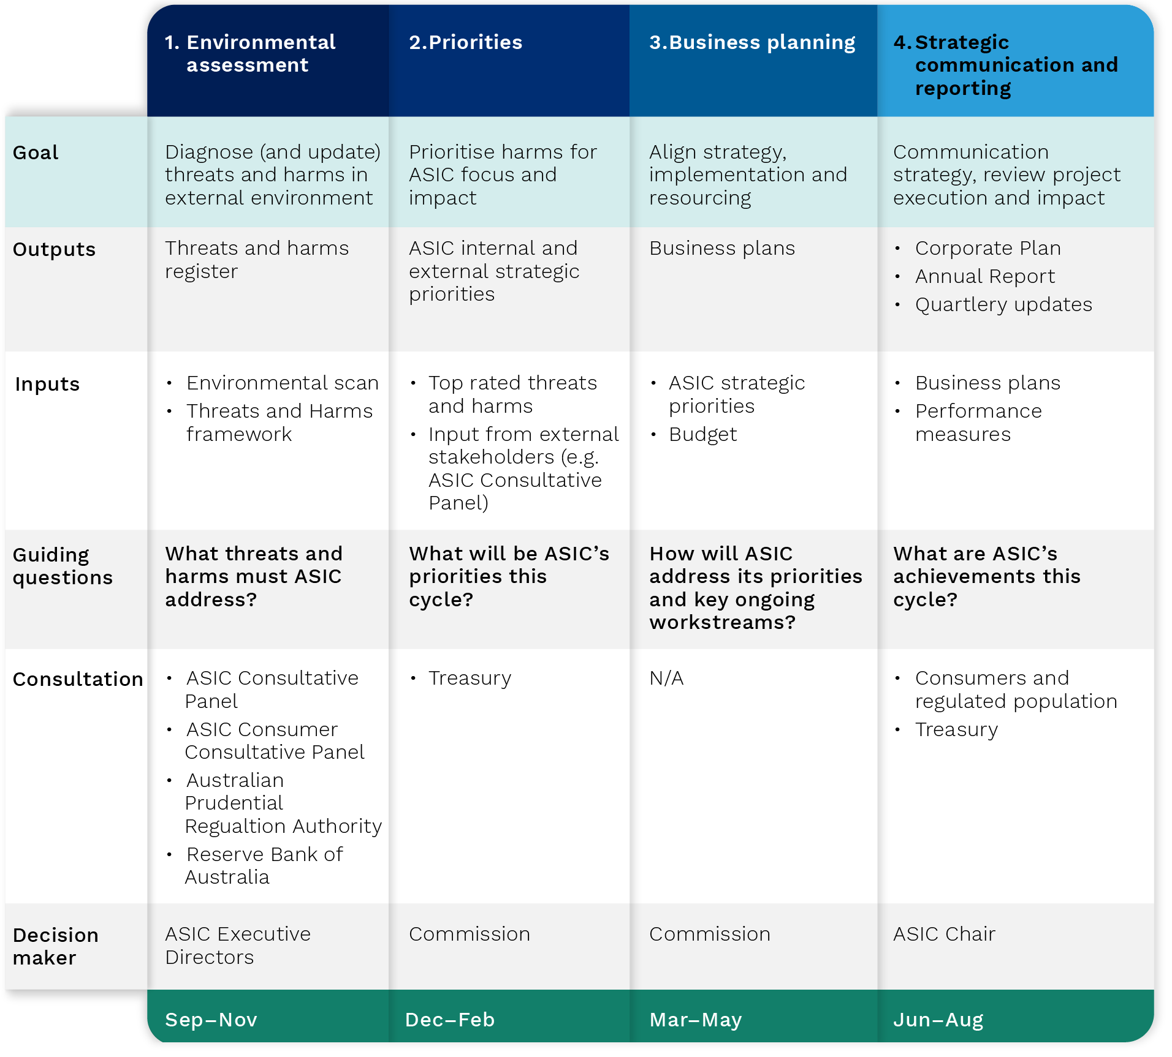

Source: ASIC, Materials supplied to this review, 2022.

1. The strategic planning process begins with an environmental assessment to identify threats and harms to consumers and the regulated population. To do this, ASIC uses insights from its regulatory work and internal and external data sources, including from peer international regulators. Identified threats and harms are allocated a risk rating (likelihood and consequence) on time horizons of 0‑2 years and 3‑5 years.
2. ASIC consolidates identified threats and harms into a register for discussion with ASIC’s commissioners and executive directors. ASIC shares this information and consults with APRA, the RBA, ASIC’s Consumer Consultative Panel (ACCP) and ASIC’s Consultative Panel to finalise its list of key threats and harms.
3. This list informs ASIC’s strategic priorities. The Commission develops draft strategic priorities, then seeks feedback from ASIC’s executive directors and the Treasury, with a view to finalising the strategic priorities ahead of the business planning process.
4. Executive directors are responsible for developing group business plans, which outline the projects that address strategic priorities and business‑as‑usual activity. The business plans capture all dimensions of group activities, including resource allocations, cross‑group and cross‑agency dependencies and risk implications.
5. The Commission approves business plans and the Executive Committee oversees progress throughout the year. The Executive Committee uses StrategyDotZero, a platform to track and report on progress in executing projects and key risks in each business plan.
6. ASIC tracks emerging threats and harms throughout the year, including issues at the edge of the regulatory perimeter, at meetings of the Emerging Threats and Harms Committee. ASIC’s internal committee structure described at paragraph 3.14 helps ASIC maintain flexibility in adapting and responding to developments in its operating environment outside the formal strategic planning phases. ASIC’s internal committees may consider changes to group activities and business plans. Any significant change to a group’s business plan is escalated to the Commission for approval.
7. ASIC conducts whole‑of‑organisation risk assessments every 4 months to identify issues or events that may affect its ability to deliver on priorities and objectives. ASIC seeks to manage material risks in line with the Commission‑approved risk appetite and mitigate risks that are outside of tolerance.
8. ASIC communicates its strategic priorities and planned activities to the public through its Corporate Plan and reports on its performance through its Annual Report. The Annual Performance Statement, included within the Annual Report, summarises and self‑evaluates how ASIC pursued its priorities. Throughout the year ASIC publishes regular updates and reports on its recent activity through media releases, social media posts, articles, sectoral newsletters and speeches.

### Decision‑making

1. ASIC’s decision‑making process establishes the organisation’s position on strategic and regulatory matters and determines the organisation’s direction and progress. It is fundamental to the effective and capable delivery of ASIC’s strategy.
2. ASIC’s decision‑making process is guided by ASIC’s Governance and Accountability Framework, which describes the responsibilities of ASIC’s leadership and committees and the accountability for decision-making.
3. The Governance and Accountability Framework notes that strategic and/or significant regulatory matters are reserved for the Commission and the Chair as Accountable Authority. The Commission makes statutory decisions in Commission meetings. Where possible, the Commission has delegated its statutory powers and functions to staff members. Decisions relating to strategic and/or significant enforcement, regulatory or risk matters are made in the relevant Commission committee meetings.
4. The Chief Operating Officer is responsible for non‑regulatory decision‑making and is accountable to the Chair and the Commission for the operational performance of ASIC. Executive directors are responsible with the Chief Operating Officer for the delivery of the strategy set by the Commission and for the day‑to‑day regulatory and enforcement decisions within their area of responsibility. Executive directors are responsible for day‑to‑day organisational matters or those delegated by the Chair or the Commission. Executive directors escalate decisions to the Commission on strategic and/or significant enforcement, regulatory or risk matters.

## Effectiveness and capability of ASIC’s strategic prioritisation, planning and decision‑making

1. This section outlines the feedback the FRAA received from stakeholders. ASIC staff, consumer advocacy bodies and industry stakeholders noted positives as well as opportunities to improve the effectiveness and capability of ASIC’s strategic prioritisation, planning and decision‑making processes.

### Efficiency

#### Processes in place

1. This review has not identified evidence to suggest that ASIC’s strategic prioritisation, planning and decision‑making processes are ineffective, however there are opportunities for ASIC to improve its performance. In the following section, the FRAA notes ASIC’s own initiatives to improve and comments on potential additional improvements for ASIC’s consideration.

#### Quality stakeholder engagement

1. ASIC consults with its external panels to seek input on identified threats and harms. Consumer advocacy bodies questioned the efficiency of the ACCP, describing it as ASIC sharing information rather than a meaningful discussion about long‑term issues raised by consumers.[42] ASIC noted that quarterly ACCP meetings are an opportunity for members to raise priority issues for discussion with the Commission and ASIC maintains a register to track the complaints raised about specific industry participants.
2. Public submissions from consumer advocacy bodies and banking and law sectors requested further engagement with ASIC as it develops its strategic priorities.[43] This view was echoed in responses to the FRAA’s survey of ASIC stakeholders where only 7% of respondents agreed that ASIC effectively incorporates the views of external stakeholders when setting priorities (66% disagreed and the rest were neutral).[44] Some stakeholders noted that further consultation with industry would better inform ASIC’s thinking on emerging issues and support effective industry engagement.[45]

‘ASIC can focus on issues that are topical but not inherently risky.’ – Public submission, Australian Securities Exchange

1. ASIC noted that external stakeholder feedback, including from its external panels, is one of many inputs as it sets its strategic priorities.
2. The FRAA notes that there will be times when industry and stakeholder groups disagree with ASIC’s priorities and activity. However, the FRAA considers it important to ASIC’s effectiveness that in setting its priorities, ASIC engages in open and constructive dialogue with stakeholders including communicating to stakeholders on how their feedback has been considered.
3. ASIC is focussing on how it engages with the regulated population and this was a primary objective in establishing the Regulatory Efficiency Unit in November 2021 under the Office of the Chair. ASIC has consulted with more than 70 stakeholders to help identify ways to improve the efficiency of its interactions with its regulated population. Initiatives flagged for 2022‑23 are set out in Box 3.1. ASIC expects implementation of these initiatives to continue into 2023‑24.

|  |
| --- |
| Box 3.1: Regulatory Efficiency Unit initiatives   * **ASIC’s approach to regulatory guidance:** ASIC will review its practices in the development and updating of regulatory guidance. As part of this workstream, ASIC will consider how best to implement a regulatory development timetable and a more coordinated approach to the maintenance of existing regulatory guidance. * **Options to improve the use of ASIC’s information-gathering powers:** ASIC will review the practices used across the organisation when using its information‑gathering powers. ASIC will pilot measures to test the effectiveness of increased engagement with the recipients of these information‑gathering requests. For example, holding meeting(s) with entities ahead of commencing a complex and/or significant investigation with a focus on ASIC’s expectations associated with the conduct of the investigation (including fairness). * **Enhance ASIC’s stakeholder engagement:** ASIC will review its existing engagement approaches. ASIC will undertake a case study that focuses on the licensing engagement model (including how ASIC deals with applicants and their advisers). ASIC will explore ways to improve the clarity and consistency in external messaging about its priorities and decision‑making. |

1. The FRAA’s view is that to improve the efficiency, and therefore effectiveness, of ASIC’s strategic planning process, ASIC should improve its approach to stakeholder engagement.

#### Effective coordination with regulators and government

1. Public submissions from legal, banking, governance and superannuation sectors suggested that ASIC could improve its coordination with government and other regulators when sequencing regulatory initiatives.[46] This point was often expressed in relation to a period of significant policy implementation in October 2021, when anti‑hawking, breach reporting and product design and distribution obligations became effective.[47]
2. The FRAA notes that these implementation timeframes were set by the Government. The cumulative impact of many reforms commencing at once was the result of legislative timeframes and not a decision of ASIC. This context was acknowledged by some stakeholders who noted that priorities can be beyond ASIC’s control and coordination occurs at the Council of Financial Regulators.

#### Flexibility to respond to changes

1. Public submissions in legal, governance, superannuation, insurance and restructuring sectors were supportive of ASIC’s response to the COVID‑19 pandemic. Submissions noted ASIC’s engagement and flexibility, including by setting interim strategic priorities and restructuring its business planning process to focus on immediate concerns arising from the pandemic.[48]
2. Submissions noted that ASIC did not maintain this approach towards the close of 2021 during a period of significant change for industry.[49] One stakeholder noted that although disruption continued due to the COVID‑19 pandemic, ASIC appeared to be less flexible with upcoming compliance obligations.[50] In response to this feedback, ASIC noted that it took a reasonable approach when introducing the new reforms during October 2021.[51] This meant that entities would not be penalised for technical or inadvertent breaches, allowing them time to address compliance issues. ASIC noted that it would ultimately enforce the law where entities were causing harm or not acting in good faith.

#### Support for decision‑making

1. When discussing decision‑making at ASIC’s senior levels, executive directors and commissioners noted that ASIC manages a large number of activities and can be reluctant to make decisions to deprioritise.[52] One executive director noted that if ASIC makes changes to its publicly communicated priorities this may carry reputational risk for ASIC and further, the market might take a negative cue that ASIC is less interested in a sector. The FRAA notes that ASIC is not expected to prevent all risks to consumers and regulated entities and the breadth of its remit can make deprioritising difficult.
2. Feedback from executive directors noted that the Commission is more clearly expressing the areas where ASIC will not take action. One executive director noted that recent changes to ASIC’s governance structure will support the Commission with a ‘whole‑of‑ASIC’ view of priorities which will improve ASIC’s ability to prioritise appropriately. Commissioners noted that ASIC was seeking to empower executive directors to make decisions in the new governance structure.
3. As part of ASIC’s annual review of its strategic planning process, ASIC identified a number of areas for improvement. The cumulative effect of ASIC’s initiatives should support the efficiency of ASIC’s decision‑making.
4. In 2022, ASIC began taking steps to integrate its budget process into its strategic planning process. This means that preliminary budgets, established before the business planning phase, reflect any changes to the allocation of the budget from the previous year from the outset of the strategic planning process. This enables teams within ASIC’s groups to understand their realistic funding envelope to inform activity planning.
5. ASIC will conduct intra‑year budget allocation through periodic reforecasting and budget review to improve resource allocation. The Executive Committee will oversee the application of any surplus funding to projects, potentially those that were not initially funded in the business planning phase and also track any overspend on projects.
6. ASIC has revised reporting to the Commission about the business‑as‑usual work that does not contribute directly to strategic priorities. This has enabled the Commission to consider whether ASIC should do more or less of this work and whether more resources should be reallocated to support strategic priorities.
7. During this review the FRAA noted that ASIC does not maintain a clear view of an organisation-wide set of critical priorities. The FRAA notes that this may impede ASIC’s ability to make trade‑offs between competing priorities and therefore inhibit the efficiency of its decision‑making. ASIC’s 2021–25 Corporate Plan outlines 74 projects (and additional sub projects) relating to 4 external priorities but provides no sense of importance or expected completion.[53]
8. The FRAA suggests that ASIC consider maintaining a clear view of the organisation-wide priorities it considers critical and ensuring appropriate resources are allocated to these priorities. This would improve ASIC’s ability to trade‑off or deprioritise non‑critical activity when faced with emerging threats and harms while retaining focus on, and progressing, critical priorities.
9. The FRAA understands that ASIC is taking steps towards this in its 2022–26 planning cycle. ASIC has identified 8 core strategic projects which have their own governance structure to support ASIC’s actions in relation to these. These projects will be set out in ASIC’s 2022–26 Corporate Plan. The FRAA will review ASIC’s progress on this initiative to focus on its critical priorities.

### Organisational capability: ASIC’s staff and systems

#### Long‑term capability development

1. ASIC staff and consumer advocacy bodies noted ASIC is better at identifying short‑term regulatory priorities than long‑term priorities. Consumer advocacy bodies involved in the ACCP also noted that the panel held a short‑term focus on matters.[54] Sixty‑seven per cent of ASIC staff agreed that ASIC is effective in identifying threats and harms for the coming 6‑12 months, while only 49% agreed that ASIC is effective in identifying threats and harms for the coming 1‑3 years.[55]
2. Commissioner and executive director interviews and focus group discussions noted that ASIC has historically focused on short‑term regulatory initiatives to the detriment of long‑term organisational priorities. This may have affected ASIC’s effectiveness and capability in delivering regulatory outcomes in the longer term. This has contributed to ASIC’s underinvestment in its data and technology capability in past capital expenditure budgets.[56] Executive directors and focus groups noted uncertainty in ASIC’s operating environment made long‑term planning difficult.[57]
3. As a result, ASIC may not have always prioritised investment in organisational capabilities.[58] Only 34% of ASIC staff agreed that ASIC has appropriate technology to identify and prioritise threats and harms, and opportunities and innovations.[59]
4. In the 2022–23 strategic planning process, ASIC shifted its strategic priorities from one year to a longer‑term horizon of 4 years, which will encourage a long‑term approach to ASIC’s technological and staff capabilities. Longer‑term strategic priority setting:

* reflects the time required to address significant strategic issues and for ASIC’s work to achieve the required impact
* conforms to ASIC’s funding timescale
* allows groups to align their activity more efficiently with strategic priorities, resourcing, and workforce trends.

1. The FRAA is supportive of this initiative.

#### Data and technology

1. Richer and more granular datasets hold the potential to enhance ASIC’s strategic prioritisation and planning processes. The lack of legislative power to collect granular recurrent data from some sectors limit ASIC’s ability to take an even more proactive, forward‑looking stance in addressing and preventing identified threats and harms and to make strategic judgements.
2. In ASIC’s strategic prioritisation, planning and decision‑making processes, ASIC staff recognise that there is an opportunity for ASIC to better leverage insights from data and data analytics to inform its strategic assessments and prioritisation process.

‘We need to analyse data (for example complaints, breach reports, product performance) to identify trends and potential harms to justify where our focus should be directed.’ – Staff survey

1. ASIC’s current strategic prioritisation, planning and decision‑making processes are perceived by some ASIC staff as reactive and short term in nature, because they lack a comprehensive basis in data and evidence.[60] ASIC acknowledges its data and IT capability require improvement.[61] In responding to the FRAA’s survey of ASIC staff, some staff cited cultural factors such as risk aversion, siloed teams and a short‑term focus as the fundamental reason for the current low level of data and technology capability at ASIC. The negative sentiment expressed by staff towards ASIC’s Customer Relationship Management (CRM) platform demonstrates that ASIC staff members need to be supported when adopting new technology.[62] ASIC’s leadership needs to ensure staff members are engaged early and often to scope, plan and execute new technology to ensure the user experience is considered and tested. Nonetheless, ASIC’s Commission, executive directors and senior executive leaders believe ASIC has demonstrated its ability to translate data and technology investments to date into business outcomes and improvements.
2. Consistent with Commission prioritisation and ASIC’s digital strategies, ASIC staff acknowledged that ASIC’s uplift in data capabilities is crucial to enhancing and better informing strategic prioritisation and planning processes. There is confidence and support at senior levels of ASIC in the ability of newly or recently hired data and technology leaders to deliver on ASIC’s capability uplift strategies. The FRAA’s view is that a cultural shift is required if ASIC is to realise its vision to become a digitally enabled regulator.
3. Some ASIC staff agree that improvements in technology systems will enable ASIC to better utilise data in its strategic prioritisation, planning and decision‑making processes. Further, some ASIC staff recognise that ASIC’s current technology systems that support its strategic prioritisation processes are behind those of its large institutional regulated entities.[63]

‘Improvements are required in technology and access to real time data to enable ASIC to prioritise strategic prioritisation and planning activities.’ – Staff survey

1. ASIC has made progress to uplift its data capabilities, hiring a Chief Data and Analytics Officer in February 2020, and establishing dedicated teams of specialists to build data and analytical capabilities within stakeholder and licensing teams.[64] ASIC also introduced a digital lead role in February 2022 to focus on ASIC’s digital strategy, and the StrategyDotZero platform to provide better oversight of business plan deliverables. To support strategic decision‑making and drive regulatory outcomes, data analytics capabilities need to be improved on an organisation‑wide basis, taking a collaborative and holistic approach across teams and groups.
2. ASIC’s Digital Strategy 2030, due to launch in August 2022, outlines the framework for achieving ASIC’s data, cyber security and technology priorities. There is a need for cultural change towards new ways of working with technology, data and analytical tools to improve regulatory activities and outcomes. During this review the FRAA noted that not all senior leaders of ASIC embraced the initiatives to‑date to uplift digital capability.

### Transparency

#### Priorities and activities are well understood by ASIC staff

1. ASIC staff held a positive view of transparency. Seventy‑seven per cent of ASIC staff agreed that they understood ASIC’s current strategic priorities as set out in its corporate plan while 71% agreed that they understood how ASIC’s business plans related to its strategic priorities.[65] Further, 88% of staff agreed that their individual roles and responsibilities were clear.[66]

#### Proactive communication

1. Industry stakeholders across regulated industries noted that ASIC’s communications have improved over recent years and now clearly outline priorities and activity.[67] One public submission from the banking sector noted that ASIC’s published documents, particularly its Corporate Plan, are appropriate and serve to inform industry of upcoming activity.[68]
2. Public submissions in legal, governance, superannuation, insurance, and restructuring were supportive of ASIC’s communications when responding to COVID‑19.[69] In July 2021, ASIC published an interim Corporate Plan 2020–21 and a revised timetable for the priorities and activity that were underway before the pandemic. Stakeholders in the legal and banking sectors commented that ASIC’s planning and communication enabled regulated entities to respond appropriately during the pandemic.[70]

‘…enabled the financial services industry to intently focus on customers and operations in an incredibly unpredictable environment. We applaud ASIC for their stance.’ – Public submission, confidential

1. To improve communications, stakeholders in consumer advocacy bodies, markets, banking and insurance noted the value in a ‘forward calendar’ of regulatory initiatives akin to the United Kingdom’s ‘Regulatory Initiatives Grid’ and the Council of Financial Regulators of New Zealand’s ‘Regulatory Initiatives Calendar’.[71] One public submission from the banking industry noted that this type of document would support planning and resource allocation in regulated entities.[72] ASIC has suggested that development of this initiative would require cooperation among several regulators.
2. ASIC plans to more effectively communicate to stakeholders the concrete work and initiatives it is prioritising in the short term, especially its surveillance and enforcement plans. This approach will complement existing publications such as the Corporate Plan in communicating concrete initiatives, specifying the products, industries and forms of conduct ASIC will focus on in the next 12 months. ASIC expects this will provide stakeholders with better transparency of ASIC’s progress and provide an ability to hold ASIC to account but has not yet committed to a publication timeframe.
3. The FRAA welcomes ASIC’s initiative and recommends ASIC commit to a communication timeframe.

#### Clearly understood decision‑making

1. Broadly, decision‑making processes are understood by ASIC staff members. In the staff survey, 63% of respondents agreed to understanding how decisions are made at ASIC.[73]
2. However, after a period of frequent changes to ASIC’s governance model, some ASIC staff noted that accountability in ASIC’s decision‑making processes is not always clear. Feedback from the ASIC staff survey noted that decision‑making processes can be complex and confusing, with multiple forums and committees to navigate when escalating a matter.

‘Decision-making could be improved and more effective if governance structures were clearer.’ – Staff survey[74]

1. Public submissions in banking, legal, superannuation, governance and markets noted that ASIC’s decisions do not always appear to align with its strategic priorities.[75] This feedback did not seem to resonate with ASIC staff, with 78% agreeing that regulatory decisions made by their team are consistent with ASIC’s priorities.
2. Public submissions in the legal sector requested more clarity on ASIC’s decision‑making processes and escalation procedures.[76] This was supported by the external stakeholder survey where only 22% of respondents agreed that ASIC clearly communicates the reasons behind its regulatory decisions.[77] One stakeholder noted that implementing a transparent decision‑making process would enable stakeholders to understand how problems can be escalated within ASIC.[78]

### Accountability

1. Accountability in ASIC’s strategic prioritisation, planning and decision‑making processes is essential to assess the progress of ASIC’s activities and outcomes against its stated objectives.

#### Strategic planning process

1. ASIC monitors its activities by quarterly reporting against group business plans and progress using StrategyDotZero. Quarterly reporting to the Executive Committee ensures executive directors discuss the progress of, and any risks to, key activities. StrategyDotZero facilitates progress‑tracking of projects by group and by strategic priority. ASIC noted that this will help the organisation track outcomes to inform future decision‑making and strategic planning.
2. Public submissions, including by a consumer advocacy body and a banking stakeholder, noted that ASIC’s publications do not report on ASIC’s success against priorities.[79] One submission noted that activities forecasted in the Corporate Plan do not align with activities in ASIC’s Cost Recovery Implementation Statement.[80] Another suggested key performance indicators be used for strategic priorities so industry can better understand ASIC’s level of commitment to delivering them.[81] Stakeholders noted that such measures would increase ASIC’s accountability and transparency. Only 9% of respondents to the stakeholder survey agreed that ASIC is accountable for delivering the priorities laid out in its Corporate Plan.[82]
3. Consumer advocacy bodies noted that ASIC could better communicate accountability for activity delivery in these documents.[83] One submission noted that ASIC could consider maintaining annual enforcement and compliance priorities that are specific, measurable and tied to specific financial products, services or industries that cause consumer harm.[84]
4. The FRAA notes that the activities outlined in ASIC’s Corporate Plan do not clearly align with the Annual Performance Statement in ASIC’s Annual Report. It is therefore difficult to understand what ASIC has achieved relative to what it set out. This observation was also noted in the 2015 ASIC Capability Review, which found that ASIC’s performance metrics were ‘not accompanied by a detailed performance narrative, or an assessment of gaps in performance or delivery against stated priorities’ making it difficult for stakeholders to assess how ASIC performs against its objectives, priorities and expectations.[85]
5. The FRAA notes there is no commentary in these documents as to whether ASIC considers it has been effective in achieving its priorities. The Corporate Plan outlines the sources of evidence it will use to measure progress to achieve ASIC’s desired outcomes. It is not clear whether this evidence has been used in the Annual Report as there is no assessment as to the success or otherwise of the activity ASIC undertakes during the year.
6. ASIC noted in its 2020–21 Annual Report that it is enhancing the quantitative measures it uses to report on efficiency and effectiveness. Projects include:

* Efficiency measures, where ASIC expects to produce a ‘scorecard’ of metrics to support an assessment of ASIC’s efficiency.
* Measures of the impact of major projects on reducing harms for consumers and investors through ASIC’s Impact Assessment Framework (refer paragraph 4.84).
* Key performance indicators for enforcement (which are yet to receive the Commission’s approval).
* Measures relating to new data streams, such as internal dispute resolution and breach reports, which is in its very early stages.

1. The outputs of these projects are not yet included in ASIC’s public reporting.
2. The FRAA’s view is that ASIC may benefit from identifying specific metrics tied to desired outcomes in its Corporate Plan, and then report those metrics in its Annual Performance Statement to demonstrate the impact of its regulatory activity. This would serve to better inform stakeholders on ASIC’s progress and improve the transparency of ASIC’s activity.

|  |
| --- |
| Box 3.2: International example – Financial Conduct Authority  In April 2022, the FCA commenced a 3‑year strategy of publishing the outcomes it expects in financial services markets and metrics that measure these outcomes. The FCA noted this process was initiated to demonstrate accountability for its progress. The FCA is the first regulator of its kind to produce this type of reporting.  Outcomes are split into:   * ‘consistent top‑line’ outcomes, which stay the same from year to year to demonstrate how the FCA delivers its statutory objectives over time, and * ‘commitment outcomes’, which are set for 3 years based on strategic priorities. The FCA tracks its consistent top‑line outcomes under themes of fair value, suitability and treatment, confidence, and access.   For 2022–23 the FCA has 13 commitment outcomes that capture its cross‑organisation priorities.  The FCA sets out these outcomes and metrics in its Business Plan and then reports these on its website.  The FCA notes that the metrics will evolve over time as the organisation better understands how to measure the outcomes it is seeking to achieve. |

#### Decision-making

1. ASIC noted that accountability for the activities outlined in business plans is enabled by the Executive Committee. The Executive Committee quarterly performance meetings report on business plan deliverables and any issues inhibiting deliverables. Fifty‑seven per cent of ASIC staff agreed that they see evidence of accountability for the outcomes of decisions.[86]
2. ASIC has also recently established a new framework to assess executive director performance. This includes details of capabilities, compliance measures and a performance expectations scorecard. Executive directors must also report against ASIC’s Management Accountability Regime accountability statement.
3. The FRAA notes that ASIC does not routinely review the outcomes of its major activities to determine the appropriateness of its decision‑making. ASIC has recently developed and begun to embed an impact assessment framework to measure the effectiveness of its major surveillance activities. The FRAA considers that such ex‑post analysis could be utilised more broadly across the organisation.[87] This analysis will help ASIC to better understand the causes of success and failure across a range of its initiatives. To be effective, this process requires ASIC to more clearly define and measure progress against its desired outcomes.

## Planned initiatives

1. Throughout this review, ASIC has identified a number of initiatives to improve the effectiveness of its strategic prioritisation, planning and decision‑making processes. These are summarised in Box 3.3.

|  |
| --- |
| Box 3.3: Current ASIC actions to improve the effectiveness and capability of strategic prioritisation, planning and decision‑making   * Amending its strategic planning process, including longer term priorities and better integration of the budget setting process (2022–23). * Communicating short‑term concrete work and initiatives (no implementation timeframe). * Enhancing the quantitative measures ASIC uses to report on efficiency and effectiveness (no implementation timeframe). * Initiatives of the Regulatory Efficiency Unit to consider ASIC’s approach to regulatory guidance, options to improve ASIC’s use of information-gathering powers and enhance stakeholder engagement (2022–23 to 2023–24). * Implementing the digital capability uplift initiatives outlined in ASIC’s Digital Strategy 2030. * Identifying and implementing 8 core strategic projects that will be set out in ASIC’s 2022–26 Corporate Plan. |

## Assessment

1. In the FRAA’s view, ASIC’s strategic prioritisation, planning and decision‑making processes are generally effective in supporting ASIC’s operations. However, there are a number of enhancements ASIC should consider, such as the need to:

* Maintain a clear view of the critical organisation-wide set priorities and ensure these are adequately resourced. Clarity around critical priorities will support confident decision‑making regarding ASIC’s activity and the level of resourcing committed to existing projects and mitigate against any cultural disinclination to deprioritise if new and more important issues emerge.

1. Engage stakeholders appropriately, including when setting strategic priorities. This may form part of ASIC’s Regulatory Efficiency Unit efforts to enhance stakeholder engagement more generally. More commentary on ASIC’s approach to stakeholder engagement is contained in following chapters.
2. Communicate its short‑term concrete work and initiatives, clearly outline timeframes where possible and seek stakeholder input on the operational aspects of implementing new obligations and guidance.
3. The importance of transparency and accountability are well acknowledged by ASIC. The FRAA suggests that ASIC could enhance the effectiveness of its existing mechanisms by assessing regulatory outcomes against the stated objectives of the planning process. These include clearly expressing the outcomes it seeks to achieve in its Corporate Plan and measuring and communicating progress on its priorities and other activities in its Annual Report.
4. Currently, ASIC’s performance measurement framework does not clearly link its Corporate Plan and Annual Report or communicate progress on activities or priorities. ASIC would have greater clarity regarding its effectiveness by better reporting the outcomes it seeks to achieve and by performing ex‑post reviews to identify future improvements. More definitive outcomes and supporting data will also improve ASIC’s ability to review its decisions.

# Chapter 4: Surveillance

## Introduction

1. This chapter provides a description of ASIC’s surveillance function, considers feedback from stakeholders and ASIC staff members, and outlines actions ASIC has underway to improve its surveillances. This chapter concludes with an overall assessment of ASIC’s effectiveness and capability in surveillance.
2. An effective and capable surveillance function can assist ASIC to change behaviour, address misconduct, promote better practice within industry, and drive good outcomes for consumers and investors. A well‑performing surveillance function is therefore a necessary element in helping ASIC realise its vision of a fair, strong, and efficient financial system for all Australians.

## Surveillance at ASIC

1. ASIC’s surveillance function covers a broad range of activities where ASIC reviews an entity, individual, product, practice, set of transactions or industry sector. The objective of these reviews is to identify misconduct or harm, understand or influence behaviours, drive compliance or promote good outcomes for consumers or investors. Complementary tools, such as enforcement action, are generally reserved for the most serious and harmful misconduct.
2. Broadly, ASIC categorises its surveillance activities into 3 types:

* **Thematic surveillances** assess current or emerging risks, market trends or compliance with the law relating to an issue or product across or within an industry sector or subsector. For example, a review of large, listed companies’ approaches to the governance and disclosure of climate change related risks and opportunities.
* **Surveillances of entities or individuals** assess an individual’s or an entity’s compliance with the law. These are typically prompted by a report of misconduct, breach report or industry insight. Some of these surveillance activities identify misconduct that may then be referred to the enforcement team for further investigation and possible enforcement action.
* **Programmatic surveillances** are undertaken in a continuous manner, such as market trading surveillance, reviews of prospectuses or advertising and the audit inspection program.

1. In 2021–22 surveillance teams represented approximately 21% of ASIC’s total funding ($87.1 million of $422 million) and approximately 25% of ASIC staff.[88]
2. Surveillance activities are undertaken by a range of teams across ASIC:

* **Financial Services and Wealth Group teams** (259 full‑time equivalent (FTE) in 2021–22) undertake activities relating to credit, deposit taking and payments, financial advice, custodians, managed investment schemes, operators of platforms, managed discretionary account providers, marketplace lenders, crowd‑sourced funding intermediaries, wholesale trustees, insurance, and superannuation.[89]
* **Markets Group teams** (224 FTE in 2021–22) undertake activities relating to market participants, liquidators, financial reporting, auditors, investment banks, corporate governance, and financial market infrastructure.
* **Small Business Engagement and Compliance team** (35 FTE in 2021–22) undertakes activities relating to illegal phoenix activity and small business compliance with Corporations Act obligations.

1. For ASIC staff within those teams, surveillance activities represent only a portion of their workload. Staff are responsible for additional activities including industry engagement, education, and policy advice. The distribution of activities within each team will vary depending on the size and nature of each team’s regulated population.

## Effectiveness and capability of ASIC’s surveillance function

### Efficiency

1. An assessment of surveillance efficiency must consider the desired outcomes. This includes changing behaviours to drive good consumer and investor outcomes; taking action against misconduct to maintain trust and integrity in the financial system; and responding to new and emerging harms.
2. Feedback on the efficiency of ASIC’s surveillances was mixed. Both ASIC and industry stakeholders reported positive outcomes flowing from surveillances, while acknowledging scope for improvement in the way surveillances are conducted (for example, the manner of issuing information requests).
3. In its self‑assessment, ASIC noted that it had consistently achieved significant regulatory outcomes from its surveillance activities. The following examples were highlighted by ASIC as having led to improved outcomes for consumers or investors:

* **January 2020 review** of insurance claims handling outcomes, for consumers affected by the 2019–20 ‘Black Summer’ bushfires, leading to the development of best practice recommendations and identification of opportunities for improvement in the participating insurers’ data and systems capability.
* **August 2021 surveillance** of ‘pump and dump’ trading, resulting in the closure of numerous trading and social media accounts, as well as the identification of a ring of traders suspected of engaging in this misconduct, now subject to investigation by ASIC enforcement.
* **June 2021 review** of self‑managed super fund auditor registration data, resulting in more than 500 individuals taking action to comply with their obligations, and the cancellation of 75 registrations.

1. Staff members in ASIC’s surveillance team were positive when assessing the effectiveness of surveillances. Sixty‑three per cent of surveillance staff believed thematic surveillances were effective in achieving their purpose, 65% believed surveillances of entities or individuals were effective in achieving their purpose and 60% of staff believed that programmatic surveillances were effective in achieving their purpose..[90]
2. Industry and consumer advocacy submissions agreed on the value of ASIC’s surveillance activities.[91] Submissions noted the importance of ASIC’s surveillance activities in identifying and driving better practice, as well as supporting positive consumer outcomes.

‘ASIC’s surveillance undoubtedly helps investors and consumers have confidence in the integrity of financial reporting and disclosure in directors’ reports and the OFR (operating and financial review).’ – Public submission, Australian Institute of Company Directors

‘ASIC’s Audit Inspection Program and Financial Reporting Surveillance are seen to play valuable roles in promoting continuous improvement in financial reporting and audit quality.’ – Public submission, Chartered Accountants Australia and New Zealand

1. Consumer advocacy submissions spoke positively about recent thematic surveillances, including ASIC’s work relating to contracts for difference, mortgage broking and buy‑now‑pay‑later services.

‘ASIC’s regulation of the contracts for difference market is a valuable example of how surveillance can be used as the basis for effective regulatory action.’ – Public submission, CHOICE

‘ASIC’s review of the mortgage broker industry is another example of how surveillance can be used effectively to improve outcomes in a financial services market.’ – Public submission, CHOICE

1. This review has not identified evidence to suggest that surveillances at ASIC are ineffective in achieving desired outcomes.

#### Targeting of surveillances

1. As ASIC has finite resources, surveillance activities should generally be targeted towards those areas of risk and harm that present the greatest potential detriment to consumers and investors.
2. ASIC’s targeting of surveillances is underpinned by 2 processes:

* **Thematic and programmatic surveillance:** activities are targeted to address the Commission’s strategic priorities and Commission‑endorsed group objectives. As detailed in Chapter 3: Strategic prioritisation, planning and decision‑making, ASIC develops its strategic priorities, group objectives and associated programs of work through the Commission‑led annual strategic planning process. This process informs the creation of group business plans, which detail the thematic and programmatic surveillance activities planned for each financial year.
* **Surveillance of entities or individuals:** ASIC’s targeting is informed by information obtained from several sources including (but not limited to) breach reports, reports of misconduct and automated monitoring.

1. Given the volume of information received by ASIC and the large number of regulated entities, ASIC adopts a risk‑based approach to targeting entity or individual specific surveillances. Decisions on which matters to pursue are primarily guided by the Commission’s strategic priorities and respective group objectives. Principles for selecting surveillances in accordance with these objectives are formalised in the ASIC CRM Risk and Priority Assessment forms, which are considered alongside team‑specific criteria by the various internal decision‑making bodies in triaging and selecting surveillances.
2. In its self‑assessment, ASIC identified an opportunity to improve the targeting of its work.

‘We need to further refine and sharpen the targeting of our work through greater use of data and data analytics.’ – ASIC self‑assessment

1. ASIC staff feedback on the targeting of surveillances was mixed. Some ASIC staff members commented that surveillances often target high‑profile areas and not areas of harm. Further, they commented that ASIC’s use of data could be improved by applying a more risk‑based target methodology. Other ASIC staff members were more positive, noting that ASIC does a good job of selecting targets, and is supported by strong risk‑based fundamentals which maximise the utility of the work.
2. Commentary in a minority of banking and markets submissions suggested that while ASIC’s risk‑based approach was clear, activities could be better targeted to relevant risks and harms. Scope for improved targeting of surveillances was similarly noted in the stakeholder survey, where only 22% of respondents agreed that ASIC surveils the right mix of market actors and activities.[92]
3. In response, ASIC noted that external stakeholders may not have access to all necessary information (for example, confidential breach reports and reports of misconduct) to enable an informed assessment of the accuracy or appropriateness of ASIC’s targeting of surveillances.
4. The FRAA has not seen strong evidence to suggest that ASIC’s targeting of surveillances is inappropriate or misaligned with ASIC’s broader strategic priorities. The FRAA agrees with ASIC’s assessment that continued enhancement of its use of data and analytics is needed to refine the targeting and selection of surveillance activities.

#### Management of regulatory impost

1. Where practicable, ASIC’s surveillance activities should seek to limit regulatory impost on the sectors it regulates. Feedback on ASIC’s management of regulatory impost during surveillances was mixed.
2. A number of industry stakeholders commented that they believed regulatory impost could be reduced through better scoped and more proportionate surveillances. This was echoed in the stakeholder survey where only 4% of stakeholder survey respondents agreed that ASIC’s surveillances seek to minimise regulatory impost.[93]
3. Many submissions and stakeholder survey respondents noted that they had received surveillance information requests they considered overly broad, issued without consultation or imposed unreasonable timeframes.[94]

‘Some existing processes for collecting information from the regulated population, such as issuing notices that require large volumes of documents to be produced, are costly and inefficient.’ – Public submission, Law Council of Australia

‘ASIC often imposes unreasonable timeframes to respond to their surveillance activities. Some of their RFIs [requests for information] are very extensive in nature and could be more targeted.’ – Stakeholder survey

‘There is still room to improve ASIC’s requirements for data of participants under notice. ASIC has requested [a] substantial volume of books and records from institutions in the past. It is likely that data requested has been larger than required.’ – Public submission, confidential

1. Other stakeholders acknowledged that ASIC does take steps to reduce the regulatory impost placed on its regulated population. For example, some submissions spoke positively of instances of early engagement to refine the scope of surveillances, the provision of draft statutory notices for feedback and discussions regarding response timeframes.

‘[ASIC is commended for] instances where ASIC has engaged with entities before notices are issued, particularly for new data requests. This can avoid a significant amount of work for companies.’ – Public submission, confidential

‘A recent example [of ASIC engaging with entities prior to issuing notices] was ASIC’s engagement with entities on group offsets resulting in members being able to understand the final notice before it was issued. This reduced the effort required from stakeholders whilst ensuring ASIC received relevant data in a timely fashion.’ – Public submission, confidential

1. In response to concerns regarding regulatory impost, ASIC identified several mechanisms and initiatives designed to reduce impost and drive greater efficiency, including:

* **Notice sign‑off procedure:** each information‑gathering notice undergoes a sign‑off process, including an assessment of alternative methods of collection, and verification of the appropriateness of the notice scope. [95] ASIC’s Internal Audit team examined the use of notices in 2020 and found that approval was occurring in accordance with the policy.
* **CRM system implementation:** the CRM system is designed to record compulsory requests for information, allowing ASIC staff to view all interactions with an entity in a single location and assess whether the same or similar information is already available. However, ASIC staff members who provided feedback regarding their experience with the CRM system conveyed a largely negative sentiment.
* **Regulatory Efficiency Unit initiatives:** in 2022–23 the Regulatory Efficiency Unit will examine how to improve ASIC’s use of its information‑gathering powers (refer paragraph 3.56).

1. The FRAA notes that despite the implementation of the CRM system and operation of the notice sign‑off procedure, a significant volume of negative feedback was received concerning information requests.
2. ASIC suggested several factors it believes may contribute to a high regulatory impost on notice recipients:

* recipients may be inhibited by poor internal systems or the need to access legacy systems
* ASIC may have to collect data in a particular format
* duplicated/overlapping information requests may occur when a supervisory team has issued an initial notice about a matter, and then referred the matter to enforcement teams.[96]

1. The FRAA considers that ASIC can further reduce regulatory impost through the improved scoping of notices and information requests, as well as enhanced engagement with notice recipients prior to issue.

#### Collaboration with other regulators

1. Only 11% of stakeholder survey respondents agreed that when conducting surveillance, there is effective coordination between ASIC and other Australian regulators such as APRA and the ACCC.[97] This sentiment was similarly expressed in public submissions.

‘The FRAA’s assessment should take into account the apparent lack of communication and coordination between ASIC and APRA in making information requests.’ – Public submission, confidential

‘The corresponding regulatory load on industry from ASIC’s data activities has never been greater’, ‘duplication of requests received from regulators with slight variations (due to different mandates) is a substantial concern and more efficient management of data and information across all of the key 6 national regulators should be a priority.’ – Public submission, confidential

‘Received requests coincided with requests from other regulators in addition to ASIC, with the regulators asking for the same information in different ways, and often within highly compressed timeframes and under more than one notice. Our members have informed us that preparing their responses took a considerable amount of time and energy.’ – Public submission, Insurance Council of Australia

1. Of ASIC staff surveyed, only 55% agreed that there is effective coordination between ASIC and other Australian regulators.[98]
2. In its self‑assessment, ASIC noted that close engagement and information‑sharing with other regulators has been and remains an organisational priority. ASIC considers that it works extensively with other regulators domestically, especially APRA, to share information, avoid duplication and promote common approaches to regulation. ASIC further noted that there may be legal limitations on the sharing of information between regulators.
3. ASIC pointed to its joint regulation with APRA of superannuation trustees as an example of collaboration. It noted that such engagement occurs at all staff levels and helps to ensure a shared understanding of the industry, legal requirements and expectations of trustees.
4. ASIC outlined several mechanisms in place to support inter‑agency collaboration:

* establishing an ASIC/APRA Memorandum of Understanding, which sets out a framework for engagement, coordination, cooperation, and information sharing
* establishing 2 joint working groups to further the development of a granular mortgage data collection and a general insurance claims and policy collection.

1. Some submissions and stakeholder survey responses observed greater communication between ASIC and other regulators and a consequential reduction in regulatory impost.

‘We would encourage ASIC to continue ongoing coordination with other regulators (in particular APRA) to minimise duplication and regulatory burden on industry, given the vast amount of information that regulated entities report on an ongoing basis. We have observed more recently in our interactions with ASIC and with other regulators the benefits of this greater coordination.’ – Stakeholder survey

1. Given its significance as a driver of reduced regulatory impost, the FRAA considers that increased collaboration with other regulators, particularly APRA, should remain a focus for ASIC.

#### Collaboration within ASIC

1. Many ASIC staff members commented that teams operate in silos within ASIC and information is rarely shared effectively between teams. Some ASIC staff members also observed opportunities for improved internal collaboration and increased awareness of available resources.

‘[there is a need for] greater internal information sharing [as] not all teams know what activities others undertake unless you have a personal network.’ – Staff survey

‘Better coordination across ASIC could help to minimise regulatory burden on the entities under surveillance – this work has started but is in its infancy and not especially well planned.’ – Staff survey

1. External stakeholders raised similar concerns about internal coordination and information sharing. Only 9% of external stakeholders agreed that ASIC surveillance staff members collaborate well with other areas of ASIC.[99]
2. In its self‑assessment, ASIC outlined several mechanisms for ensuring visibility of key projects across the organisation. This includes the production and dissemination of fortnightly reports and formal liaison meetings between teams, for example enforcement and supervisory teams.
3. ASIC further detailed examples of cross‑team project work undertaken to address issues that span the boundaries of its internal structure. For example, in response to harms arising during the COVID‑19 pandemic, ASIC established cross‑team working groups focused on scams, unlicensed advice and misleading advertising. ASIC has subsequently set up a cross‑team working group focused on cyber‑related issues and recognises the need to continue and extend its cross‑team efforts.
4. ASIC staff perception of coordination between surveillance and licensing was more positive. Sixty‑six per cent of ASIC staff agreed that where relevant, information is appropriately shared between ASIC teams to support surveillance activities, and 59% of staff agreed that they have access to information collected during licensing applications to assist surveillances.[100] ASIC staff from both the surveillance and licensing teams spoke of sharing findings between teams to inform post‑licence monitoring and risk assessment.[101]
5. The FRAA considers that there is scope to increase collaboration within ASIC to more effectively share information and help drive efficiency.

### Organisational capability: ASIC’s staff and systems

#### Surveillance staff

1. Feedback on ASIC staff skills and experience, both generally and in surveillances, was mixed.
2. Across ASIC, 76% of staff agreed that their team has the right skills and capabilities.[102] Stakeholder survey respondents were less positive, with only 13% agreeing that ASIC staff have the right skills and capabilities to make regulatory decisions.[103]
3. In the context of surveillances, only 16% of stakeholder survey respondents agreed that ASIC staff carrying out surveillance activities have the right skills and capabilities.[104]
4. One submission considered that in a particular surveillance area, increased inspection capability was required, and that ASIC should ensure that staff have the appropriate skills and experience.[105] Another submission noted that while ASIC’s surveillance function is technically sophisticated and capable, it would encourage ASIC investigators to have greater market experience and understanding to interpret trading activity undertaken by professional portfolio managers.[106]
5. Similarly, one submission raised concerns about members of review teams having access to the necessary skills and knowledge, but did acknowledge the expertise of senior staff members.

‘We note that this [concerns regarding skills, knowledge and expertise] does not extend to all ASIC staff, for example, ASIC senior executives are highly regarded by directors and auditors. The challenge is the relatively limited depth of expertise within the organisation.’ – Public submission, Australian Institute of Company Directors

1. While it is expected that the regulated population may be critical of the regulator, a number of ASIC surveillance staff members supported the need for increased skills and experience in surveillance teams. In the survey, some ASIC staff members noted inconsistent capability across teams, and that many staff members lacked industry experience, limiting their understanding of industry practice.

‘The quality, oversight and structures of supervision vary massively across ASIC, which includes the capabilities and expertise of the staff allocated to matters.’ – Staff survey

‘ASIC lacks the industry expertise to really understand what industry is doing. As a result, surveillances typically only find the obvious problems, the more nuanced, technical problems (for example, ones flowing out of use of Big Data and Artificial Intelligence as well as blockchain) are missed.’ – Staff survey

1. Results from initial staff self‑assessments conducted under ASIC’s most recent capability framework suggest that while, on average, the majority of surveillance staff members are meeting the desired regulatory and technical capabilities, development and upskilling opportunities remain.[107]
2. In response to stakeholder concerns about market experience, ASIC noted that as at the last comprehensive assessment of staff qualifications and experience in 2016, 80% of staff externally recruited into Executive Level 1 roles and above had industry experience (49% in financial services).[108] ASIC also considers that many teams have strong industry experience (for example, in 2021 the Financial Advisers team found that 45% of team members had experience in the financial advice industry, with a further 27% having experience in other parts of the financial service industry).
3. ASIC is developing a learning strategy to address the gaps identified during staff self‑assessments, as well as a strategy to uplift staff digital capabilities as part of its Digital Uplift program. ASIC is working with the Gartner Group to ensure it has the right skills, capability and culture across the planning, delivery and operation of ASIC’s digital transformation. The Gartner Group’s work with ASIC focuses on cultural change and user experience enhancements. These initiatives are supported by a broader People Strategy, which ASIC recently finalised and will begin implementing over the next 12 to 24 months.[109]
4. ASIC also informed the FRAA that since the creation of the Chief Data and Analytics Officer role and the ‘hub and spokes’ data governance model (refer paragraph 4.65), there has been an increase in qualifications and experience in digital and data analytics.[110] ASIC has also adjusted the allocation of graduate placements to reflect priorities and future capability needs, and in 2023 will target areas such as mathematics, statistics, IT and data and analytics.
5. In interviews and focus groups, some commissioners, executive directors and senior leaders spoke about the challenges of staying up to date with emerging threats, such as threats relating to cyber risk and crypto assets. ASIC staff members agreed with this sentiment, with only 29% agreeing that they have access to expertise in ‘emerging areas’.[111]

‘ASIC does not have sufficient AI, crypto and cyber experience, nor does it seem to cultivate these skills in its staff.’ – Staff survey

‘[ASIC] need[s] more experts in cyber and crypto areas.’ – Staff survey

1. International peer regulators are also experiencing the challenges of recruiting and retaining skilled staff in emerging areas. The United States’ Securities and Exchange Commission (SEC) has established a dedicated team for emerging threats, that will proactively engage with financial firms and provide expertise to other areas of the SEC.[112]
2. Recognising the need for development in these emerging areas, as part of its current business planning process, ASIC has identified crypto and cyber as major work areas that will be appropriately resourced and have their own governance structure under an accountable executive director.
3. The FRAA considers that ASIC should continue to focus on developing and maintaining the right mix of skills to ensure it remains effective into the future. Noting the importance of industry experience in an effective surveillance function, the FRAA encourages ASIC to continue recruiting staff members with appropriate regulatory and market experience, including a focus on increasing qualifications and experience in digital and data analytics. Where appropriate, ASIC should look to engage private‑sector professionals or representatives from financial institutions to conduct in‑house seminars and training for ASIC staff to help increase industry knowledge.

#### Surveillance systems

1. Data and technology capability across the Markets Group and the Financial Services and Wealth Group is varied.
2. ASIC staff and external stakeholders view ASIC’s Markets Group surveillance data and technology platforms as advanced, especially in listed equity markets surveillance.[113] This capability has been developed in part through access to real‑time data and 2 rounds of Government funding, which was used to develop sophisticated data analytics technology (for example, the Markets Assessment Intelligence system detailed in Box 4.1).
3. In the Financial Services and Wealth Group, teams appear less confident in their use of data and technology. This view was echoed in focus groups and in staff surveys, where Financial Services and Wealth staff members noted they were inhibited by sub-optimal data tools and platforms.

*‘Investment in technological capabilities such as the use of AI … would be particularly helpful in the detection and assessment of risk and misconduct in the context of high volumes of information.’ – Staff survey*

1. Financial Services and Wealth teams are in‑part inhibited by the lack of complete and timely data, because of both the nature of the sectors regulated, as well as the absence of legislative power to collect and publish recurrent data. Consequently, ASIC staff members commented that they must resort to bespoke, one‑off requests to collect data from certain sectors, such as the investment management industry.

‘It would be beneficial to have access to recurrent data (for example in the investment funds sector), in order to better identify where poor consumer outcomes are occurring or might occur.’ – Staff survey

‘It would be great if ASIC could resume its good work to collect data [on a recurrent basis prior to COVID‑19], as we don’t always have clear visibility of our regulated entities and it is a limitation on our ability to be an innovative regulator.’ – Staff survey

1. Where data is available, ASIC staff cited challenges in obtaining and accessing this information. Most staff agreed that they know what information is collected and stored across ASIC that might be useful in their team’s surveillance activities.[114] However, staff survey comments noted that accessing this data internally is problematic and that this inhibited their ability to use data to inform surveillance activities.

‘Data is located on too many systems, [and so staff] cannot form an overall big picture of an entity or organisation.’ – Staff survey

1. The new ASIC CRM system is viewed by ASIC staff as an obstacle to effective surveillances. ASIC staff reported that the poor user interface and design of the new CRM system make tracking, reporting and coordinating surveillance activities difficult and time‑consuming. Only 22% of ASIC staff agreed that their surveillance activities are supported by an easy‑to‑use information management system.[115] There was broad feedback from ASIC staff members in the survey, focus groups and interviews around the inadequacy of the CRM system, it being described as time‑consuming and overly cumbersome.[116]

‘[The CRM system] is a major hindrance – hard to search for past work, hard to record information in current work, time [intensive] in managing cases.’ – Staff survey

‘Many of the barriers to ASIC’s supervisory activities relate to the current case management system, which is best described as a barely minimum viable product and takes up significant resources and capacity. This heavily affects information sharing, because teams avoid using the system as it’s so unfriendly and time consuming, which makes it harder for other teams to learn about our work or access our information.’ – Staff survey

1. Additionally, ASIC’s centralised data storage platform, the ‘data lake’, has not been widely used by ASIC surveillance staff. This is in part due to the limited volume of data currently available on the platform, as well as lack of analyst skill and familiarity with the platform. ASIC notes that it is in the process of connecting its systems and data into the platform, and that analysts’ skills are expected to improve over time.[117] ASIC has indicated that increasing the subject areas covered by data in the data lake, as well as increasing data literacy generally, are key priorities of the Commission.
2. To better integrate data and analytics into surveillances, ASIC set up a ‘hub‑and‑spoke’ data governance model in 2020. Under this model the Chief Data and Analytics Officer team provides and oversees data and analytical capability uplift initiatives (‘hub’) and data specialists within surveillance teams who facilitate an increase in the use of data for surveillance activities (‘spokes’).[118] This is intended to increase the ability of surveillance teams to process large volumes of data, and to use analytics to underpin assessments and support decision‑making.
3. While the hub‑and‑spoke model holds potential for ASIC to improve its data analytics capabilities, some ASIC staff have raised concerns about their ability to secure resources for the duration of surveillances, as well as a lack of industry knowledge from the ‘spoke’ analysts.

*‘I have reservations that ASIC has the data analysis capability to understand and draw correct conclusions from the data it collects. The analysis is generally undertaken by [a] specialist data team who have limited understanding of the underlying context of the data.’ – Staff survey*

1. ASIC is trialling the use of artificial intelligence (AI) and machine learning in its surveillances. Box 4.1 provides some examples of these initiatives.

|  |
| --- |
| Box 4.1: Data analytics in surveillance  **Markets Assessment Intelligence (MAI) system:** the MAI system alerts ASIC to suspicious trading activity, is used to conduct real‑time monitoring of listed equities markets and post‑trade monitoring of listed equities and derivatives markets. In 2020–21, ASIC upgraded this system and enhanced its data and analytics capabilities by moving it to a cloud provider. The improved system stores more data securely and facilitates the analysis of a larger volume of data from financial markets to identify suspicious trading activity. The MAI system generates approximately 200 alerts per day (through assessment of approximately 200,000 daily trades) and is the source for the majority of equities surveillances.  **Using AI to assess breach report data:** before the October 2021 amendments to breach reporting requirements, ASIC received over 4,000 breaches every year. These breach reports were assessed manually. In 2020, ASIC trialled applying an AI algorithm to breach report data. This initiative sought to help triage breach reports to identify matters more quickly for referral to stakeholder or enforcement teams. The AI algorithm also helped identify matters where no further action should be taken. This initiative demonstrated that AI could be used to reduce manual effort in the triage process and simplify the assessment process, resulting in a more efficient, less resource‑intensive process. Using a representative sample of breach reports, the AI trial provided 65% accuracy in triaging breaches to the correct team. ASIC considers that the results of the trial are encouraging and it has plans to operationalise an automated AI‑assisted triaging process in 2022‑23.  **Using machine learning to review prospectuses:** the Corporations team receives around 800 prospectus submissions a year. These prospectuses undergo a time‑sensitive manual risk‑rating process. Using a predefined set of keywords and machine learning algorithms, ASIC developed an automation solution that will improve the efficiency and accuracy of the prospectus risk‑rating process. This solution will reduce the manual work required from the Corporations team. ASIC expects the first version to be operational by 31 August 2022, noting that utility of the first version may be limited and there will need to be ongoing development and enhancements, including integration with portal data. |

1. The FRAA considers appropriate systems and platforms to be critical to support ASIC’s effectiveness and capability in surveillance activities. The FRAA views current iterations of the data lake and CRM system as sub‑optimal, and notes that while uplift initiatives are underway, substantial improvements are required. Notwithstanding limitations regarding data access and availability, the FRAA considers that greater emphasis should be placed on developing innovative surveillance systems and technology platforms, particularly in Financial Services and Wealth teams, given their potential impact on increasing overall effectiveness.

### Transparency

1. Feedback on the transparency of surveillances was mixed.
2. Some submissions spoke positively of specific elements of ASIC’s surveillance‑related communication and engagement. For example, the Law Council of Australia highlighted ASIC’s approach to communicating surveillance focus areas in financial reporting as effective in improving the quality of financial reports, and suggested replicating this for other sectors.
3. As to communicating findings, outcomes and recommendations of thematic and programmatic surveillances, both ASIC and stakeholders observed scope to improve.[119] One submission noted a general lack of publicly available information regarding ASIC’s surveillance activities, particularly regarding outcomes.

‘It is difficult to comment on the effectiveness of ASICs surveillance activities as there is little information available as to the detail of these activities in each sub‑sector.’ – Public submission, confidential

1. In response, ASIC noted that it publishes a large number of reports on thematic surveillances, in addition to media releases on selected individual surveillances. ASIC also publishes sector‑specific updates on regulatory activities (for example, the Market Integrity Update and Corporate Finance Update) and includes details of surveillances in its Annual Report.
2. Despite this, ASIC acknowledged in its self‑assessment a need to make its communication more effective, including through direct engagement.[120] Staff survey responses observed that increased communication, including additional public reporting, publishing of media releases and a generally greater media presence would help promote awareness of risks and poor practice and increase adoption of recommendations.
3. ASIC’s recent use of social media to deter ‘pump‑and‑dump’ trading was widely commended by stakeholders as an effective means of communication.
4. Two submissions suggested that reports should differentiate between minor and major issues, and potentially include a ranking system, so that regulated entities can focus on key risks.[121] CPA Australia noted that unlike the SEC, the published results from ASIC’s financial reporting surveillance programs do not distinguish between major and minor issues. ASIC noted that reports published as a result of its audit inspection program focus on risks of material misstatement. ASIC is trialling a method of categorising these risks of material misstatement, but has not made a decision as to the nature and form of such a publication.
5. Market operators observed that ASIC often provided limited feedback regarding referrals of possible misconduct. They noted that increased engagement would enable market operators to focus their monitoring to align with ASIC surveillance priorities. It would also allow for clear and consistent messages to the market, from market operators and ASIC, on surveillance priorities.
6. ASIC has increased its focus on communicating its enforcement, surveillance, and other regulatory outcomes. This is being achieved through commissioners presenting to the media and developing a stronger media profile. A recent example includes a deputy chair delivering media briefings following ASIC’s action against 2 firms for allegedly disguising loans as lease contracts for whitegoods.[122] The focus on communicating outcomes supplements ASIC’s ongoing activities such as writing articles for industry publications and delivering speeches to industry forums.
7. ASIC has indicated that future initiatives to improve the transparency of its surveillances include considering the resourcing needs of its communications function and the recruitment of a new Chief Communications Officer.
8. The FRAA is supportive of ASIC’s initiatives to enhance the communication of outcomes. The FRAA considers it important for ASIC to continue this focus to most effectively influence behaviour, drive compliance and promote positive outcomes for consumers and investors.

### Accountability

1. Commentary on ASIC’s accountability in respect of surveillances was mixed.
2. ASIC noted that it currently uses a number of mechanisms to promote accountability and drive continuous improvement in its surveillance work:

* Continuous improvement mechanisms include a ‘lessons learned’ process to encourage ASIC staff to reflect on surveillances and identify areas for improvement, as well as post‑surveillance reviews to determine whether entities have responded to recommendations made by ASIC.
* Internal accountability mechanisms include monitoring the efficiency of surveillance activities through consolidated organisational performance reporting, quarterly performance reports generated in StrategyDotZero, and monthly reporting from ASIC’s CRM system.
* External accountability mechanisms include reporting outcomes through documents such as the Annual Report (refer paragraph 1.15). Measures reported include the number of surveillances completed by team, as well as associated outcomes (for example, quantum of potentially misleading or deceptive promotional material withdrawn or amended).

1. Despite the above, in its self‑assessment, ASIC recognised that there remains scope to improve the measurement of its surveillance impact. This would help inform planning, decision‑making and resource allocation. Until recently, ASIC did not have a fully embedded process for measuring the impact of its surveillance activities.
2. Some ASIC surveillance staff members echoed this sentiment in survey comments.

‘Outcomes, goals and related metrics for thematic and programmatic surveillance need to be more clearly defined. There has been a drive to do this in more recent years and improvement have been made, but further work is still needed.’ – Staff survey

1. In response to these concerns, ASIC has developed and begun to embed an evidence‑based ‘impact assessment framework’ for testing the effectiveness of major surveillances and thematic reviews. The framework will help the Commission better understand whether ASIC’s major surveillances have been effective in addressing key risks and priorities.
2. Under the framework, ASIC is required to identify the harm it seeks to address, as well as associated outcomes and metrics. Teams must then monitor and test how these outcomes and metrics change by reason of ASIC’s intervention. All projects included in 2022 business plans that involve addressing broad or systematic harms must apply the framework.
3. Implementation of the impact assessment framework will help improve accountability by enabling ASIC to better articulate and communicate outcomes flowing from its surveillance work.
4. ASIC is also developing a granular time recording system. The system will allow ASIC staff members to record time against a specific case or surveillance and industry subsector, enabling more accurate efficiency measurement.
5. The FRAA considers the measurement of surveillance impact to be a key component of an effective and capable surveillance function and encourages ASIC to ensure the impact assessment framework is appropriately embedded and utilised as soon as practicable. The FRAA expects ASIC to undertake regular reviews of its appropriateness and iterate as necessary.

## Planned initiatives

1. Throughout this review, ASIC has identified a number of initiatives to improve the effectiveness and capability of its surveillance function. These are summarised in Box 4.2.

|  |
| --- |
| Box 4.2: Current ASIC actions to improve the effectiveness and capability of its surveillance function   * Embedment of an Impact Assessment Framework (2022–23) * Implementation of a capability framework, people strategy and digital uplift program (ongoing) * Recruitment of Head of Workforce Management (ongoing) * Continued focus on communication of surveillance outcomes (ongoing) * Execution of Regulatory Efficiency Unit initiative examining the use of information-gathering powers (2022–23 to 2023–24) |

## Assessment

1. The FRAA’s overall assessment is that ASIC’s surveillance function appears to be broadly effective and capable. The FRAA identifies the following as areas where there is scope for improvement: management of regulatory impost, transparency, accountability, organisational capability and the use of data and technology, particularly in the Financial Services and Wealth Group.
2. ASIC’s risk‑based approach to the prioritisation of surveillances, as well as the various categories of surveillance utilised, enable it to effectively select, target and design surveillance activities. Notwithstanding areas for improvement outlined below, the FRAA notes that surveillances are generally supported by capable staff and systems, and that ASIC has measures in place, with additional measures planned, to mitigate regulatory impost and promote greater efficiency. The FRAA has not seen any evidence to suggest that surveillances are not generally effective in identifying misconduct and harm, understanding, and influencing behaviours, driving compliance, and promoting good outcomes for consumers or investors.
3. The FRAA notes that there are opportunities for ASIC to refine the targeting of surveillance activities, particularly through improved use of data and analytics. ASIC can increase the efficiency of its surveillances through improved scoping of notices and information requests, as well as increased stakeholder engagement and greater utilisation of existing data (noting the limitations that may arise in relying on older data). Increased inter‑agency and cross‑team collaboration can help drive such an efficiency uplift.
4. The FRAA considers there is scope to improve transparency across the lifecycle of surveillances, particularly relating to the communication of outcomes. Early feedback from consumers and industry regarding ASIC’s recent increased focus on surveillance related communication is positive, although it is too early to determine if these measures are adequate.
5. ASIC should continue its work to increase the measurement of the effectiveness of surveillance activity impacts in order to improve planning, resource allocation and decision‑making.
6. Similarly, there remains scope for improvement in ASIC staff members’ technical and regulatory skills capability, as identified under the refreshed capability framework. ASIC should continue to focus on ensuring it is adequately resourced to respond to emerging threats and harms.
7. An uplift in ASIC’s surveillance systems and data and analytical capability would enhance its effectiveness in conducting surveillances. Improved use of data and technology would enable ASIC to systematically and proactively detect emerging threats, address misconduct and minimise harm. The FRAA notes that the need for such improvement is most pressing in ASIC’s Financial Services and Wealth Group, which is comparatively less sophisticated in its data and technology capabilities than the Markets Group. It is noted that the Markets Group capability has been developed in part through access to real‑time data and 2 rounds of Government funding.
8. The FRAA suggests that ASIC should build a sound case for law reform and additional funding to enhance ASIC’s data collection powers and its ability to process such data. ASIC intends to work with Government to secure the necessary funding and data collection powers.

# Chapter 5: Licensing

## Introduction

1. This chapter provides a description of ASIC’s licensing function, considers feedback from stakeholders and ASIC staff, and outlines actions ASIC currently has underway to improve its licensing function. This chapter concludes with an overall assessment of ASIC’s effectiveness and capability in licensing.
2. An effective licensing function ensures only those who are proper, competent and have adequate resources and systems, are able to enter in the financial system. It supports ASIC’s regulatory mandate to:

* promote the confident and informed participation of investors and consumers
* maintain, facilitate and improve the performance of the financial system and entities in it.[123]

Licensing seeks to minimise harm and misconduct, and to reduce the need for more costly surveillance and enforcement activities.

## Licensing at ASIC

1. ASIC’s licensing function acts as a gatekeeper governing entry into Australia’s financial system. ASIC’s licensing activities represent approximately 1% of ASIC’s total departmental appropriation ($4 million of $422 million in 2021–22), and 1.5% of ASIC’s staff.[124]
2. ASIC administers the licensing regimes for the AFSL, the ACL, and auditor and liquidator registrations.[125] ASIC is also responsible for granting market infrastructure licences. Licences are granted to applicants that meet the legislative criteria (or are approved by the Minister or their delegate). ASIC’s licensing function is split across 2 teams:

* Financial Services and Wealth Group’s licensing team (licensing team), which licenses financial services, credit and auditor registrations
* Markets Group’s market infrastructure team, which assesses market infrastructure licences (for example, operating financial markets, clearing and settlement facilities).

1. Figure 5.1 sets out the number of applications received by both the licensing team and the market infrastructure team over the last 3 years.

Figure 5.1: Applications received over the past 3 years for AFSL and credit licences (new and variation) and professional registrations and market infrastructure licences (new)

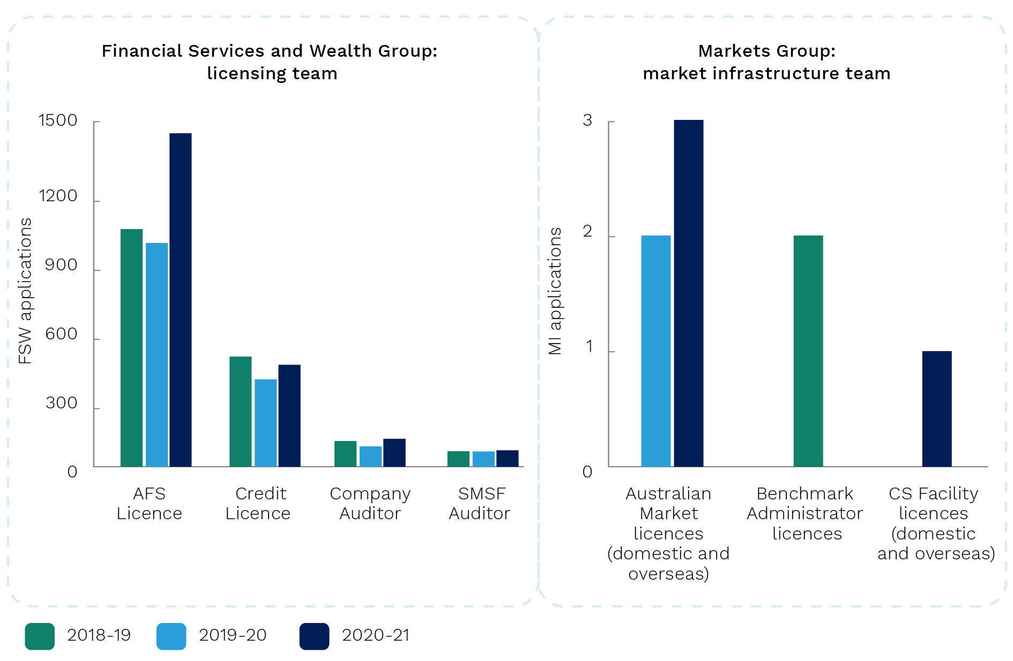

Source: ASIC, Material supplied to this review, 2022.

1. As the majority of ASIC’s licences are Australian financial service and credit licences, they are the focus of this review. There are 2 key legislative features of this licensing regime. First, once an application has been lodged that meets the legislative requirements, ASIC must grant a licence or registration unless it can substantiate grounds not to. This differs from some jurisdictions where regulators have more discretion when deciding to approve or deny licence applications.[126] Second, ASIC’s licences and registrations are point‑in‑time assessments. Once a licence is granted, except in limited circumstances, the licensee is not required to undergo periodic reassessment and indeed, the licence may be transferred to a third party at any time.

### Organisational changes

1. ASIC has implemented organisational changes to its licensing function since 2014 (Figure 5.2). The most recent change has been to move the function into the Financial Services and Wealth group, alongside stakeholder teams that conduct surveillance activities.[127] ASIC reported that this change has enabled more flexible resource allocation and better information flow and cooperation between licensing and surveillance staff (refer paragraph 4.42).

Figure 5.2: Timeline of the licensing function (2014–22)

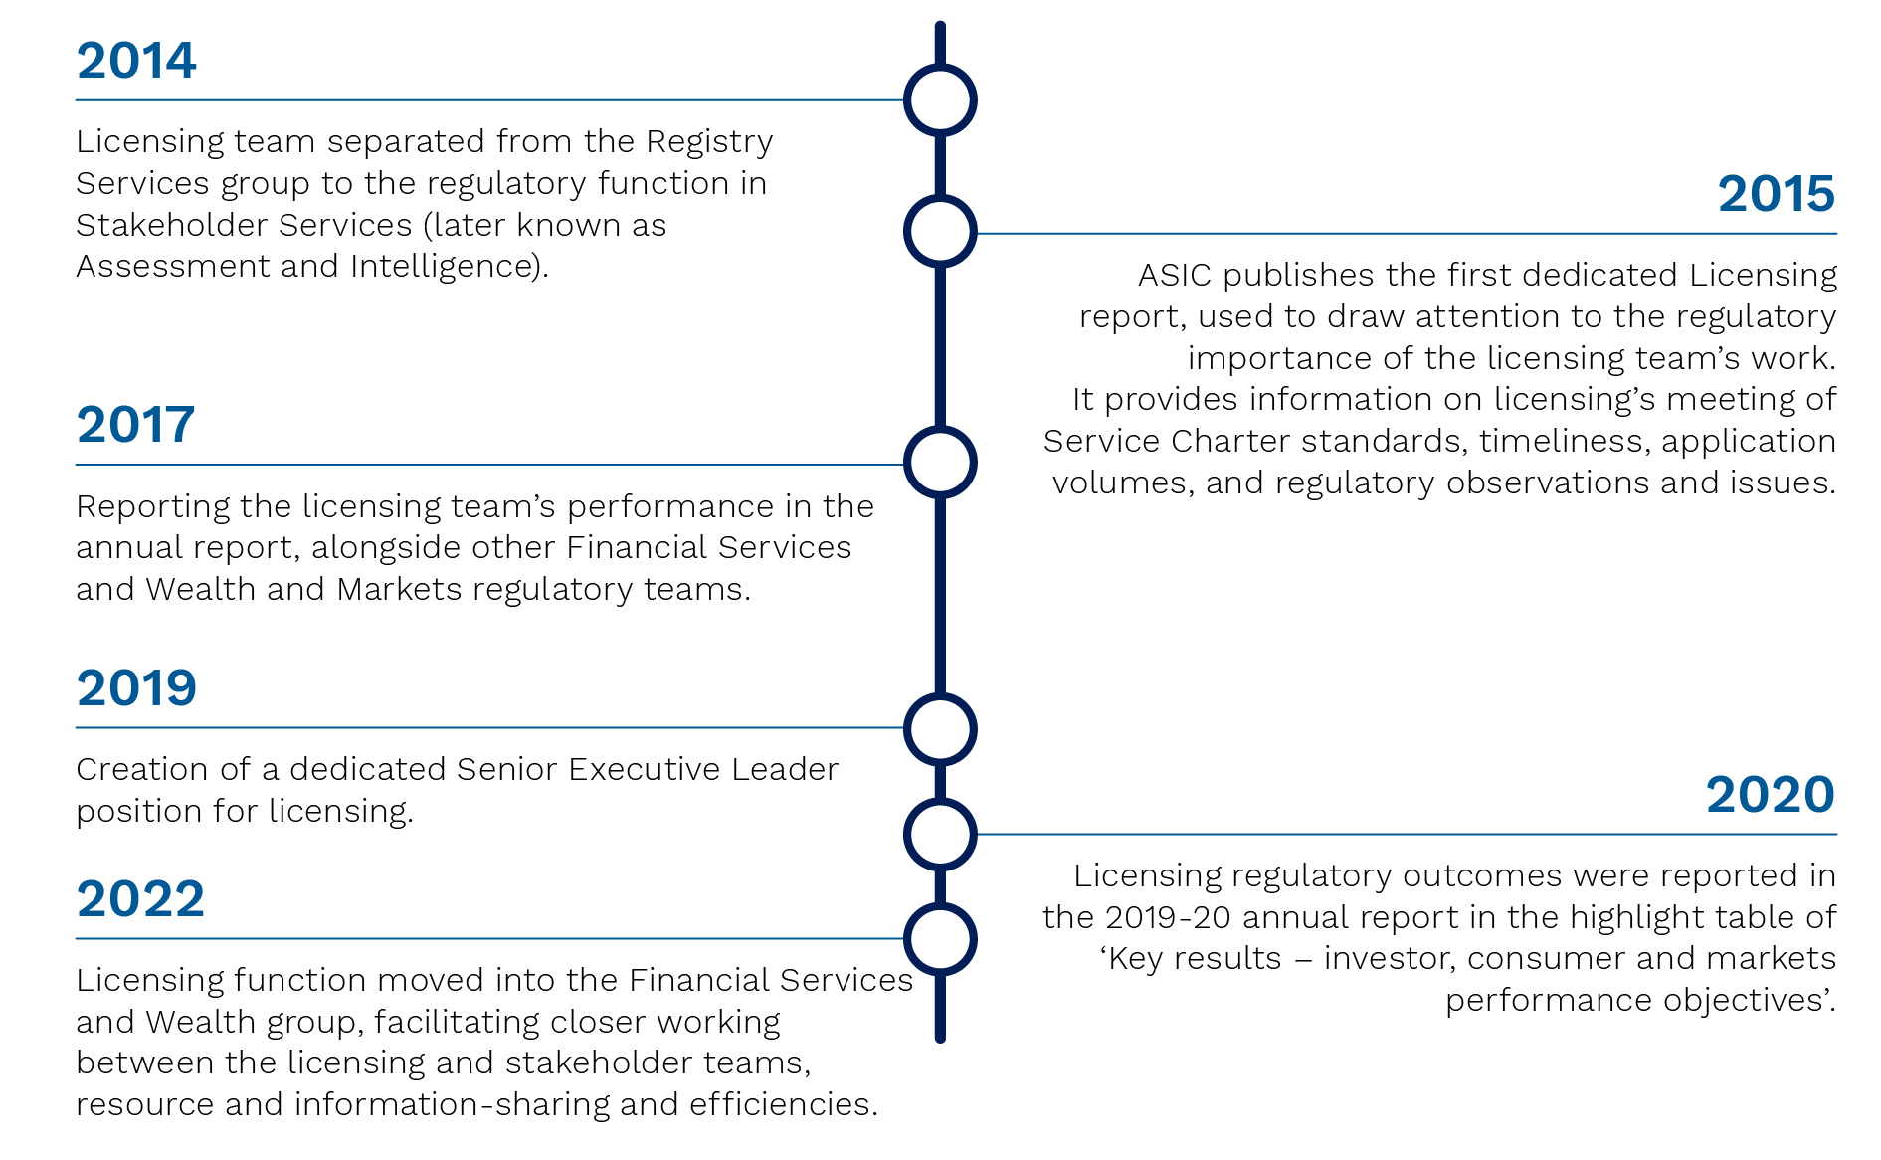

Source: ASIC, Material supplied to this review, 2022.

## Effectiveness and capability of ASIC’s licensing function

1. This section outlines the feedback received, most of which was provided by industry stakeholders and associations. Their feedback focused on the AFSL and credit licensing function, specifically relating to lodging an application, timeliness of decisions, communication with the applicant, outcomes of licensing decisions, and accountability. Consumer advocacy bodies’ feedback on the licensing function was limited.[128] Figure 5.3 illustrates an outline of the licensing application process.

Figure 5.3: Licensing application process

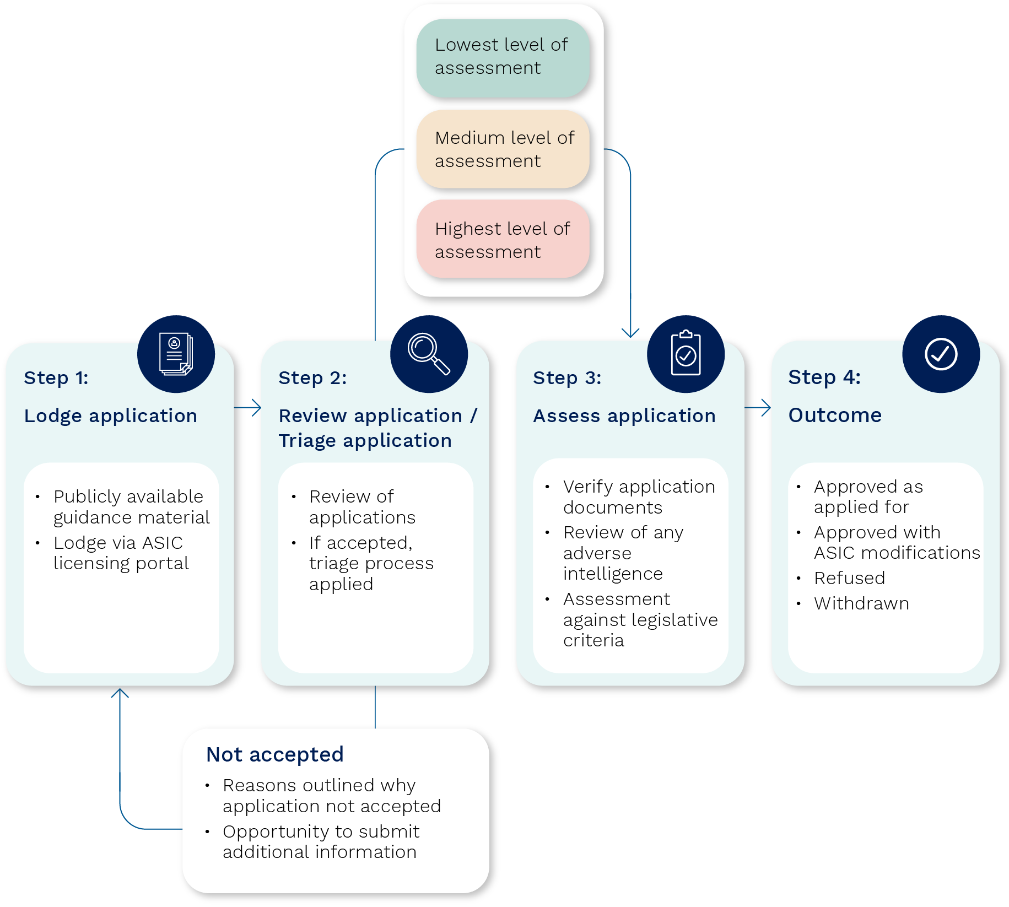

Source: ASIC, Material supplied to this review, 2022.

### Lodging an application

#### Guidance materials

1. An applicant’s first interaction with ASIC may be through the guidance materials on the licensing process ASIC publishes on its website. ASIC publishes extensive guidance materials to promote fairness and transparency.[129]
2. Stakeholder views on the quality of these materials was neutral with some areas for improvement noted.[130] Forty‑two per cent of respondents to the stakeholder survey agreed that ASIC’s published guidance was clear.[131] Targeted industry stakeholders noted there was a lot of information available and that it was updated regularly. Others commented that it could be difficult for the lay person to find all of the information available since it is published in both regulatory guides and information sheets.[132] A consumer advocacy body commented that there was a need for clearer licensing regulatory guides, since they are currently long, yet lacking in detail.[133]
3. ASIC has acknowledged that the guidance materials can be difficult to follow given the volume and complexity of some requirements. ASIC plans to integrate guidance materials into the application process through the upgraded licensing portal (refer paragraph 5.15), which will improve the usability and accessibility of the information.

#### Licensing portal experience

1. Applicants complete and lodge their licensing application via ASIC’s licensing portal. The portal is old and industry stakeholders highlighted the inability to upload documents to the portal and the cumbersome process to update licensee details.[134] In targeted interviews, industry commented that the portal was old and not intuitive, with one noting that the portal hasn’t changed since 2008.[135] Stakeholders noted that once an application has been lodged, the licensing portal does not update on the progress of applications. Applicants must seek to obtain updates directly from the licensing team, which the team is not always resourced to respond to (refer paragraph 5.40).[136]
2. Feedback from ASIC echoed these views. The ASIC staff survey found that software and digital tools for licensing activities are perceived by many staff as ‘ad hoc’ and ‘basic’.[137] In a focus group with senior ASIC licensing staff members, it was suggested that a more automated portal presented a clear opportunity to reduce manual processing and address current gaps in the licensing workflow process. ASIC’s self‑assessment highlighted that investment in licensing technology and data use held considerable potential to improve the timeliness and efficiency of ASIC’s licensing processes.[138]
3. Both ASIC and their stakeholders acknowledge that the Modernising Business Registers (MBR) program has affected ASIC’s ability to progress its licensing portal and systems upgrade.[139] ASIC noted that upgrades to the licensing portal had previously been delayed to align with the delivery of the MBR program and to avoid needing to reengineer legacy systems multiple times. However, ASIC recently decided that given how dated the portal is becoming upgrades should proceed decoupled from the MBR program.[140]
4. The proposed new licensing portal is expected to provide a user‑friendly experience for licensing applications or registrations. ASIC plans to commence its digital upgrade in   
   2022–23.[141] Specifically, the new portal is intended to:

* provide integrated guidance throughout the application process, consolidating the information into the one place[142]
* automatically review applications prior to lodgement to allow only completed applications to be submitted, reducing the time taken to chase up missing documents and subsequent information requests, and enabling ASIC to track improvements more readily in its timeframes[143]
* enable the collection of data into ASIC‑wide databases including ASIC’s CRM system (refer paragraph 4.27), allowing other ASIC teams to better access such information and intelligence.

1. ASIC also has 2 smaller projects that will bring incremental improvements.[144] These projects will assist the licensing team by automating record keeping and enabling AFSL applicants to upload supporting documents, previously sent via email.[145] These projects were scheduled to be completed by 30 June 2022 but have been delayed as ASIC seeks the resources to complete them.
2. The FRAA supports the proposed portal and systems upgrades and suggests that a key focus of the upgrade should be how ASIC can most effectively use technology to enhance the user experience.

#### Process inconsistencies

1. Once an application has been lodged ASIC analysts may contact the applicant and request that they provide further documentation.[146] A few stakeholders noted inconsistencies in these decisions.[147]
2. In its self‑assessment, ASIC noted that assessments require some level of subjectivity and judgement. Because of this, while there are processes in place to ensure consistency (refer paragraph 5.21), variations will occur from time to time as some analyst’s views as to the significance of matters may vary.[148]
3. Public submissions by the Law Council of Australia and targeted interviews with industry stakeholders reported procedural inconsistences in their licensing applications, noting the process appeared to vary depending on the analyst assigned to the assessment. Stakeholders noted these inconsistencies in operational decisions created additional uncertainty, delays in processing times and additional costs.[149]
4. ASIC responded that it has processes in place to assist making consistent assessments, such as written policy and procedures, the use of assessment worksheets with decision‑making templates, onboarding training and a mentor/buddy program. ASIC also implements a quality assurance process to review decisions each month, promoting consistency by measuring analyst compliance with ASIC’s licensing policies and procedures.[150]
5. An applicant’s individual circumstances are key to a licensing assessment.[151] ASIC noted that while applications may seem similar to the applicant, ASIC may hold confidential intelligence about an applicant or its personnel which impacts a particular application.
6. The FRAA notes that it is difficult to assess operational consistency due to the subjective considerations required for licence assessments and situations where ASIC holds confidential information.[152] The FRAA supports the licensing function’s consistency measures and encourages ASIC to continue to review and refine its methodology and staff capabilities to promote consistency, including via its digital upgrade.

### Timeliness of decisions

1. Timeliness of licensing application decisions was the main concern raised by licensing stakeholders. Several industry stakeholders commented that ASIC’s licensing processing times are too long.[153] One stakeholder commented that it can be faster to take over a licenced entity than process a licence application with ASIC.[154]
2. Public submissions from the Business Council of Australia and Law Council of Australia pointed to licensing timeframes of 6 months.[155] This did not reconcile with the data provided by ASIC that showed 70% of AFSL applications were completed within 143 days (under 5 months). The comments reflected in these submissions may have come from individuals whose applications fell in the 90% of AFSL applications completed in 240 days (over 7 months).

‘…ASIC’s decisions in response to Australian Financial Service Licences are not timely. It usually takes over 6 months for an application to be considered, even for run‑of‑the‑mill applications.’ – Public submission, Business Council of Australia

#### Service Charter timeframes

1. ASIC’s targeted licensing timeframes are published in its Service Charter which are set by the Commission. These are broadly consistent with the average timeframes set by international peer regulators, with some ahead, such as the Monetary Authority of Singapore (MAS) and some behind, such as the FCA. The Service Charter states that ASIC will aim to complete the assessment of:

* 70% of AFSL and ACL applications within 150 days
* 90% of AFSL and ACL applications within 240 days
* 80% of auditor and authorised audit company registrations with 28 days.[156]

1. There are a number of complexities when comparing jurisdictions. Some key differences include the time measurement methodology (stop the clock vs total elapsed time), assessment requirements, legislative framework, and resourcing. ASIC’s Service Charter standards are based on total elapsed time, which includes time spent waiting for applicants to respond to requisitions. Other jurisdictions, such as the FCA, can stop the clock when waiting for applicants’ responses, while others only consider complete applications (refer Figure 5.4).

Figure 5.4: Comparison of international regulators, based on service charter equivalents[157]

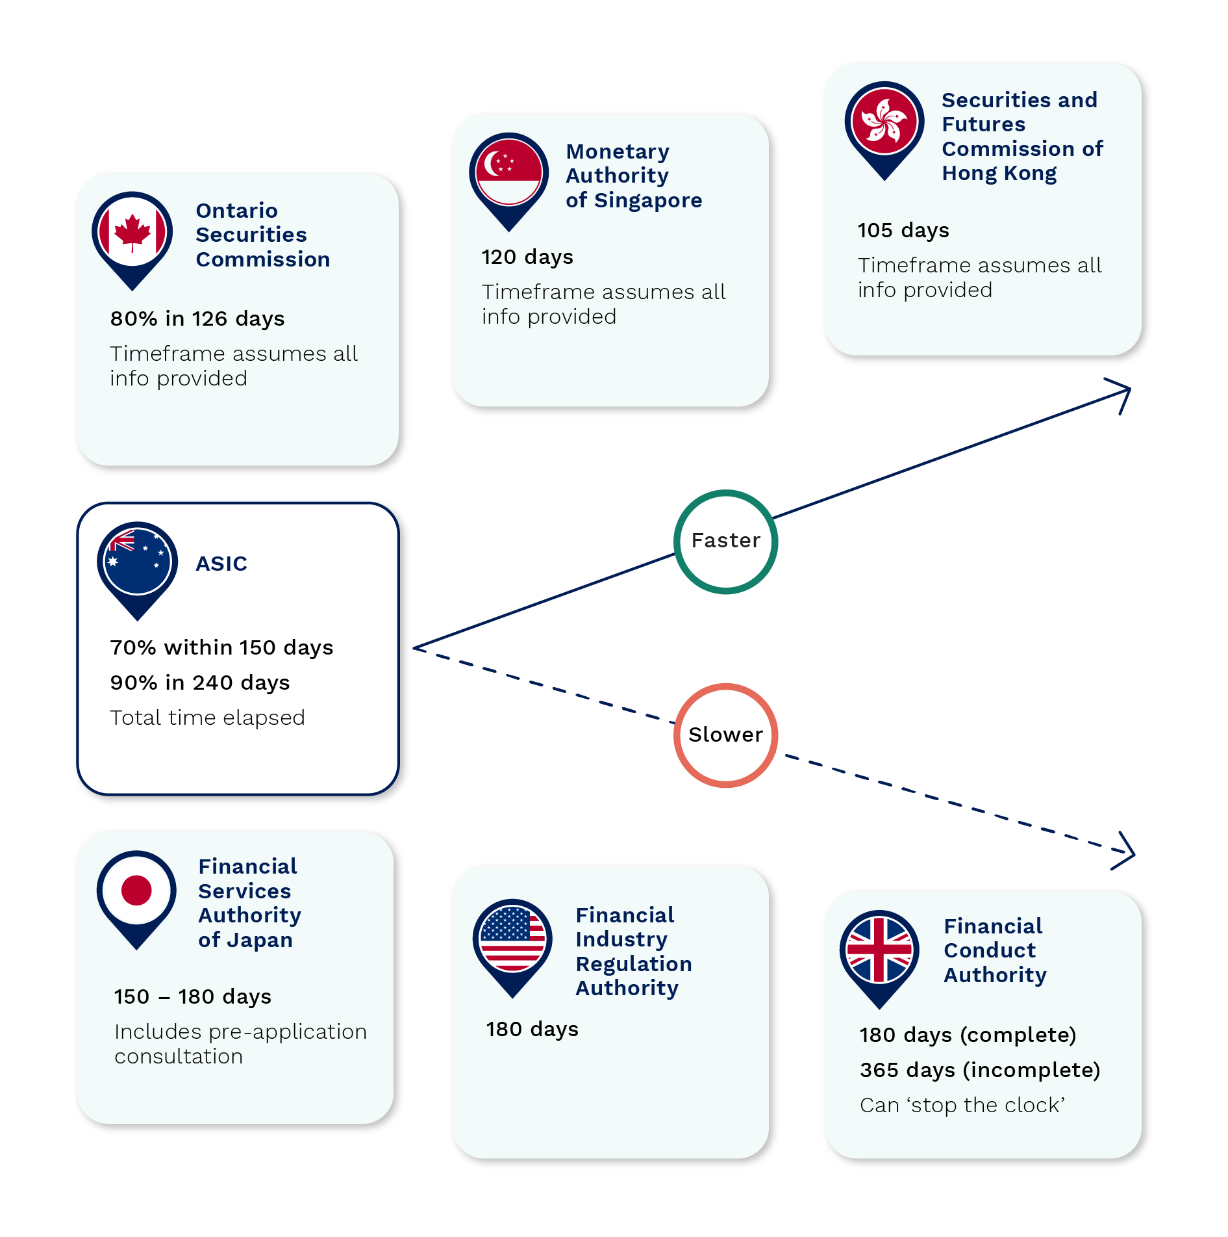

Source: ASIC, Material supplied to this review,2022.

1. Over the last 3 years ASIC has generally met its Service Charter standards (refer Figure 5.5).[158] ASIC noted that there had been a small increase in timeframes in recent years primarily due to legislative reforms that at times, have increased licensing volumes by up to 40%.[159] During these high‑volume periods, the Commission, in considering its broader mandate, did not increase the licensing resources, but made strategic decisions to prioritise incoming applicants to meet legislative transitional arrangement timings.

Figure 5.5: Performance against ASIC Service Charter standards for licensing

|  |  |  |  |  |  |  |
| --- | --- | --- | --- | --- | --- | --- |
| Licence type and outcome | 70% in 150 days  (2018–19) | 90% within 240 days  (2018–19) | 70% in 150 days  (2019–20) | 90% within 240 days  (2019–20) | 70% in 150 days  (2020–21) | 90% within 240 days  (2020–21) |
| AFSL – New | Figure 5.5 is a table that displays the outcome of whether AFSL (new or variation) and ACL (new or variation) performance targets of “70% in 150 days” or “90% in 240 days” were met in 2018-19, 2019-20 and 2020-21.  The top row sets out 7 columns. The first column is titled “Licence type and outcome”. The second column is titled “70% in 150 days (2018-19)”. The third column is titled “90% in 240 days (2018-19)”. The fourth column is titled “70% in 150 days (2019-20)”. The fifth column is titled “90% in 240 days (2019-20)”. The sixth column is titled “70% in 150 days (2020-21)”. The seventh column is titled “90% in 240 days (2020-21)”.  Under the first column, below “Licence type and outcome”, the second row is titled “AFSL – new”. The third row is titled “AFSL – variation”. The fourth row is titled “ACL – new”. The fifth row is titled “ACL – variation”. The remainder of the columns and rows are populated by a tick symbol in a green circle to show where performance was met. Where performance was not met, this is shown by a cross symbol in a blue circle and percentage immediately below the symbol. There are 3 instances where ASIC did not meet the Service Charter Standards over this period | 86% |  | 89% |  |  |
| AFSL – Variation |  |  |  | 88% |  | 88% |
| ACL – New |  |  |  |  |  |  |
| ACL – Variation |  |  |  |  |  |  |

Source: ASIC, Material supplied to this review,2022.

#### Triage process

1. ASIC’s licensing team has a triage process, where low‑risk applications have a lower level of assessment and are therefore able to be processed faster.[160] On average in 2020–21, 25% of AFSL applications were finalised in 35 days, 50% finalised in 90 days and 70% finalised in 143 days.[161] One industry stakeholder commented on their experience of a 2‑month turnaround for simple applications, providing support that ASIC’s triage process appears effective.[162]
2. Submissions and comments made during targeted interviews criticised the processing times for more complex applications. For the 50% of applications that are not classified ‘low‑risk’ the processing time is significantly longer than 90 days.[163] The variation in processing times was noted in targeted interviews, where one industry stakeholder noted that low‑risk applicants could be processed as quickly as a few weeks; while more complex applicants could wait for over a year without a resolution.[164] Some stakeholders consider these timeframes unacceptable and noted that the long processing times, particularly experienced by complex and innovative business models, are a barrier to Australia’s growth as a financial centre.[165] One industry stakeholder suggested ASIC, or the Government, could consider implementing a maximum timeframe for processing applications, as they have done in the United Kingdom, to promote transparency and certainty for business, which would require law reform.[166]
3. ASIC noted that there are only a small number of applications with a processing time of more than 300 days. In 2020–21, there were 29 applications awaiting a decision with a processing time of greater than 300 days, approximately 1.5% of total applications.[167] In such cases ASIC may have intelligence concerns about the applicant (they may be under surveillance or subject to an impending enforcement proceeding), it may raise a policy consideration (which may be subject to public consultation by Government or ASIC), or the application may be incomplete and therefore not able to be finalised.
4. The FRAA questions whether ASIC’s licensing timeframes are keeping pace with timeliness expected.[168] For example, there have been substantial service improvements by other government departments (Service NSW, Australian Taxation Office (ATO)) and the corporate sector.[169] In one case (refer Box 5.1), a major bank advised that in the last year the average time taken to provide a small business loan has been reduced from 17 days to less than 4 days.[170]

|  |  |  |  |  |
| --- | --- | --- | --- | --- |
| Box 5.1: Industry example – comparison of ASIC’s licensing application process to a business loan application process  Advancements in data, technology and business process innovations have enabled consistent reduction in processing timeframes across the economy. The similarities in the requirements for business loan applications and ASIC’s AFSL applications make for an interesting comparison. Table 1 outlines the similarities in the base level documentation.  Table 1: ASIC core documents against a bank’s minimum requirements   |  |  | | --- | --- | | **ASIC and bank requirements** | Identification documents, overview of applicant business and organisational chart, bankruptcy check, balance sheet, income statement, statement of cash flows | | **Additional ASIC requirements** | For each nominated responsible manager, a national criminal history check, appropriateness of qualifications and 2 business references |   Business loans are processed in a matter of days for most applicants, and a number of minutes for some. While not directly comparable due to differences in measurement and ASIC’s need to analyse additional information such as intelligence separately available, suitability of authorisations for business, compliance arrangements, appropriateness of qualifications and business references etc, the timeframes for processing business loans are significantly faster than average low‑risk AFSL timeframes which were 118 days in 2020–21.[171]  The reduced timeframes in the banking sector have been driven by a commercial imperative, whereas the purpose of the ASIC licensing function is to reduce harm and misconduct in the financial sector thereby promoting confident and informed market participation for investors, consumers and market participants. Different loan providers have reduced their timeframes in different ways: fintech companies have used data and automation while for more traditional banks, the reduction in timeframes have been achieved through a mix of data analytics and cultural change. For example, the bank reduced its business loan approval timeframe from 17 days to less than 4 days in one year by changes to resourcing and culture around processing. The business unit processing the loans adopted a ‘same day not service‑level agreement’ mantra and implemented daily work in progress meetings to ensure applications were processed as quickly as possible.[172]  Timeliness of processing applications was the main concern raised by stakeholders in this review, suggesting ASIC could be more ambitious in seeking to reduce timeframes. |

#### Resourcing

1. One reason timeframes may not have kept pace with the community’s expectations is the allocation of licensing resourcing within ASIC. Industry stakeholders and several of ASIC’s licensing staff commented that the licensing function is under resourced.[173] Several ASIC commissioners and executive directors noted that the licensing function had not been prioritised relative to other organisational and regulatory priorities.[174]

‘…Licensing requires more staff to process the ever‑increasing volume of applications we receive annually.’ – Staff survey

1. One stakeholder noted that as new sectors have been brought into the licensing regime, the licensing team has not grown.[175]

‘[it is] uncertain whether the importance of the licensing function is fully appreciated, as it often seems to be short of sufficiently skilled resources, and resources generally (which is disappointing).’ – Public submission, Law Council of Australia

1. Senior ASIC officials agree that with more resourcing, licensing assessment timeframes could be improved. However, they considered this speed would come at a cost of consumer protection and market integrity as resources would be diverted from other areas of the organisation.[176] Senior ASIC officials noted the constraints of the licensing regime, it being a point‑in‑time assessment.[177] It was suggested to the FRAA that while increasing licensing resources would increase the speed of licensing assessments, it would not strengthen ASIC’s gatekeeper role or reduce the need for more costly surveillance and enforcement activities. If anything it would cause resources to be diverted from these areas. These ASIC officials feel the current licensing resourcing arrangements strike the right balance.[178]
2. The FRAA notes that the portal and digital upgrades ASIC is undertaking (refer paragraph 5.15) will likely reduce the timeframes for processing applications. The FRAA encourages ASIC to be ambitious in seeking to reduce timeframes and specifically to:

* consider afresh whether there are sufficient resources dedicated to this function
* use the rollout of the proposed systems to learn how others in governments, not‑for‑profits and businesses have reduced processing timeframes.

### Communication with the applicant

1. Communication with ASIC during the application process was raised by industry stakeholders in both targeted interviews and the stakeholder survey. There were 2 areas of concern. Firstly, some reported frustration around the difficulties contacting ASIC, and a perceived lack of willingness by ASIC staff members to discuss their applications. Secondly, there was a perception that ASIC was unnecessarily formal in its communication.
2. Some stakeholders in targeted interviews expressed frustration at the difficulties getting analysts to return their phone calls or emails, suggesting that the licensing team appeared routinely to fail to meet their Service Charter commitment to provide prompt and timely responses, and noted that they often seemed unwilling to discuss applications.[179] The lack of prompt and timely responses was particularly relevant to complex applications (see paragraph 5.31). The broader results on ASIC’s responsiveness from the stakeholder survey were neutral: 32% agreed that they could easily communicate with ASIC’s team throughout the assessment process while 30% disagreed and the remainder were neutral.[180]
3. Another example where applicants felt ASIC was unwilling to engage came from the Australian Restructuring Insolvency and Turnaround Association’s (ARITA) submission in relation to registrations of liquidators. ARITA suggested there could be more sharing of non‑sensitive information to assist in educating their members and to improve the efficiency of the process.
4. ASIC noted the licensing team’s endeavours to keep applicants informed of the status of applications. The team acknowledges receipt and confirms when applications have been accepted for assessment, and then updates an applicant within 60 days of initial contact and on every 60‑day interval until the assessment is finalised.[181] ASIC noted that the level of communication with applicants could be affected by staff resourcing particularly in periods of high volume, as experienced over the last few years.
5. ASIC has a strong preference for its communication with applicants to be in writing.[182] Industry stakeholders suggested the licensing process could be improved by making more use of discussions with applicants.[183] Stakeholders noted that verbal discussions would assist ASIC to gain a better understanding of applications. One stakeholder recounted a positive experience where the ASIC analyst telephoned the applicant, discussed the matter and then followed up with a tailored, written request for information. The stakeholder noted this was an efficient way for ASIC to obtain targeted information, instead of requesting a wide range of documents without a discussion as was their more typical experience with ASIC.[184]
6. A stakeholder in the fintech space was also complimentary of informal licensing information provided through ASIC’s Innovation Hub.[185] ASIC reported that on average, fintech businesses that engaged with the Innovation Hub before submitting their application for an AFSL or ACL received approval 28% faster than those seeking these licences without assistance (112 days compared to 144 days), suggesting there are significant efficiency benefits to increasing this kind of engagement.[186]
7. The FRAA welcomes the recently announced stocktake of stakeholder engagement by ASIC’s Regulatory Efficiency Unit (refer paragraph 3.56) and the identification of licensing as an early case study.
8. One stakeholder suggested the use of interviews could improve the licensing regime.[187] For example, the stakeholder suggested such discussions may give ASIC an opportunity to test the competency of an applicant and test an applicants’ knowledge, leading to better outcomes.[188] Other jurisdictions, such as Singapore’s MAS, the United Kingdom’s FCA, the Dubai Financial Services Authority and the Cayman Islands Monetary Authority, were mentioned as having an interview component to their licensing regimes.[189]
9. The FRAA notes Canada’s Ontario Securities Commission (OSC) introduced a ‘pre‑registration interview’ process in 2015 as part of their licensing regime. The OSC reported that the interviews have assisted in their understanding of proposed business activities and also enabled businesses to address potential deficiencies before commencing operations.[190]
10. More verbal discussions with applicants may also help ASIC showcase their industry knowledge. Stakeholders, in targeted interviews, noted they would like to see ASIC staff display a greater understanding of different business models. On the other hand, 62% of the licensing team agreed that they received training and knowledge to support the assessment of licence applications.[191] Licensing staff members have indicated an interest in improving their data literacy and skills around regulatory strategies and interventions.[192]
11. The FRAA considers that there appears to be scope to improve the licensing function if ASIC displays a greater willingness to engage with applicants. The FRAA supports the Regulatory Efficiency Unit’s case study of the licensing function. The FRAA notes increasing verbal engagement would be a significant change in the way the team operates and would require appropriate training and systems to ensure staff are capable and confident.

### Outcomes of decisions

#### ASIC conduct robust and fair assessments

1. Stakeholders held a general view that ASIC conducts robust and fair licensing assessments. Fifty per cent of stakeholders and 62% of ASIC staff surveyed agreed that ASIC conducts robust and fair assessments of licence applications.[193] This was the most positive stakeholder response to the FRAA’s stakeholder survey.
2. Another way of assessing the outcomes from the licensing process is to analyse the appeals data – a high number of successful appeals would indicate ASIC is refusing too many applications. If the licensing team makes a recommendation to refuse an application, the applicant can withdraw their application or proceed to an ASIC hearing with an ASIC delegate for decision. The delegate’s decision is reviewable by the Administrative Appeals Tribunal (AAT).
3. Over the last 3 years, 833 AFSL applications have been refused, withdrawn or rejected (refer Figure 5.6).[194] In the same period, 3 applicants had their applications decided by an ASIC delegate (all refused), and there have been 4 appeals decided at the AAT, all upholding ASIC’s decision to refuse a licence.[195]

Figure 5.6: AFSL (new and variation) assessments from 2018–19 to 2020–21 outcomes at end of financial year[196]

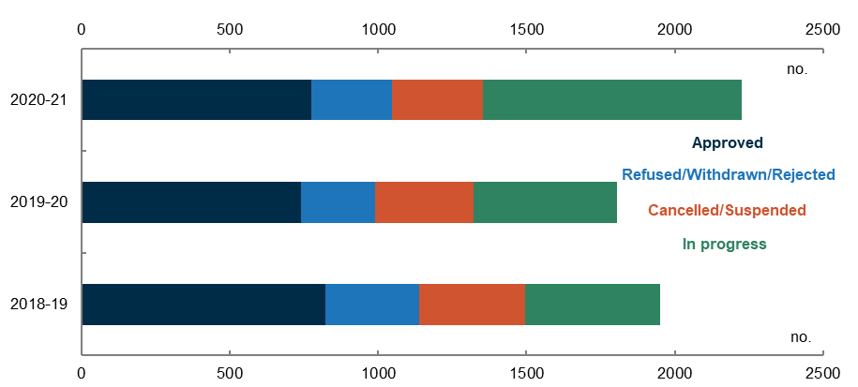

Source: ASIC, Material supplied to this review, 2022.

1. While the low number of appeals regarding licensing decisions supports the view that ASIC conducts robust and fair assessments, the FRAA notes it has some limitations. For example, applicants may decide not to appeal a decision to the AAT because of the associated effort and costs or because the applicant decided not to proceed with their business operations for other reasons. Appeals against licensing decisions provide one measure available to ASIC that could indicate whether ASIC are impeding satisfactory applicants from obtaining a licence.
2. The perception that ASIC conducts robust and fair licensing assessments is also supported by the low levels of complaints data.[197] Complaints are low and have declined over the past 5 years, despite an increased volume of applications.[198] In 2016–17 there were 41 complaints received in relation to licensing matters; 9 complaints were substantiated. In 2020–21, 19 complaints received, with 3 substantiated complaints.[199] This is a small number given ASIC approved over 1,500 applications for AFSLs and ACLs in 2016–17 and approximately 1,000 in 2020–21.[200]
3. Feedback from stakeholders, and data from appeals and complaints supports the view that ASIC conducts robust and fair assessments. While this feedback is reassuring, the FRAA would like to see ASIC more proactively measuring the quality of their licensing decisions (discussed below).

### Accountability

1. The main focus of ASIC’s licensing reporting is whether it meets the timeliness targets set in the Service Charter. ASIC does not report on the quality of licensing decisions or the user experience of applicants.
2. ASIC has generally met the Service Charter targets (refer paragraph 5.26) which are based on the total time elapsed before a licensing decision is made. ASIC also annually reports on:

* number of applications received and the outcomes (approved, cancelled/suspended, withdrawn or refused)
* number of additional regulatory outcomes (that is, imposition of a key person condition or changes to authorisations).[201]

1. The FRAA encourages ASIC to consider whether the elapsed time method for assessing licensing applications gives ASIC enough information on the efficiency of their operations and gives sufficient scope for comparison with other regulators.
2. ASIC does not have a systematic process to review the quality of its licensing decisions. As discussed at paragraph 5.50, AAT reviews are recorded and used by ASIC to support its licensing decisions to providers. Currently ASIC does not track information to support its decisions as to whether recent licensees are operating competently and honestly. One way this could be done is by recording the level of reports of misconduct of recent licensees.
3. When requested by FRAA, ASIC provided a snapshot on reports of misconduct of recently granted licensees. From 1 July 2019 to 29 April 2022, ASIC granted 939 new AFSLs. Of these, 71 licensees (7.6%) had been subject to reports of misconduct, and of those, only 3 licensees (0.3%) were subject to enforcement investigations.
4. Reports of misconduct can be an indicator of concern regarding the actions of licensees, but has limitations as a tool for assessing the effectiveness of the licensing function:

* Licensing is a point‑in time assessment. Poor conduct by a licensee at a later time may have been unforeseeable by ASIC as the time it made its assessment.
* Every report of misconduct is recorded by ASIC, but not all reports are substantiated or require ASIC to take action.
* The reasons for when enforcement investigations are undertaken should be considered – whether the misconduct could have been detected by the licensing assessment.[202]
* Some benchmarking is required. It is not clear how many reports of misconduct would be acceptable for a licensing function to be considered effective, or for how many years after a licence is granted that ASIC’s gatekeeper role is being judged.

1. The FRAA suggests that ASIC could consider systematically monitoring reports of misconduct data on recently granted licences. While not a perfect measure, when considered with other data such as the AAT appeals, it can be a useful indicator to track the licensing function’s effectiveness.
2. Unlike some other regulators, ASIC does not have a systematic process to measure the ‘user’ experience of licence applicants and licensees. For example, New Zealand’s Financial Markets Authority (FMA) conducts an annual ‘Ease of Doing Business’ survey where corporate entities share feedback on their perception of and interactions with their regulator.[203] While complaints data is measured (refer paragraph 5.52), satisfaction of user experience is not captured. ASIC could also monitor and report on user experience to identify areas for further improvement.
3. The FRAA considers there are a number of ways ASIC may enhance the effectiveness and capability of its licensing function including by better measuring, assessing, and reporting on key metrics. This chapter makes some suggestions around potential metrics and considers a more systematic review would be beneficial (refer paragraph 6.26).

## Planned initiatives

1. Throughout this review, ASIC has identified initiatives that will likely improve the effectiveness and capability of its licensing function. These are summarised in Box 5.2.

|  |
| --- |
| Box 5.2: Current ASIC actions to improve the effectiveness and capability of licensing   * Upgrading its licensing portal for licensing applications or registrations to improve the user experience and improve licensing timeframes (commence 2022–23). * Streamlining and automating aspects of the licensing assessment process through a new workflow system that will integrate the licensing portal into ASIC’s CRM system (commence 2022–23). * Considering ASIC’s approach to enhance stakeholder engagement, with the licensing function as a case study, through the Regulatory Efficiency Unit (2022–23 to  2023–24). |

## Assessment

1. The FRAA’s overall assessment is that ASIC’s licensing function is broadly effective, and the licensing team is capable although somewhat constrained by limited resourcing and technology. Feedback from stakeholders supports the view that ASIC undertakes robust and effective licensing decisions, but could benefit from more resourcing.
2. ASIC staff and stakeholder feedback suggest that better technology, data and systems will improve the efficiency of the licensing process, thereby reducing both the time taken to process applications and the burden experienced by applicants.
3. The FRAA considers that additional emphasis on the user experience including the advantages of ASIC’s licensing staff to willingly engaging in more verbal communication with applicants would improve the effectiveness of the licensing function. Such verbal engagement is consistent with the Chair’s objective of a confident regulator.
4. ASIC should consider whether it can better measure, assess and report on the effectiveness and capability of its licensing function through the data it monitors and reports on. Routinely measuring reports of misconduct data on recently granted licences and AAT reviews will complement existing data that ASIC reports on and assist ASIC in tracking its performance. Collecting data on the applicant’s user experience could also help ASIC to assess whether they are meeting community expectations and identify key areas for improvement.

# Chapter 6: Outcomes of this review

## Introduction

1. The previous chapters have set out the evidence considered by the FRAA relating to the 3 functional areas in‑scope for this review: ASIC’s strategic prioritisation, planning and decision‑making (refer Chapter 3: Strategic prioritisation, planning and decision‑making), surveillance (refer Chapter 4: Surveillance) and licensing (refer Chapter 5: Licensing).
2. A number of common themes emerged during this review that form the basis of the FRAA’s recommendations. These themes relate to ASIC’s data and technology capability, the nature of its relationships particularly with external stakeholders, the need for it to assess the outcomes of its activities and the skill sets of its people to support these areas.
3. In this chapter the FRAA makes recommendations which, if implemented, should improve the effectiveness and capability of ASIC and fulfill the ASIC Chair’s vision of being an ambitious, confident and digitally enabled regulator.

## Data and technology

1. The Government’s Regulator Performance Guide suggests that data and digital technology can be leveraged to help regulators better understand and manage risks. This requires building capability and having the right infrastructure to support effective data use and digital literacy.[204]
2. For ASIC to remain effective, credible and relevant as Australia’s market conduct regulator into the future, ASIC requires further investments in skilled technology and data specialists and modern technology platforms, analytical tools and digital capabilities. Alongside such investments it is essential that ASIC focuses on the cultural settings necessary to support the benefits of an uplift in these capabilities.
3. The FRAA considers that improvement in data, analytics and technology capabilities would support ASIC to better identify and act on emerging harms, set strategic priorities, create efficiencies, lower the regulatory burden, and deliver a digital stakeholder experience. The effective use of data and technology holds the potential for ASIC to efficiently access, digest and analyse vast amounts of data. This would enable it to better target work, identify and act on misconduct earlier, and to draw better insights. It could also significantly improve the timeliness of licensing decisions and the experience of licence applicants.
4. ASIC has historically underinvested in technology (both funding and capability). ASIC has a comparatively lower annual technology spend than some other domestic public sector agencies and international market conduct regulators.[205] The FRAA considers that ASIC’s immediate demands may have resulted in this underinvestment. It is also a function of ASIC’s capital expenditure budget which is set by government, with limited flexibility to reallocate its operational expenditure budget to capital expenditure.
5. Improved use of data and technology would enable ASIC to systematically and proactively detect emerging threats, address misconduct and minimise harm. The need for such improvement is most pressing in ASIC’s Financial Services and Wealth Group, which is comparatively less sophisticated in its data and technology capabilities than the Markets Group. It is noted that the Markets Group’s capability has been developed in part through access to real‑time data and 2 rounds of Government funding.
6. ASIC has recognised the need to increase its investment in high‑quality technology, modernised technology platforms, analytical tools, digital capabilities and appropriately trained staff. ASIC has developed digital capability uplift strategies including its Digital Strategy 2030 and Data Strategy and Roadmap 2021–26. These strategies set out the organisational changes, skills development, investments and recurrent data collection powers that ASIC believes are required over the next 5 years to realise its ambition to become a digitally enabled and data‑informed regulator.
7. ASIC intends to work with Government to obtain the necessary funding and data collection powers to deliver on these strategies.
8. The FRAA supports ASIC’s ambition to become a digitally enabled and data‑informed regulator and is supportive of ASIC prioritising this in its allocation of internal resources. The FRAA recognises that additional funding and government support will be necessary if ASIC is to achieve its ambition given the historic underinvestment in technology and the resulting technology debt.
9. It is the FRAA’s view that any data and technology investments will need to be accompanied by material cultural change to realise the benefit from those investments. The poor experience of the development and deployment of the new CRM system (refer paragraph 4.63) illustrates that investment in technology without the necessary cultural engagement will not succeed.
10. The FRAA considers that to successfully execute ASIC’s digital and data strategies, ASIC’s Chair, Commission and executive directors need to ensure ASIC staff members are fully supported in the cultural and mindset change that will be required to execute these strategies.

|  |
| --- |
| Recommendation  ASIC requires a substantial uplift in its data and technology capability which will involve cultural change. |

## Quality of engagement with stakeholders

1. ASIC’s regulated population, consumer advocacy bodies and broader stakeholders have a strong shared interest in identifying and preventing misconduct and breaches of the law. However, while there may be an alignment of objectives at large, for the benefits of such objectives to be realised there is a requirement that ASIC has a strong, trusted and where appropriate, open and collaborative relationship with its stakeholders.
2. Improving stakeholder engagement in a thoughtful and considered way need not compromise the imperative that ASIC maintains clear independence from the community it regulates and resists regulatory capture. It is vital that ASIC resists regulatory capture and has the freedom to use its regulatory tools in the national interest.
3. ASIC has a range of stakeholders including regulated entities, investors, consumers, industry and consumer advocacy bodies, other regulators and government. ASIC uses different channels to engage with its stakeholders including corporate communications (for example, the annual report, corporate plan, media releases, articles and podcasts), commissioner speeches, external advisory panel meetings and other stakeholder meetings.
4. Overall, the feedback as described in the previous 3 chapters suggest that ASIC could improve the quality and consistency of its engagement and relationships and that doing so would support ASIC to better achieve its objectives.
5. The FRAA considers that quality engagement goes beyond the number of meetings that commissioners and ASIC senior leaders have with stakeholders. Quality stakeholder engagement requires open and transparent communications to listen to and understand stakeholders’ issues and perspectives.[206] Developing quality engagement and relationships with stakeholders should occur right across the organisation. Quality engagement should be supported by corporate communications that are clear and consistent.[207]
6. Strong relationships with stakeholders improve transparency and builds the trust and confidence of stakeholders, thereby enhancing ASIC’s effectiveness and capability. For example, it would enable ASIC to draw on a broader set of information and access intelligence that would enable it to act earlier to minimise harm. Better engagement in the establishment of surveillance projects can enable ASIC to tailor its activities to meet its objectives more efficiently. In licensing, better engagement with applicants can improve the applicant experience and lead to more timely licensing decisions.
7. ASIC has recognised the need to improve its communications of priorities and surveillance outcomes. ASIC is seeking to communicate its priorities in speeches and publications by commissioners and recently used innovative communication channels, via social media, to address and communicate emerging harms in the markets space. ASIC’s newly established Regulatory Efficiency Unit has identified initiatives to improve the efficiency of its engagement with its regulated population (refer paragraph 3.56).
8. The FRAA is supportive of ASIC’s initiatives to improve its engagement with stakeholders and considers these initiatives are a good starting point to improve the quality and consistency of this engagement.
9. The FRAA considers that to meaningfully enhance its stakeholder relationships ASIC will need a cultural shift with a deep focus on its stakeholders and their experience in interacting with ASIC. Staff members should be empowered to develop quality engagements with stakeholders and drive a more confident organisation. It will also require greater collaboration and information sharing across ASIC teams so issues raised by stakeholders can be passed to the teams that can best action them. The FRAA notes that, as a regulator, ASIC necessarily needs to remain independent and avoid regulatory capture. ASIC’s ability to be an independent, strong and confident regulator should not conflict with improving its stakeholder engagement in a thoughtful and considered way. This should support ASIC’s effectiveness by providing early intelligence to detect harms.
10. The ATO provides a powerful example of how a regulator can achieve better outcomes by leveraging its stakeholder relationships. The ATO implemented a program (Reinventing the ATO) designed to improve its regulatory outcomes through cultural and technological transformation. The ATO had an objective of placing its stakeholders at the centre of all engagements. The ATO has raised its stakeholder experience satisfaction to an average of 66 out of 100 on key metrics, compared with 62 out of 100 two years prior.[208] Refer Box 6.1 for more information on this program and client satisfaction results.

|  |
| --- |
| Box 6.1: Reinventing the Australian Taxation Office  To achieve its vision of being a contemporary, service‑oriented organisation, the ATO has transformed how its stakeholders (called ‘clients’ by the ATO) and staff experience the tax and super systems.  The design has been centred around the client, making sure the ATO’s services and interactions are professional, contemporary and tailored, making it easy for clients and staff to get things right. The ATO’s staff have been empowered and trusted to act and have access to contemporary tools. The ATO has focussed on building strong working relationships with partners in the system to ensure effective and efficient services are provided to the community.  The ATO recognised that a critical dependency for supporting improvements to the client experience has been a parallel focus on improving the experience staff have at work when serving the community and the culture of the organisation.  The ATO has committed to a program of cultural transformation as represented in its 2024 Culture strategy. The strategy includes 5 cultural traits: ‘Client focused’, ‘United and connected’, ‘Empowered and trusted’, ‘Future‑oriented’ and ‘Passionate and committed’. This cultural change in the way the ATO does its business has led to a better experience for taxpayers and a more satisfied workforce.[209]  The ATO’s cultural transformation has enabled a multi‑year rebuild of IT systems to digitise its services, including digitising and pre‑filling the personal income tax form; automating pay‑as‑you‑go and superannuation reporting between businesses and government through the Single Touch Payroll; modernising its business registers to streamline how businesses register, view and maintain information with government; and improving its website interface for client useability. The ATO has embedded data into its core services and is now almost wholly digital. In 2020, only about 1.5% of individual tax returns were lodged on paper.  The ATO collects user feedback through multiple channels to ensure it reaches its goals. Its results on factors such as ease, helpfulness, timeliness and effectiveness increased between 3 and 5 index points from 2018–19 to 2020–21, resulting in scores between 66/100 and 71/100. Community confidence in the ATO in relation to fairness and partner perceptions of how the ATO is working with them to administer the tax and superannuation system improved 7 index points between 2018–19 to 2020–21 to 68/100 and 71/100 respectively.[210] |

1. While the organisations are different, ASIC can learn from the ATO experience about how culture, processes and systems can be improved, with a focus on the stakeholder experience that provides benefits to the organisation and its stakeholders. As an example, as part of its reinvention efforts the ATO allowed its call centre staff go ‘off script’ when communicating with callers and this led to better resolution of callers’ queries and ATO staff members feeling more empowered. This is a notable example for ASIC to consider in the licensing context.
2. The FRAA considers that a cultural shift is required in the way that ASIC thinks about and engages with its regulated population and broader stakeholders. This shift would see ASIC become a more ambitious and confident regulator.

|  |
| --- |
| Recommendation  ASIC should have a stronger focus across the organisation on enhancing the quality of its engagement with stakeholders. |

## Measuring, assessing and reporting on outcomes

1. As outlined in Chapter 1: FRAA objectives and methodology, the FRAA considers it important to have enduring metrics that measure regulator effectiveness and capability over time. There are few established measures to draw from and there are inherent challenges in developing new measures. The FRAA intends to work with ASIC and broader stakeholders to develop metrics for measuring the effectiveness and capability of the regulators.
2. As discussed in previous chapters, ASIC does not have embedded measures to assess the outcomes of its activities across strategic planning, prioritisation and decision‑making and licensing and is at an early stage in developing these for its surveillance activities.
3. The FRAA considers it is important that ASIC tackle the question of measuring the effectiveness and capability of its regulatory activities, while acknowledging the challenges in doing so.
4. Establishing these measures is expected to provide an evidence base for continual review of ASIC’s effectiveness and capability and is consistent with ASIC’s commitment under its Statement of Intent to identify and pursue opportunities to continuously improve its performance.[211] It is consistent with the Government’s Regulator Performance Guide that encourages regulators to develop outcomes focussed performance measures to report on their performance.[212]
5. The FRAA’s view is that embedding assessment measures into business processes should allow ASIC to make better decisions around priorities and resource allocation. It should also support ASIC to assess whether surveillances are having the intended impact, as well as whether any regulatory impost is justified by the outcomes being achieved. In licensing, it would allow ASIC to assess the quality of its decisions and the effectiveness of its role as a gatekeeper to the financial system.
6. The FRAA acknowledges ASIC’s plans to better measure the outcomes of its activities and supports ASIC achieving this via a well‑considered and transparent process. In its 2021–25 Corporate Plan ASIC sets out how it will measure outcomes and the evidence ASIC would gather to determine whether those outcomes have been achieved.[213] It includes a sample of outcomes that it will use to evaluate its performance and the evidence of those outcomes.
7. The FRAA considers that the results of the measures that ASIC develops should be published to increase transparency and accountability. This reporting would supplement existing reporting mechanisms such as the annual performance statement in the Annual Report and support the work of other accountability mechanisms such as the Parliamentary Joint Committee on Corporations and Financial Services.

|  |
| --- |
| Recommendation  ASIC should develop measures of its effectiveness and capability in meeting its objectives, and communicate the outcomes transparently both internally and externally. |

## Mix of skill sets

1. Maintaining the right mix of skill sets is essential to the effectiveness and capability of any organisation. In this review, the FRAA has considered the skills of ASIC’s people and any cultural factors that influence its performance. It also had regard to how ASIC is placed to develop the necessary skill sets and competencies for the future.
2. To implement the recommendations in this report, the FRAA considers that ASIC will need to continue to build its people and organisational skills, and cultural setting to:

* support data and technology uplift plans
* improve engagement with stakeholders
* enable continual self‑assessment.

1. Alongside investments in technology, ASIC will need to build skill sets in the use of technology and data analytics to support it to become a digitally enabled regulator. These skill sets should support ASIC to efficiently analyse data for insights and trends and to draw meaningful conclusions from complex and varied data sources. The Government’s Regulator Performance Guide recognises the importance of regulators building ‘staff and organisational data capability and digital literacy’ to help regulators better understand and manage risks.[214]
2. To enhance the quality of engagement with its stakeholders, ASIC staff should be equipped with the necessary skills and experience. This will require building capability across ASIC to engage in open and constructive dialogue with stakeholders. Quality engagements will also need to be supported with the necessary experience in contemporary and emerging market areas of risk such as those relating to crypto, cyber and climate change. These types of experience and skill sets must be complemented with regulatory skills and experience in regulatory judgement.
3. Developing and implementing measures of its effectiveness and capability will need to be accompanied by a culture of continuous improvement. The Government’s Regulator Performance Guide suggests that regulators should ‘actively build staff capability’, and ensure they ‘have the capacity and are empowered to identify and implement improved practices’.[215]
4. ASIC recognises that its staff members are key to the ongoing effectiveness of the organisation. Since 2020, there has been an increase in staff members’ qualifications and experience in digital and data analytics. ASIC has adjusted the allocation of graduate placements to reflect priorities and future capability needs and in 2023 it will target areas such as mathematics, statistics, IT and data and analytics (refer paragraph 4.53).
5. During this review, ASIC completed a new People Strategy. This strategy is designed to support ASIC to become more digitally enabled and regulate emerging areas, equip staff members with the right mindset, tools and capabilities and uplift organisational leadership to embed a ‘whole‑of‑ASIC’ culture. ASIC intends to recruit a Head of Workforce Management who will be responsible for, among other things, defining and building the organisational workforce strategy.
6. The FRAA supports ASIC’s new People Strategy and its initiatives to deliver the strategy. The FRAA’s view is that ASIC should continue to focus on broadening its mix of skill sets to support the implementation of the recommendations in this report.

|  |
| --- |
| Recommendation  ASIC should continue to broaden its mix of skill sets to ensure it can meet the current and future needs of the organisation. |

# Abbreviations and acronyms

| Term | Definition |
| --- | --- |
| AAT | Administrative Appeals Tribunal |
| ACCC | Australian Competition and Consumer Commission |
| ACL | Australian credit licence |
| ACCP | ASIC Consumer Consultative Panel |
| AFSL | Australia financial services licence |
| AI | Artificial intelligence |
| APRA | Australian Prudential Regulation Authority |
| ASIC | Australian Securities and Investments Commission |
| ASIC Act | *Australian Securities and Investments Commission Act 2001* |
| ASL | Average staffing level |
| ARITA | Australian Restructuring Insolvency and Turnaround Association |
| ATO | Australian Taxation Office |
| Corporations Act | *Corporations Act 2001* |
| CRM | Customer relationship management system |
| ED | Executive Director |
| FCA | Financial Conduct Authority, United Kingdom |
| fintech | Financial technology |
| FMA | Financial Markets Authority, New Zealand |
| FRAA | Financial Regulator Assessment Authority |
| FRAA Act | *Financial Regulator Assessment Authority Act 2021* |
| FSAP | Financial Sector Assessment Program |
| FSI | Financial Soundness Indicators |
| FTE | Full‑time equivalent |
| G20 | Group of 20 |
| GFC | Global Financial Crisis |
| IFM | Industry funding model |
| IMF | International Monetary Fund |
| IOSCO | International Organization of Securities Commissions |
| IT | Information technology |
| MAI | Market Assessment Intelligence |
| MAS | Monetary Authority of Singapore |
| MBR | Modernising Business Registers |
| NCCP Act | *National Consumer Credit Protection Act 2009* |
| OECD | Organisation for Economic Co‑operation and Development |
| OSC | Ontario Securities Commission, Canada |
| PGPA Act | *Public Governance, Performance and Accountability Act 2013* |
| RBA | Reserve Bank of Australia |
| regtech | Regulatory technology |
| Royal Commission | Royal Commission into Misconduct in the Banking, Superannuation and Financial Services Industry |
| SEC | Securities and Exchange Commission, United States |
| SMSF | Self‑managed super funds |

# Appendix A: Methodology of this review

### Methodology

The FRAA has used a range of methods to gather evidence from a broad range of external stakeholders and ASIC staff during the course of this review.

Boston Consulting Group was engaged to provide support to the FRAA, in particular conducting the surveys, international peer regulator consultations and interviews with ASIC staff members.

### Public consultation

The FRAA conducted a public consultation between 29 November 2021 and 28 January 2022. The consultation paper outlined the scope of this review and sought feedback on 14 questions.[216] The FRAA received 16 public submissions (outlined below) and 5 confidential submissions.[217]

Australian Banking Association

Australian Financial Markets Association

Australian Institute of Company Directors

Australian Institute of Superannuation Trustees

Australian Restructuring Insolvency and Turnaround Association

Australian Securities Exchange

Business Council of Australia

CHOICE

CPA Australia

Customer Owned Banking Association

Financial Services Institute of Australasia

Institute of Public Accountants

Insurance Council of Australia

Knox Millhouse

Law Council of Australia

Self‑Managed Super Fund Association

### Consultation with a broad range of stakeholders

The FRAA consulted with a broad range of stakeholders to gather information, data and feedback.

#### Individuals with relevant experience

Alan Cameron AO, former ASIC

Tony D’Aloisio, former ASIC

John Fraser, former Treasury

Belinda Gibson, former ASIC

Mark Gray, ASIC Capability Review

Kenneth Hayne AC QC, Royal Commission

Jacob Hook, Oliver Wyman

Dimity Kingsford Smith, University of New South Wales

Alan Kirkland, CHOICE

Phillip Lowe, RBA

Greg Medcraft, former ASIC

John Price, former ASIC

Andrew Procter, Herbert Smith Freehills

Ian Ramsay, University of Melbourne

James Shipton, former ASIC

Rod Sims, former ACCC

Glenn Stevens, former RBA

Mark Steward, FCA

Geoff Summerhayes, former APRA

#### Consumer advocacy bodies

Consumer Action Law Centre

Consumer Credit Legal Service Western Australia

Council on the Ageing

Financial Counselling Australia

Financial Rights Legal Centre

Indigenous Consumer Assistance Network

Super Consumers Australia

#### Licensing industry stakeholders

Australian Securities Exchange

Kit Legal

MEX Exchange

National Stock Exchange of Australia

Sophie Grace – Compliance and Legal

The Fold Legal

#### ASIC external panels

Ross Buckley, Chair, ASIC Digital Financial Advisory Panel

Gordon Renouf, Chair, ACCP

Peter Achterstraat AM, Chair, ASIC Audit and Risk Committee

#### Domestic organisations

Australian Taxation Office

#### International peer regulators

Authority for the Financial Markets (Netherlands)

FCA (United Kingdom)

Financial Industry Regulatory Authority (United States)

FMA (New Zealand)

Financial Services Agency (Japan)

MAS (Singapore)

National Futures Association (United States)

OSC (Canada)

Securities and Futures Commission (Hong Kong)

SEC (United States)

#### Academic roundtable

The FRAA conducted a roundtable with prominent academics to discuss the development of a framework for measuring outcomes of the financial system, facilitated by Emeritus Professor Kevin Davis from the University of Melbourne. Seven academics with expertise in financial and regulatory policy attended the discussion.

Kevin Davis, Emeritus Professor, University of Melbourne

Carole Comerton‑Forde, Professor, University of Melbourne

Andrew Grant, Senior Lecturer, University of Sydney

Carsten Murawski, Professor, University of Melbourne

Ian Ramsay, Redmond Barry Distinguished Professor Emeritus, University of Melbourne

Michael Taylor, Managing Director, Moody’s Investors Services

Eliza Wu, Associate Professor, University of Sydney

### Survey of external stakeholders

The FRAA conducted a survey of ASIC’s external stakeholders during the period between 24 February 2022 and 11 March 2022. The survey had 37 questions requiring respondents to choose from a scale of strongly agree to strongly disagree and 6 free‑text questions. Free text questions asked stakeholders to provide their views on what ASIC does well and what improvements it could make, in the 3 scope areas of this review.

The FRAA sent the survey to 34 financial institutions, corporations, consumer advocacy bodies and 14 industry bodies (outlined below) who distributed the survey to their members.

Australian Banking Association

Australian Finance Industry Association

Australian Financial Markets Association

Australian Restructuring Insolvency and Turnaround Association

The Association of Superannuation Funds of Australia

Business Council of Australia

Certified Practising Accountants Australia

Chartered Accountants Australia & New Zealand

Customer Owned Banking Association

Financial Planning Association of Australia

Financial Services Council

Fintech Australia

Insurance Council of Australia

Mortgage & Finance Association of Australia

There were 82 respondents to the external stakeholder survey. The respondents to the external stakeholder survey represent a subset of ASIC’s regulated population. Figures 1 and 2 show the respondents by sector and size of organisation. Further details of the respondents are outlined below:

15% had interacted with ASIC as part of a consultation process in setting out ASIC’s strategic priorities

49% interacted with ASIC as part of a surveillance process

44% had interacted with ASIC in relation to a licence application in the last 3 years

83% had previously interacted with ASIC for another reason in the last 3 years

Figure 1: Number of respondents to the external stakeholder survey by sector

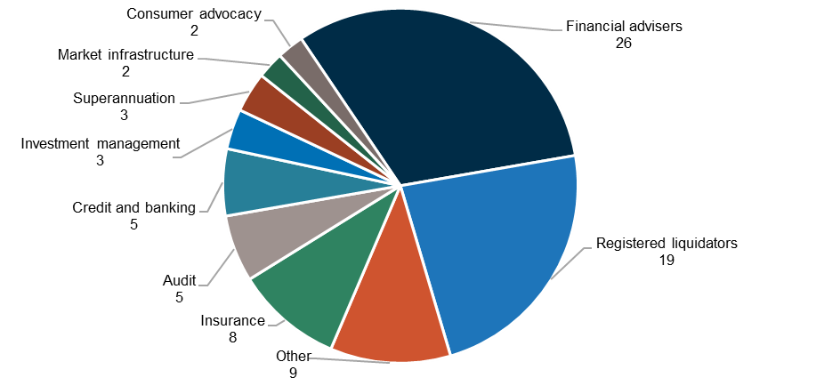

Source: Treasury, 2022.

Figure 2: Organisation size of survey respondents based on number of FTE employees

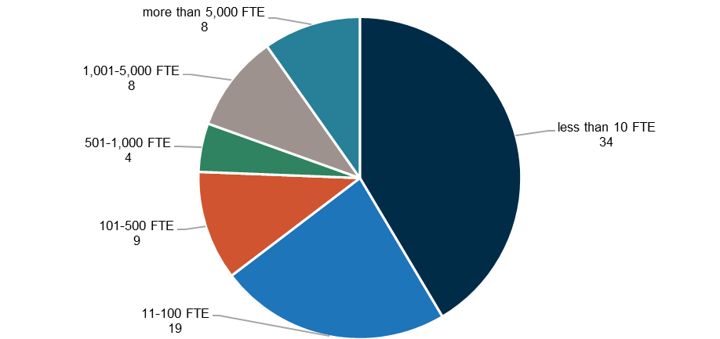

Source: Treasury, 2022.

### Information from ASIC

ASIC provided information, data and a self‑assessment of its effectiveness and capability in relation to the 3 areas of this review.

### Survey of ASIC staff

The survey contained 72 questions requiring respondents to choose from a scale of ‘strongly agree’ to ‘strongly disagree’ and 6 free‑text questions. Free‑text questions asked stakeholders to provide their views on what ASIC does well and what improvements it could make. The survey questions covered each of the scope areas of this review, as well as data and technology. The survey had 806 responses, representing a 41% response rate.

### ASIC interviews and focus groups

The FRAA held meetings and interviews with individual ASIC commissioners and executives and conducted 8 focus groups with ASIC’s senior leaders.

#### Commissioners

Karen Chester, Deputy Chair

Sarah Court, Deputy Chair

Cathie Armour, Commissioner[218]

Sean Hughes, Commissioner

Danielle Press, Commissioner

#### ASIC executives

Scott Barber, Chief Data and Analytics Officer

Joanna Bird, Executive Director, Financial Services and Wealth

Warren Day, Chief Operating Officer

Zack Gurdon, Chief Risk Officer

Zak Hammer, Executive Director, Operations

Greg Kirk, Executive Director, Strategy

Louise Macaulay, Chief of Staff

Greg Yanco, Executive Director, Markets

#### Focus groups

Strategic prioritisation, planning and decision-making (Strategy Group), senior executive leaders

Strategic prioritisation, planning and decision-making (Strategy Group), senior specialists and senior managers

Surveillance (Financial Services and Wealth Group and Operations Group – Misconduct and Breach Reporting), senior specialists and senior managers

Surveillance (Markets Group), senior specialists and senior managers

Licensing (Financial Services and Wealth Group), senior specialists and senior managers

Licensing (Markets Group), senior executive leaders, senior specialists and senior managers

# Appendix B: Examples of international frameworks for measuring performance

### OECD Framework for Regulatory Policy Evaluation

The OECD Measuring Regulatory Performance program aims to help OECD countries improve their regulatory quality. The program has developed Indicators of Regulatory Policy and Governance to measure regulatory performance. The indicators aim to both use these metrics to improve regulatory practices and demonstrate how improvements to regulatory governance deliver actual benefits to business and citizens.

### Financial System Assessment Program

The G20 members have committed to assessment through the Financial Sector Assessment Program (FSAP) by the IMF every 5 years. The goal of FSAP assessments is twofold:

to gauge the financial sector’s stability and soundness

assess its potential contribution to growth and development.

FSAP assessments include examining micro‑prudential and macroprudential frameworks; the quality of bank and non‑bank supervision and financial market infrastructure oversight; and the ability of central banks, regulators and supervisors, policymakers, backstops, and financial safety nets to respond effectively in case of systemic stress.

### Financial Soundness Indicators

The IMF collects reporting on countries’ performance against the Financial Soundness Indicators (FSIs). The FSIs were created by the IMF to support international comparisons and support macroprudential analysis of the financial market.

These indicators are composed of 2 parts: the ‘core set’, which includes basic indicators for the banking sector and is compulsory for participating countries, and the ‘encouraged set’, which includes additional supplementary indicators for the banking sector and selected indicators characterising other financial and non‑financial institutions, households, market liquidity and the real estate market.

### Basel Committee on Banking Supervision Regulatory Consistency Assessment Programme

The Basel Committee monitors the timely adoption of the Basel III regulations by its members, assesses their consistency with the Basel framework and examines the consistency of banks’ calculation of the prudential ratios across jurisdictions. The Regulatory Consistency Assessment Programme also helps member jurisdictions to identify and assess the materiality of any deviations from the Basel framework.

1. Refer paragraph 2.6.
2. Refer Chapter 3, Figure 3.2.
3. ASIC, [*Chair’s remarks at Corporate Counsel Association event*](https://asic.gov.au/about-asic/news-centre/speeches/chair-s-remarks-at-corporate-counsel-association-event/)[speech], ASIC website, 25 May 2022, accessed 21 July 2022. ASIC, [*Reflections from the ASIC Chair*](https://asic.gov.au/about-asic/news-centre/speeches/reflections-from-the-asic-chair/)[speech], ASIC website, 4 June 2022, accessed 21 July 2022.
4. KM Haynes, Recommendations 6.13 and 6.14, *Final Report Royal Commission into Misconduct in the Banking, Superannuation and Financial Services Industry*, Australian Government, 2019, p 41.
5. *Financial Regulator Assessment Authority Act 2021* (FRAA Act), ss 12‑13.
6. FRAA Act 2021, ss 12(1)(c), 14.
7. FRAA Act, s 12(2).
8. *Australian Securities and Investments Commission Act 2001* (ASIC Act); *Australian Prudential Regulation Authority Act 1998*; *National Consumer Credit Protection Act 2009* (NCCP Act); *Corporations Act 2001*; *Public Governance, Performance and Accountability Act 2013*; Commonwealth of Australia, Department of the Prime Minister and Cabinet, *Regulator Performance Guide*, Australian Government, 2021; Department of Finance, [*Australian Government Charging Framework Resource Management Guide No. 302*](https://www.finance.gov.au/publications/resource-management-guides/australian-government-charging-framework-rmg-302#:~:text=The%20Charging%20Framework%20builds%20on,improved%20and%20consistent%20government%20charging.), Australian Government, 2015.
9. For ASIC staff members within those teams, surveillance and licensing activities may represent only a portion of their workload. Staff are responsible for additional activities including industry engagement, education, policy advice and guidance. The distribution of activities within each team will vary depending on the size and nature of each team’s regulated population.
10. Internal budget allocation provided by ASIC based on the 2021-22 Budget. Total may not add to 100 due to rounding. Enforcement figures are based on ASIC’s internal budget allocation for the Office of Enforcement. The surveillance figures are based on ASIC’s internal budget allocation for the Markets Group and Financial Services and Wealth Group. Licensing figures do not include licensing work undertaken by the Market Infrastructure team which sits under the Markets Group. Other includes the Misconduct and Breach Reporting team and programs funded from Section 74 receipts (Modernising Business Registers program and Global Switch Unit exit).
11. In a discussion with the FRAA, several prominent academics expressed the view there is not ‘one’ approach, nor one set of metrics available to measure and compare the effectiveness and capability of regulators. See Appendix A for further details.
12. ASIC, Table 2.2.1 Key Results, [*Annual Report 2020–21*](https://asic.gov.au/about-asic/corporate-publications/asic-annual-reports/#ar21), p 31.
13. The FCA has developed approximately 90 metrics across 4 top‑line outcomes, 7 strategic transformation outcomes and 13 commitments; Financial Conduct Authority, [*FCA outcomes and metrics*](https://www.fca.org.uk/data/fca-outcomes-metrics#lf-chapter-id-measuring-the-outcomes-of-our-commitments), FCA website, 7 April 2022, accessed 21 July 2022.
14. ASIC, [*ASIC Corporate Plan 2021–25: Focus 2021–22*](https://download.asic.gov.au/media/qzcaljce/asic-corporate-plan-2021-25-focus-2021-22-published-26-august-2021.pdf), ASIC website, 2021, accessed 21 July 2022, p 34.
15. As per ASIC’s statutory mandate underASIC Act*,* s 1(2).
16. The Treasury, [*Financial System Inquiry Final Report*](https://treasury.gov.au/publication/c2014-fsi-final-report), December 2014, Characteristics of an effective financial system, xv.
17. During the GFC, Australian equity prices fell sharply, however Australian companies were able to raise equity capital; a record high of $63 billion being raised between January and September 2009. Similarly, during the COVID‑19 pandemic in Australia, listed entities raised around $65 billion – higher than in previous years. Australia’s banks remained well capitalised during the COVID‑19 pandemic and continued to deliver credit to businesses and households.
18. More than $240.5 million in compensation was awarded in response to 75,510 complaints being received during 2020–21. AFCA, [*2020*–*21 Annual Review*](https://www.afca.org.au/about-afca/annual-review), AFCA website, 2021, accessed 21 July 2022, p 4.
19. ASIC Act,s1(2).
20. The FRAA has been informed by sources including domestic and overseas regulator performance measures and the Government’s guide for regulator performance including: ASIC, [*ASIC Service Charter*](https://asic.gov.au/about-asic/what-we-do/how-we-operate/performance-and-review/asic-service-charter/asic-service-charter/), ASIC website, 2021, accessed 21 July 2022; APRA, APRA Service Charter, APRA website, n.d., 21 July 2022; Australian Taxation Officer (ATO), [*ATO Regulator Performance Framework*](https://www.ato.gov.au/about-ato/commitments-and-reporting/annual-report-and-other-reporting-to-parliament/regulator-performance-framework/), ATO website, 2022, accessed 21 July 2022; Department of the Prime Minister and Cabinet, [*Regulator Performance Guide*](https://www.pmc.gov.au/news-centre/regulation/new-regulator-performance-guide), Australian Government, 2021; IOSCO, [*Objectives and Principles of Securities Regulation*](https://www.pmc.gov.au/news-centre/regulation/new-regulator-performance-guide), IOSCO website, 2003, accessed 21 July 2022; FCA, [*Annual Report and Accounts 2020–21*](https://www.fca.org.uk/publication/annual-reports/annual-report-2020-21.pdf), FCA website, 2021, accessed 21 July 2022; HM Treasury, [*Financial Services Future Regulatory Framework Review: Proposals for Reform*](https://assets.publishing.service.gov.uk/government/uploads/system/uploads/attachment_data/file/1032075/FRF_Review_Consultation_2021_-_Final_.pdf), HM Treasury website, 2021, accessed 21 July 2022.
21. S Wallis, B Beerworth, J Carmichael, I Harper and L Nicholls, *Financial System Inquiry Final Report*, Australian Government, 1997, p 31.
22. ASIC also administers the *Business Names Registration Act 2001, Insurance Contracts Act 1984,* NCCP Act; and parts of the *Banking Act 1959, Life Insurance Act 1995, Medical Indemnity (Prudential Supervision and Product Standards) Act 2003, Retirement Savings Accounts Act 1997, Superannuation (Resolution and Complaints Act) 1993* and *Superannuation Industry (Supervision) Act 1993*.
23. ASIC Act, s 12A(2) and (3).
24. ASIC Act, s 1(2).
25. Note: this chart is a visual aid and has been simplified for clarity. Areas of responsibility as based on Australia’s regulatory framework and may not precisely align with frameworks adopted in other jurisdictions. The RBA has responsibility for payment systems and APRA for prudential regulation. In Australia, the ACCC is the primary competition regulator, but ASIC is required to have regard to competition issues.
26. ASIC, *Annual Report 2020*–*21*, 2021, p 223.
27. Average staffing level adjusts for casual and part‑time staff in order to show the average number of full‑time equivalent employees and is almost always a lower figure than a headcount of employees.
28. Australian Government, *Portfolio Budget Statements 2022*–*23 Treasury Portfolio*, Australian Government, 2022, pp. 144, 160.
29. The expenditure in excess of ASIC’s appropriation revenue relates to revenue received from other agencies, as well as own source revenue such as court recoveries.
30. For ASIC’s internal allocation of total funding by regulatory and operational teams refer paragraph 1.9.
31. ASIC, *Cost Recovery Implementation Statement: ASIC industry funding model (2021*–*22)*, ASIC, 2022, p 12.
32. Additionally, ASIC did not recover $34 million with respect to the personal advice subsector due to the temporary relief granted to this subsector in 2020–21 (refer [Mid‑Year Economic and Fiscal Outlook   
    2021–22](https://archive.budget.gov.au/2021-22/myefo/download/myefo-2021-22.pdf), measure ‘*ASIC Industry Levies – fee relief’*).
33. Note that the ASL counts, as reported in the Portfolio Budget Statements 2022–23 Treasury Portfolio, are an estimated forecast for the upcoming year. Cost recovery and statutory levies were both introduced in 2017–18 and fees‑for‑service was introduced in 2018–19. The 2021–22 IFM figures are indicative only.
34. Under the ASIC Act s 9 the Commission is to consist of no fewer than 3 and no more than 8 members.
35. ASIC, [*Statement of Intent: Australian Securities and Investments Commission – August 2021*](https://asic.gov.au/about-asic/what-we-do/how-we-operate/accountability-and-reporting/statements-of-expectations-and-intent/statement-of-intent-australian-securities-and-investments-commission-august-2021/), ASIC website, 2021, accessed 27 July 2022.
36. ASIC’s Groups (or divisions) as at July 2021 were Financial Services and Wealth; Financial Services Enforcement; Markets; Markets Enforcements; Supervision; Chief Legal Office; Strategy; Communications; Risk and Integrity; and Operations.
37. HIH Insurance Limited was an insurance company that was placed into provisional liquidation on 15 March 2001. The collapse of HIH Insurance Limited was the subject of a royal commission.
38. The Financial Sector Advisory Council was established in response to a recommendation of the Financial Systems Inquiry, with part of its function to provide industry views on the performance of the financial regulators. The Financial Sector Advisory Council was suspended in 2018 as its role overlapped with the Royal Commission into Misconduct in the Banking, Superannuation and Financial Services Industry.
39. K Chester, M Gray and D Galbally, *Fit for the future: A capability review of the Australian Securities and Investments Commission*, Australian Government, 2015.
40. ASIC disputed this evidence noting that over a one‑month period between September and November 2015, ASIC commissioners spent around 59% of their time on strategic matters and activities. The Capability Review maintained the view that its findings stood given other sources of evidence (observations, internal and external discussions, survey data).
41. Staff survey free‑text comments.
42. Confidential submissions.
43. CHOICE, Law Council of Australia, Australian Banking Association.
44. The stakeholder survey evidenced in this review represents a sample of ASIC’s regulated population and may not be indicative of all organisations and markets sectors regulated by ASIC. For more details see Appendix A.
45. Australian Banking Association, CHOICE.
46. Law Council of Australia, Customer Owned Banking Association, Australian Institute of Company Directors, Australian Institute of Superannuation Trustees, confidential submissions.
47. Law Council of Australia, Australian Banking Association, Customer Owned Banking Association, Insurance Council of Australia, confidential submission.
48. Law Council of Australia, Australia Institute of Company Directors, Australian Institute of Superannuation Trustees, Australian Restructuring Insolvency and Turnaround Association, Insurance Council of Australia, confidential submissions.
49. Law Council of Australia, Australian Banking Association, Customer Owned Banking Association, Insurance Council of Australia, confidential submissions.
50. Law Council of Australia.
51. ASIC, [*ASIC’s approach to new laws reforming financial services sector*](https://asic.gov.au/about-asic/news-centre/find-a-media-release/2021-releases/21-213mr-asic-s-approach-to-new-laws-reforming-financial-services-sector/) [media release], ASIC website, 12 August 2021, accessed 21 July 2022.
52. Executive director and commissioner interviews.
53. ASIC, [*Corporate Plan 2021*–*25: Focus 2021*–*22*](https://asic.gov.au/about-asic/corporate-publications/asic-corporate-plan/), ASIC website, 2021, accessed 21 July 2022.
54. Confidential submissions.
55. 9% and 16% disagreed respectively and the remainder neutral.
56. This underinvestment is also a function of ASIC’s capital expenditure budget which is set by Government, with limited flexibility to reallocate its operational expenditure budget to capital expenditure.
57. Executive director interviews and focus groups.
58. Refer paragraph 3.81 regarding changes ASIC has made in relation to data and technology since 2020.
59. 31% disagreed and the remainder neutral.
60. Staff survey free‑text comments.
61. ASIC, Material supplied to this review,2022*.*
62. Refer paragraph 4.27 for more information on ASIC’s CRM system.
63. Staff survey.
64. ASIC, Material supplied to this review,2022.
65. 6% and 10% disagreed respectively and the remainder neutral.
66. 4% disagreed and the remainder neutral.
67. Law Council of Australia, Australian Institute of Company Directors, Australian Banking Association, Insurance Council of Australia, Australian Securities Exchange, confidential submission.
68. Confidential submission.
69. Law Council of Australia, Australian Institute of Company Directors, Australian Institute of Superannuation Trustees, Australian Restructuring Insolvency and Turnaround Association, Insurance Council of Australia, confidential submission.
70. Confidential submission.
71. Australian Banking Association, Customer Owned Banking Association, Insurance Council of Australia, Consumer Action Law Centre and confidential submission. FCA, [*Regulatory Initiatives Grid*](https://www.fca.org.uk/publications/corporate-documents/regulatory-initiatives-grid), FCA website, 2022, accessed 21 July 2022. Council of Financial Regulators, [*Regulatory Initiatives Calendar*](https://www.cofr.govt.nz/news-and-publications/regulatory-initiatives-calendar.html), New Zealand Government, 2022, accessed 21 July 2022.
72. Australian Banking Association.
73. 18% disagreed and the remainder neutral.
74. Staff survey free‑text comments.
75. Australian Banking Association, Australian Institute of Superannuation Trustees, Law Council of Australia, Australian Financial Markets Association, confidential submissions.
76. Law Council of Australia and confidential submission.
77. 57% disagreed and the remainder neutral.
78. Confidential submission.
79. CHOICE, Australian Banking Association, confidential submission.
80. Confidential submission. ASIC’s Cost Recovery Implementation Statement contains information on how ASIC will implement its industry funding model, that is via levies, and how ASIC will recover regulatory costs.
81. Australian Banking Association.
82. 49% disagreed and the remainder neutral.
83. CHOICE and confidential submission.
84. CHOICE.
85. K Chester, M Gray and D Galbally, *Fit for the future: A capability review of the Australian Securities and Investments Commission*, Australian Government, 2015.
86. 20% disagreed and the remainder neutral.
87. For more information on the impact assessment framework, refer paragraph 4.84.
88. ASIC, Material supplied to this review,2022. Total ASIC staffing for 2021–22 is 1,948 FTE.   
    Twenty‑five per cent represents the 259 Financial Services and Wealth Group staff members and 224 Markets Group staff members. Small Business Engagement and Compliance has been included under Enforcement.
89. ASIC, Material supplied to this review,2022.
90. Thematic surveillances are effective in achieving their purpose: 63% agreed, 6% disagreed and the remainder neutral); surveillances of entities or individuals are effective in achieving their purpose:   
    65% agreed, 5% disagreed and the remainder neutral; programmatic surveillances are effective in achieving their purpose: 60% agreed, 6% disagreed and the remainder neutral.
91. CHOICE, Consumer Action Law Centre.
92. 49% disagreed and the remainder neutral. The stakeholder survey evidenced in this review represents a sample of ASIC’s regulated population and may not be indicative of all organisations and markets sectors regulated by ASIC. For more details see Appendix A.
93. 66% disagreed and the remainder neutral.
94. Law Council of Australia, Australian Institute of Superannuation Trustees, Business Council of Australia, Australian Financial Markets Association, confidential submissions, stakeholder survey, compulsory notices refer to ASIC’s use of information‑gathering powers to inspect books and records, or to compel the production of documents or the disclosure of information.
95. ASIC, [*ASIC’s compulsory information‑gathering powers* (INFO 145)](https://asic.gov.au/about-asic/asic-investigations-and-enforcement/asic-s-compulsory-information-gathering-powers/), ASIC website, 2020, accessed 27 July 2022.
96. One submission noted that on occasion, they encountered duplicated information requests from ASIC.
97. 45% disagreed and the remainder neutral.
98. 14% disagreed and the remainder neutral.
99. 35% disagreed and the remainder neutral.
100. Where relevant, information is appropriately shared between ASIC teams to support surveillance activities: 66% agreed, 13% disagreed and the remainder neutral; I have access to information collected during licensing applications to assist my surveillance activities: 59% agreed, 18% disagree and the remainder neutral.
101. ASIC focus groups.
102. 10% disagreed and the remainder neutral.
103. 58% disagreed and the remainder neutral.
104. 50% disagreed and the remainder neutral.
105. CPA Australia.
106. Business Council of Australia.
107. The capability descriptors and associated proficiency levels included in the staff self‑assessment described where ASIC wanted its team members to be over the next 3 to 5 years. ASIC is still in the process of embedding the capability framework across the organisation.
108. Since July 2019, 1,982 positions have been internally or externally advertised across ASIC, with 1,078 (54%) positions filled by external candidates.
109. The 3 pillars of the strategy are to support and enable ASIC to be more digitally enabled and regulate emerging areas; equip staff with the right mindset, tools and capabilities to ensure an engaged, thriving and diverse workforce; and uplift organisational leadership to embed a ‘whole‑of‑ASIC’ culture that will support its organisational purpose into the future.
110. Since July 2019, 83% of positions in the Chief Data and Analytics Office team (20 of 24) have been filled by external candidates and 70% of positions in the IT team (152 of 216) positions have been filled by external candidates.
111. 33% disagreed and the remainder neutral.
112. SEC, [*Press Release*](https://www.sec.gov/news/press-release/2020-165), SEC website, 2020, accessed 19 May 2022.
113. Business Council of Australia. Commissioner and executive director interviews.
114. 58% agreed, 22% disagreed and the remainder neutral.
115. 57% disagreed and the remainder neutral.
116. In response to user feedback, ASIC has launched a CRM uplift program, focused on improving user experience. Twenty‑three enhancements have been identified, with delivery to commence in December 2022.
117. Commissioner and executive director interviews.
118. As at April 2022 the data teams comprising the ‘spokes’ are spread across Markets (12 FTE), Financial Services and Wealth (16 FTE) and Enforcement (12 FTE) Groups, compared to total headcount in these teams: Markets (224 FTE), Financial Services and Wealth (259 FTE) and Enforcement (339 FTE across Markets Enforcement, and Financial Services and Wealth Enforcement).
119. ASIC, Material supplied to this review, 2022.Australian Institute of Company Directors, CPA Australia, Consumer Action Law Centre, Chartered Accountants Australia and New Zealand.
120. ASIC, Material supplied to this review,2022.
121. Australian Institute of Company Directors, CPA Australia.
122. ASIC, Material supplied to this review,2022*.*
123. ASIC, Material supplied to this review,2022*.* 
124. ASIC, Material supplied to this review, 2022. 31 FTE. This excludes licensing work conducted by the market infrastructure team as applications are infrequent and do not make up a large portion of the market infrastructure team’s day to day business. For completeness, there are 2 FTE staff for market infrastructure licensing activities.
125. ASIC’s licensing function also provides administrative support to the Liquidator Assessments Committee and manages the Register of Liquidators (which will be transferred to the ATO in the future under the Modernising Business Registers (MBR) program).
126. For example, the FCA.
127. ASIC, Material supplied to this review,2022.
128. For the list of consumer advocacy bodies the FRAA consulted with, see Appendix A.
129. ASIC, Material supplied to this review*,* 2022*.* 
130. Confidential interview. Stakeholder survey free‑text comments.
131. 29% disagreed and the remainder neutral. The stakeholder survey evidenced in this review represents a sample of ASIC’s regulated population, and may not be indicative of all organisations and market sectors regulated by ASIC. For more details see Appendix A.
132. Confidential interviews.
133. Stakeholder survey free‑text comment.
134. Confidential interviews, confidential submissions. For licensees, the portal is used to update information about the licence (such as the responsible managers, contact details or lodging annual accounts and reports).
135. Confidential interviews.
136. Confidential interviews.
137. Staff survey: *Software and digital tools for licensing activities are mainly perceived by staff,* 39% ad hoc, 43% basic, 18% systematic.
138. ASIC, Material supplied to this review,2022*.* 
139. ASIC, Material supplied to this review, 2022. Consumer Action Law Centre.
140. ASIC, Material supplied to this review,2022*.* 
141. ASIC, Material supplied to this review,2022. No timeframe for completion has been provided.
142. ASIC, Material supplied to this review,2022. Primary legislation, regulations, ASIC Class Instruments, ASIC Pro Forma 209 conditions, ASIC Regulatory Guides and ASIC Information Sheets.
143. ASIC, Material supplied to this review,2022. Pre‑lodge rejects can be time consuming. In 2020–21, 16% of applications lodged were rejected by ASIC or applicants withdrew after discussions with ASIC, due to the applications being submitted without the required information (304 of 1,883 applications).
144. ASIC, Material supplied to this review,2022. Enhancements to the licensing function’s Digital Assessment Worksheet and secure Dropbox automation projects.
145. Confidential interviews, Law Council of Australia. Stakeholders raised that email was problematic with size limits. Emailing supporting documents would often mean multiple attachments and multiple emails.
146. This process is explained in ASIC Information Sheet 240. AFS licence applications: Providing information for fit and proper people and certain authorisations.
147. Raised in public submission by the Law Council of Australia and targeted interviews.
148. ASIC, Material supplied to this review,2022. Note the context, looking at operational decisions only, not licensing decisions. The licensing regime allows a level of discretion in satisfying the legislative requirements.
149. Confidential interviews.
150. The Quality Assurance process involves a quality check against defined qualitative and quantitative measures for a random selection of 10 AFS licence assessments each month. It is a review of process, not the decision. Licensing staff undertake the ‘peer’ quality assurance review process with oversight from ASIC’s quality assurance team. Between October 2019 and June 2021, the overall average analyst assessment quality has ranged between 83% to 90%. The 17% to 10% quality reduction observed was for administrative matters (that is, not appropriately documented). No deficiencies were detected in assessments.
151. ASIC, Material supplied to this review*,* 2022*.*
152. ASIC notes that it is possible to test claims of consistency of operational decisions. The FRAA did not review individual decisions and was advised by ASIC that consistency audits are not conducted.
153. Confidential submissions, Business Council of Australia, Law Council of Australia, Insurance Council of Australia, CPA Australia, confidential interviews.
154. Confidential submission. Unlike some international regulators, licensees are not required to seek approval from ASIC to have a change of control in licensee, ASIC must only be notified after the change. For example, the FCA requires prior approval to acquire or increase control in a regulated firm, and a person must be approved by the Securities and Futures Commission of Hong Kong before becoming a substantial shareholder in a licensed entity.
155. Business Council of Australia, Law Council of Australia.
156. ASIC, [*ASIC Service Charter*](https://asic.gov.au/about-asic/what-we-do/how-we-operate/performance-and-review/asic-service-charter/asic-service-charter/), ASIC website, 2021, accessed 21 July 2022
157. The Ontario Securities Commission (OSC) comparison is of routine applications, not complex or novel applications. The United Kingdom’s FCA timeframes refer to statutory timeframes of ‘complete’ applications and ‘incomplete’ applications submitted.
158. ASIC, Material supplied to this review,2022.
159. ASIC, Material supplied to this review*,* 2022.
160. ASIC, Material supplied to this review*,* 2022. Confidential interview.
161. ASIC, Material supplied to this review*,* 2022.
162. Confidential interview.
163. ASIC, Material supplied to this review,2022.
164. Confidential interview, validated by other confidential interviews.
165. Confidential interviews, stakeholder survey free‑text comments, confidential submission. The FRAA acknowledges that the licensing regime is governed by the Corporations Act and NCCP Act*,* and if an innovative product does not fall within the definition of a financial product or service, or credit activity, set out in the legislation or regulations, ASIC cannot license the provision of the product, service or activity.
166. Confidential interview.
167. ASIC, Material supplied to this review, 2022. There were 1,965 AFSL and ACL applications approved, refused/withdrawn/rejected, cancelled/suspended.
168. It is acknowledged that ASIC has a different mandate to a business.
169. ATO Reinvention program; Service NSW was recognised for customer service in 2021 by the Customer Service Institute of Australia awards.
170. The bank uses a ‘stop the clock’ method to assess timeframes. ASIC measures total elapsed time.
171. ASIC, Material supplied to this review, 2021. The 118 days is the average days to finalisation for green risk rated applications for 2020–21. ASIC measures total elapsed time. The 118‑day timeframe is inclusive of the time taken to retrieve missing or additional documents.
172. Service‑level agreement is the bank’s target to provide customers a decision within 2 business days of them submitting a completed application.
173. Law Council of Australia, confidential interviews, stakeholder survey, staff survey.
174. ASIC, Material supplied to this review, 2022. Commissioner and executive director interviews.
175. Confidential interview.
176. Interviews with senior ASIC executives.
177. Changes to the point‑in‑time assessment would require law reform.
178. Interviews with senior ASIC executives.
179. Stakeholder survey free‑text comments, confidential interviews.
180. Similarly, it is easy to communicate with members of ASIC’s licensing team throughout the assessment process when I need to: 31% agreed, 30% disagreed and the remainder neutral.
181. ASIC, Material supplied to this review, 2022*.* 
182. ASIC, Material supplied to this review*,* 2022. The rationale for written communication is to manage risk and record keeping purposes to document procedural fairness.
183. Law Council of Australia, confidential interviews.
184. Confidential interview.
185. Confidential interview, interview with chair of Digital Finance Advisory Panel. Since introduction in 2015, the Innovation Hub has provided informal assistance and guidance to 677 fintech and regtech organisations.
186. ASIC, Material supplied to this review, 2022.
187. Interviews are not part of the licensing process.
188. The stakeholder noted unplanned interviews or verbal discussions did not mean that applicants could not defer to responding at a later date, waive their right to seeking advice or providing a more comprehensive written response. The comment was made in reference to answering what should be basic competency questions, if the applicant was competent, it would not be a problem.
189. Confidential interview. Note it is difficult to compare the overall efficiency of international regulators as mandates, requirements and resourcing levels all differ. These regulators are noted only as having an interview component as part of their method of assessment.
190. OSC, *Annual Summary Report for Dealers, Advisers and Investment Fund Managers,* OSC website, 2015, accessed 21 July 2022, pp 3, 24.
191. 14% disagreed and the remainder neutral. The FRAA’s survey did not ask if the quality and quantity of training had been sufficient, but rather that it had occurred.
192. Results from initial staff self‑assessments conducted under ASIC’s refreshed capability framework. The capability descriptors and associated proficiency levels included in the staff self‑assessment described where ASIC wanted its team members to be over the next 3 to 5 years. ASIC is still in the process of embedding the capability framework across the organisation.
193. Stakeholder survey: 19% disagreed and the remainder neutral and staff survey: 4% disagreed and the remainder neutral.
194. Approximately 10% of the applications assessed by ASIC are voluntarily withdrawn by the applicant, typically after the licensing team explains reasons for why they will recommend a refusal to the ASIC delegate.
195. ASIC, Material supplied to this review,2022. ASIC, Material supplied to this review,2021.
196. Note that outcomes that were marked ‘in progress’ were in progress at the end of the financial year they were applied for.
197. Stakeholder survey ASIC conducts fair and robust licensing assessments:50% agreed, 19% disagreed and the remainder neutral; staff survey: 62% agreed, 4% disagreed and the remainder neutral.
198. ASIC, Material supplied to this review,2022.
199. ASIC, Material supplied to this review, 2022.
200. ASIC, Material supplied to this review, 2022. ASIC, *Annual Report 2016*–*17,* p 35.
201. Annual Report and Licensing and professional registration activities update.
202. ASIC, Material supplied to this review,2022. The reasons the 3 licensees were subject to enforcement investigations were (1) cold‑calling to switch superannuation accounts – note this would not be considered from licensing assessment (2) potential fraud – note ASIC has regard to previous criminal offences and intelligence on past conduct that may impact future conduct, if no probity issues then unable to predict future misconduct, and (3) concerns liquidation of assets may not be in best interests of investors – this reflects business judgement and was beyond scope of assessment at the licence application stage.
203. FMA, [*Ease of doing business survey,*](https://www.fma.govt.nz/news-and-resources/reports-and-papers/ease-of-doing-business-survey/)New Zealand Government, 2020, accessed 21 July 2022.
204. Department of the Prime Minister and Cabinet, [*Regulator Performance Guide*,](https://deregulation.pmc.gov.au/sites/default/files/regulator-performance-guide.pdf) Australian Government, 2021, p 8.
205. ASIC’s annual technology spend as a proportion of total spend, averaged over 4 years is around 10%. Comparatively, Services Australia is 12%, ATO is 16%, the United States’ SEC is 17%, and the United Kingdom’s FCA is 21%. Sources include Boston Consulting Group analysis, international peer regulator financial statements and annual reports. Public information was used and judgement was applied to ensure like‑for‑like comparisons, noting that global market conduct regulators account for their data and technology spending in various ways, using different accounting methodologies to present this information.
206. The Government suggests that best practice regulators are transparent, open and responsive to feedback on how they operate, engaging in genuine two‑way dialogue with stakeholders and the broader community on their performance. Department of the Prime Minister and Cabinet, [*Regulator Performance Guide*](https://deregulation.pmc.gov.au/sites/default/files/regulator-performance-guide.pdf), Australian Government, 2021, p 9.
207. The Government’s view is that transparency in process supports community trust by demonstrating a regulator’s priorities and integrity and that regulators should clearly communicate regulatory processes and be transparent about decision‑making criteria. Department of the Prime Minister and Cabinet, [*Regulator Performance Guide*](https://deregulation.pmc.gov.au/sites/default/files/regulator-performance-guide.pdf), Australian Government, 2021, p 9.
208. Percentages are based on 2020–21 and 2018–19 numbers, rounded to the nearest whole. ATO, [*ATO Regulator Performance Framework self‑assessment report 2020‑21*](https://www.ato.gov.au/About-ATO/Commitments-and-reporting/In-detail/ATO-Regulator-Performance-Framework-self-assessment-report-2020-21/?page=13), ATO website, 2022, accessed 21 July 2022, p 13. ATO, [*ATO Regulator Performance Framework self‑assessment report 2020‑21*](https://www.ato.gov.au/About-ATO/Commitments-and-reporting/In-detail/ATO-Regulator-Performance-Framework-self-assessment-report-2020-21/?page=13), ATO website, 2022, accessed 21 July 2022, p 13.
209. Since Reinventing the ATO began, staff satisfaction is at its highest levels recorded. The 2021 APS Census result recorded a score of 76% employee engagement.
210. ATO, [*ATO Regulator Performance Framework self‑assessment report 2018‑19: Survey‑based metrics*](https://www.ato.gov.au/About-ATO/Commitments-and-reporting/In-detail/ATO-Regulator-Performance-Framework-self-assessment-report-2018-19/?page=11), ATO website, 2020, accessed 21 July 2022, p 11; ATO, 2022, [*ATO Regulator Performance Framework self‑assessment report 2020‑21: Survey‑based metrics*](https://www.ato.gov.au/About-ATO/Commitments-and-reporting/In-detail/ATO-Regulator-Performance-Framework-self-assessment-report-2020-21/?page=13), ATO website, 2022, accessed 21 July 2022, p 13.
211. ASIC, [*Statement of Intent: Australian Securities and Investments Commission – August 2021*](https://asic.gov.au/about-asic/what-we-do/how-we-operate/accountability-and-reporting/statements-of-expectations-and-intent/statement-of-intent-australian-securities-and-investments-commission-august-2021/), ASIC website, 2021, accessed on 21 July 2022.
212. Department of the Prime Minister and Cabinet, [*Regulator Performance Guide*](https://deregulation.pmc.gov.au/sites/default/files/regulator-performance-guide.pdf), Australian Government, 2021, p 5.
213. ASIC, [*Corporate Plan 2021–25: Focus 2021–22*](https://asic.gov.au/about-asic/corporate-publications/asic-corporate-plan/), ASIC website, 2021, accessed 21 July 2022.
214. Department of the Prime Minister and Cabinet, [*Regulator Performance Guide*](https://deregulation.pmc.gov.au/sites/default/files/regulator-performance-guide.pdf), Australian Government, 2021, p 8.
215. Department of the Prime Minister and Cabinet, [*Regulator Performance Guide*](https://deregulation.pmc.gov.au/sites/default/files/regulator-performance-guide.pdf), Australian Government, 2021, p 7.
216. FRAA, consultation paper, [Scope of assessment of the Australian Securities and Investments Commission, 29 November 2021 – 28 January 2022](https://fraa.gov.au/consultations/scope-assessment-australian-securities-and-investments-commission), accessed 26 July 2022.
217. Public submissions are available on the FRAA website at [fraa.gov.au](https://fraa.gov.au).
218. Cathie Armour’s term as Commissioner concluded in June 2022.